Unit 3 Lesson 11: Using Equations to Solve Problems

1 Remember Tape Diagrams (Warm up)

Student Task Statement
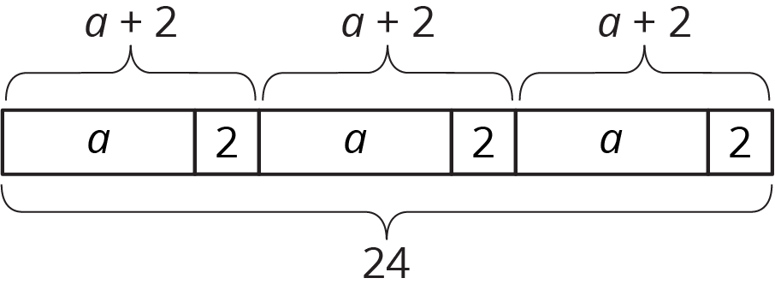
- Write a story that could be represented by this tape diagram.
- Write an equation that could be represented by this tape diagram.

2 At the Fair

Student Task Statement
- Tyler is making invitations to the fair. He has already made some of the invitations, and he wants to finish the rest of them within a week. He is trying to spread out the remaining work, to make the same number of invitations each day. Tyler draws a diagram to represent the situation.
  - Explain how each part of the situation is represented in Tyler’s diagram:
  - How many total invitations Tyler is trying to make.
  - How many invitations he has made already.
  - How many days he has to finish the invitations.
  - How many invitations should Tyler make each day to finish his goal within a week? Explain or show your reasoning.
  - Use Tyler’s diagram to write an equation that represents the situation. Explain how each part of the situation is represented in your equation.
  - Show how to solve your equation.
- Noah and his sister are making prize bags for a game at the fair. Noah is putting 7 pencil erasers in each bag. His sister is putting in some number of stickers. After filling 3 of the bags, they have used a total of 57 items.
  - Explain how the diagram represents the situation.
  - Noah writes the equation $3(x+7)=57$ to represent the situation. Do you agree with him? Explain your reasoning.
  - How many stickers is Noah's sister putting in each prize bag? Explain or show your reasoning.
- A family of 6 is going to the fair. They have a coupon for $1.50 off each ticket. If they pay $46.50 for all their tickets, how much does a ticket cost without the coupon? Explain or show your reasoning. If you get stuck, consider drawing a diagram or writing an equation.

3 Running Around

Student Task Statement
Priya, Han, and Elena, are members of the running club at school.
- Priya was busy studying this week and ran 7 fewer miles than last week. She ran 9 times as far as Elena ran this week. Elena only had time to run 4 miles this week.
  - How many miles did Priya run last week?
  - Elena wrote the equation $\frac{1}{9}(x−7)=4$ to describe the situation. She solved the equation by multiplying each side by 9 and then adding 7 to each side. How does her solution compare to the way you found Priya's miles?
- One day last week, 6 teachers joined $\frac{5}{7}$ of the members of the running club in an after-school run. Priya counted a total of 31 people running that day. How many members does the running club have?
- Priya and Han plan a fundraiser for the running club. They begin with a balance of -80 because of expenses. In the first hour of the fundraiser they collect equal donations from 9 family members, which brings their balance to -44. How much did each parent give?
- The running club uses the money they raised to pay for a trip to a canyon. At one point during a run in the canyon, the students are at an elevation of 128 feet. After descending at a rate of 50 feet per minute, they reach an elevation of -472 feet. How long did the descent take?
© CC BY Open Up Resources. Adaptations CC BY IM.

