## Lesson 12: How Many Are Missing?

* Let’s fill 10-frames in different ways.

### Warm-up: Which One Doesn’t Belong: 10-frames

Which one doesn’t belong?

A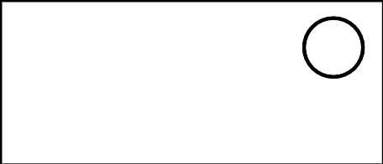

B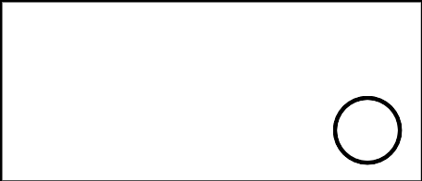

C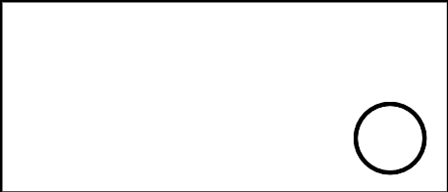

D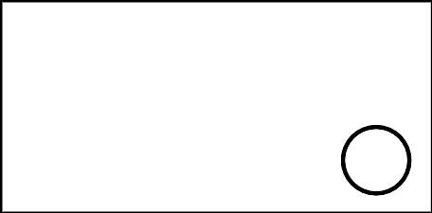

### 12.1: Shake, Spill, and Arrange with 10



### 12.2: How Many to Fill the 10-frame?



* 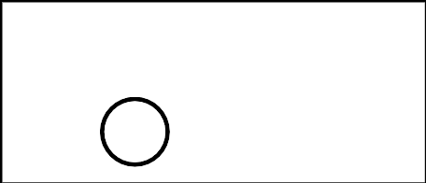
* _______________



* 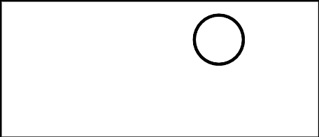
* _______________



* 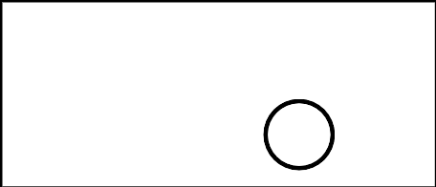
* _______________



* 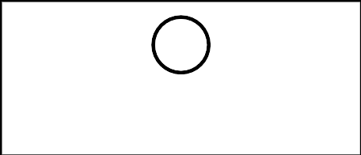
* _______________



* 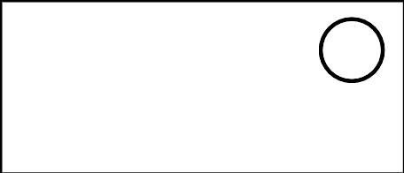
* _______________



* 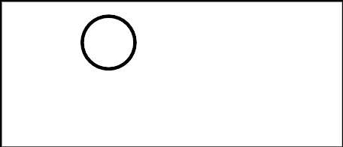
* _______________

### 12.3: Centers: Choice Time

Choose a center.

Shake and Spill



Counting Collections

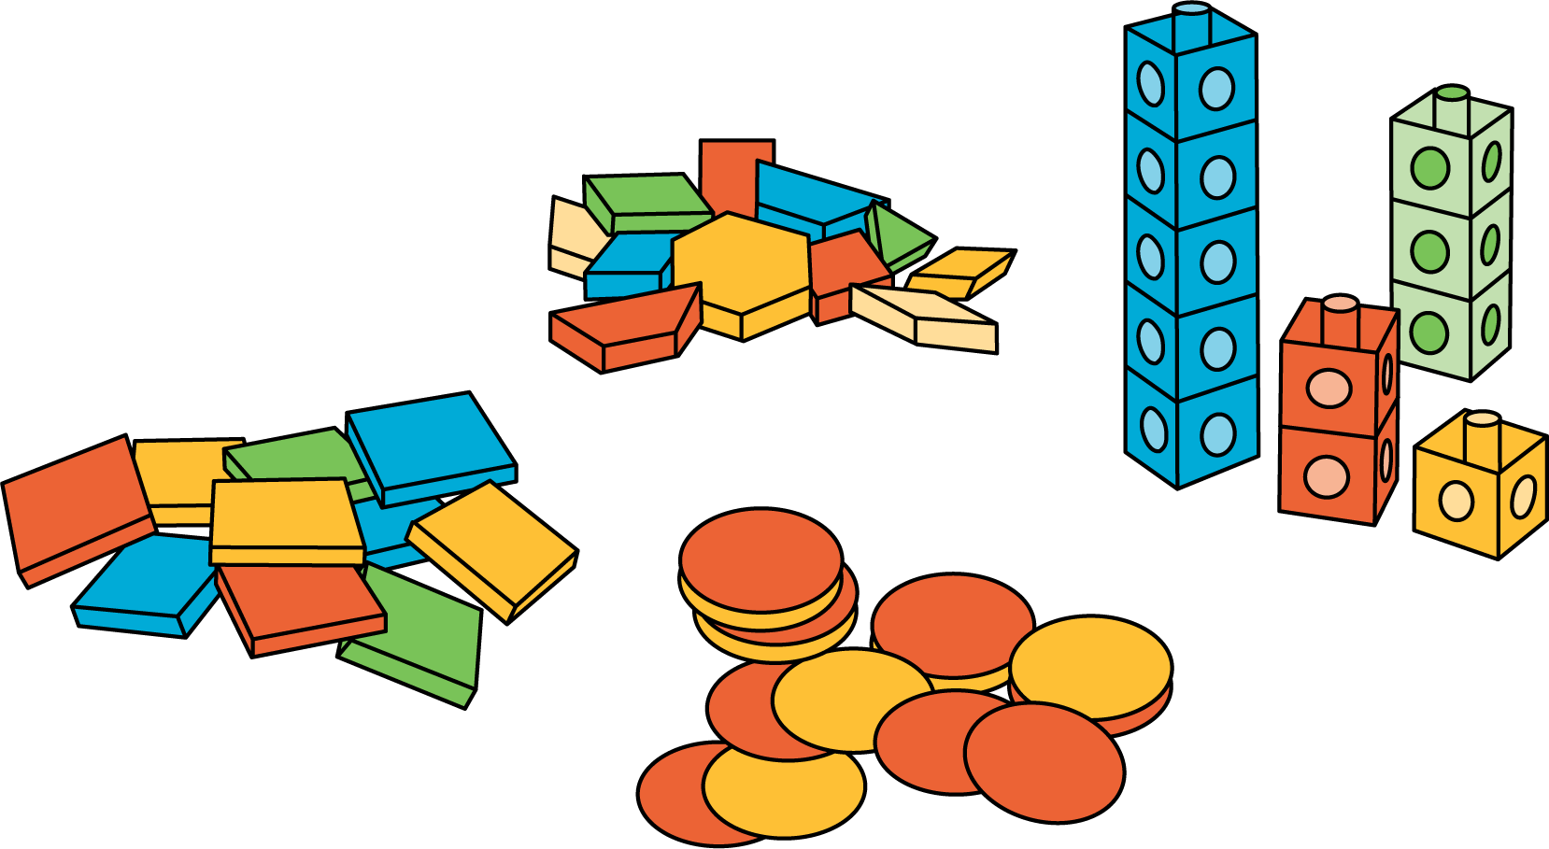

Roll and Add

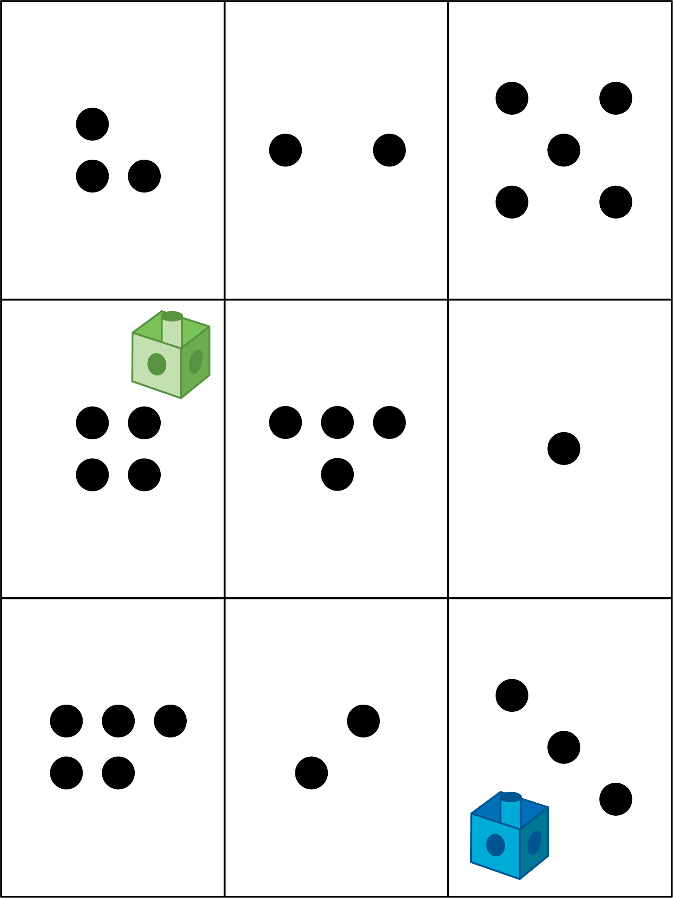



© CC BY 2021 Illustrative Mathematics®