Unit 4 Lesson 10: Domain and Range (Part 1)

1 Number of Barks (Warm up)

Student Task Statement
Earlier, you saw a situation where the total number of times a dog has barked was a function of the time, in seconds, after its owner tied its leash to a post and left. Less than 3 minutes after he left, the owner returned, untied the leash, and walked away with the dog.
- Could each value be an input of the function? Be prepared to explain your reasoning.
- 15
- $84\frac{1}{2}$
- 300
- Could each value be an output of the function? Be prepared to explain your reasoning.
- 15
- $84\frac{1}{2}$
- 300

2 Card Sort: Possible or Impossible?

Student Task Statement
Your teacher will give you a set of cards that each contain a number. Decide whether each number is a possible input for the functions described here. Sort the cards into two groups—possible inputs and impossible inputs. Record your sorting decisions.
- The area of a square, in square centimeters, is a function of its side length, $s$, in centimeters. The equation $A\left(s\right)=s^{2}$ defines this function.
  - Possible inputs:
  - Impossible inputs:
- A tennis camp charges $40 per student for a full-day camp. The camp runs only if at least 5 students sign up, and it limits the enrollment to 16 campers a day. The amount of revenue, in dollars, that the tennis camp collects is a function of the number of students that enroll.
- The equation $R\left(n\right)=40n$ defines this function.
  - Possible inputs:
  - Impossible inputs:
- The relationship between temperature in Celsius and the temperature in Kelvin can be represented by a function $k$. The equation $k\left(c\right)=c+273.15$ defines this function, where $c$ is the temperature in Celsius and $k\left(c\right)$ is the temperature in Kelvin.
  - Possible inputs:
  - Impossible inputs:

3 What about the Outputs?

Student Task Statement
In an earlier activity, you saw a function representing the area of a square (function $A$) and another representing the revenue of a tennis camp (function $R$). Refer to the descriptions of those functions to answer these questions.
- Here is a graph that represents function $A$, defined by $A\left(s\right)=s^{2}$, where $s$ is the side length of the square in centimeters.
- 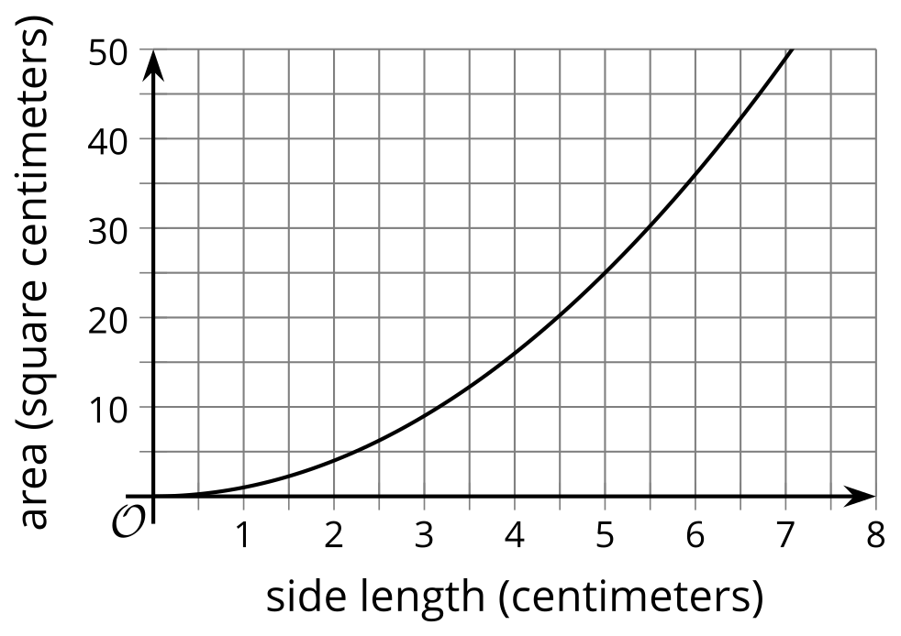
  - Name three possible input-output pairs of this function.
  - Earlier we describe the set of all possible input values of $A$ as “any number greater than or equal to 0.” How would you describe the set of all possible output values of $A$?
- Function $R$ is defined by $R\left(n\right)=40n$, where $n$ is the number of campers.
  - Is 20 a possible output value in this situation? What about 100? Explain your reasoning.
  - Here are two graphs that relate number of students and camp revenue in dollars. Which graph could represent function $R$? Explain why the other one could not represent the function.
  - 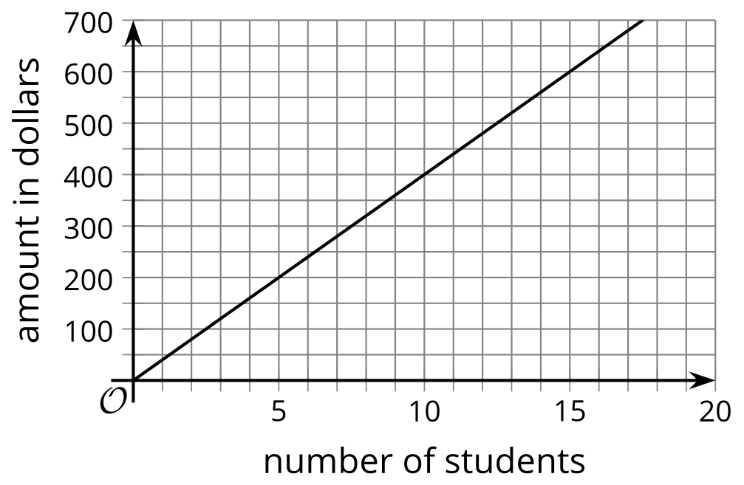
  - 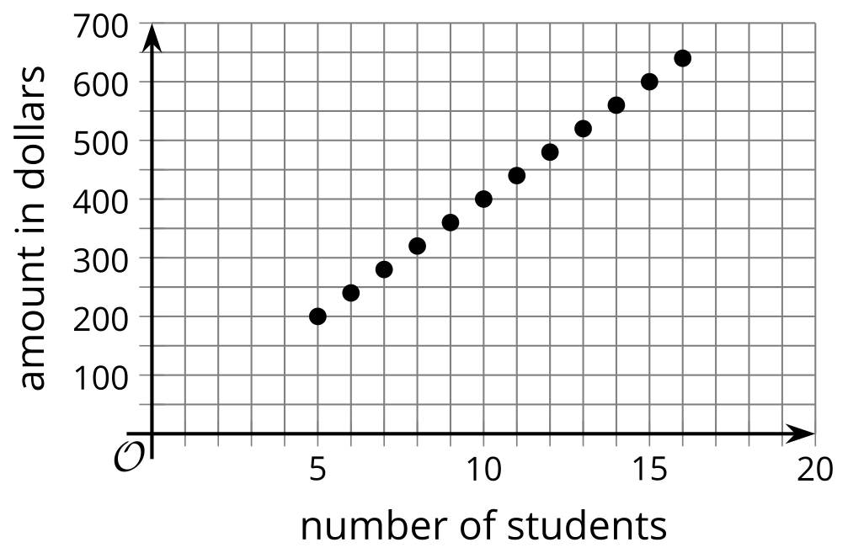
  - Describe the set of all possible output values of $R$.

4 What Could Be the Trouble? (Optional)

Student Task Statement
Consider the function $f\left(x\right)=\frac{6}{x−2}$.
To find out the sets of possible input and output values of the function, Clare created a table and evaluated $f$ at some values of $x$. Along the way, she ran into some trouble.
- Find $f\left(x\right)$ for each $x$-value Clare listed. Describe what Clare’s trouble might be.
- $x$ | - -10 | - 0 | - $\frac{1}{2}$ | - 2 | - 8
- $f\left(x\right)$
- Use graphing technology to graph function $f$. What do you notice about the graph?
- Use a calculator to compute the value you and Clare had trouble computing. What do you notice about the computation?
- How would you describe the domain of function $f$?
© CC BY 2019 by Illustrative Mathematics®

