Lesson 11 Practice Problems
- Here is a central angle that measures 1.5 radians. Select all true statements.
- 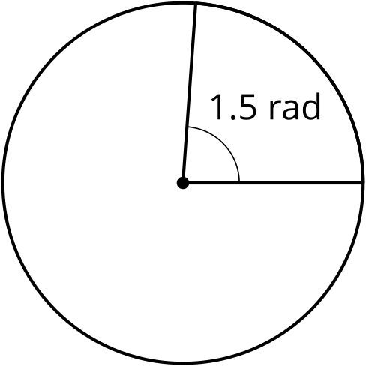
  - The radius is 1.5 times longer than the length of the arc defined by the angle.
  - The length of the arc defined by the angle is 1.5 times longer than the radius.
  - The ratio of arc length to radius is 1.5.
  - The ratio of radius to arc length is 1.5.
  - The area of the whole circle is 1.5 times the area of the slice.
  - The circumference of the whole circle is 1.5 times the length of the arc formed by the angle.
- Match each arc length $ℓ$ and radius $r$ with the measure of the central angle of the arc in radians.
  - $r=2,ℓ=\frac{π}{2}$
  - $r=3,ℓ=2$
  - $r=3.5,ℓ=2.8$
  - $r=4,ℓ=3$
  - $r=5,ℓ=π$
  - $r=6,ℓ=4$
  - $\frac{π}{5}$ radians
  - $\frac{2}{3}$ radians
  - 0.75 radians
  - $\frac{π}{4}$ radians
  - 0.8 radians
- Han thinks that since the arc length in circle A is longer, its central angle is larger. Do you agree with Han? Show or explain your reasoning.

- circle A
- 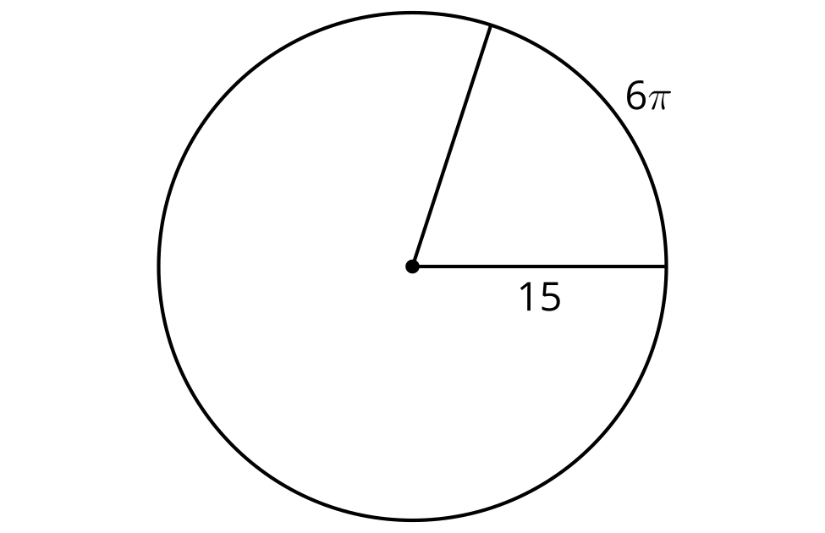

- circle B
- 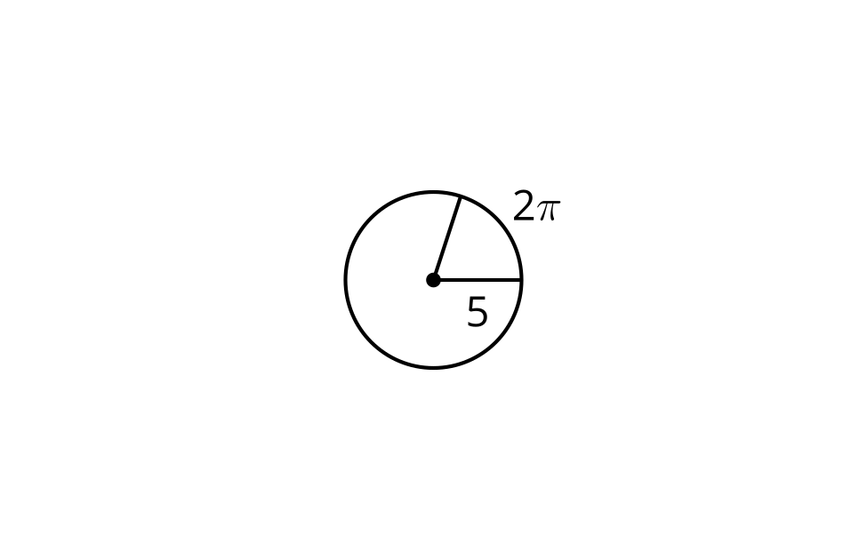
- Circle B is a dilation of circle A.

- circle A
- 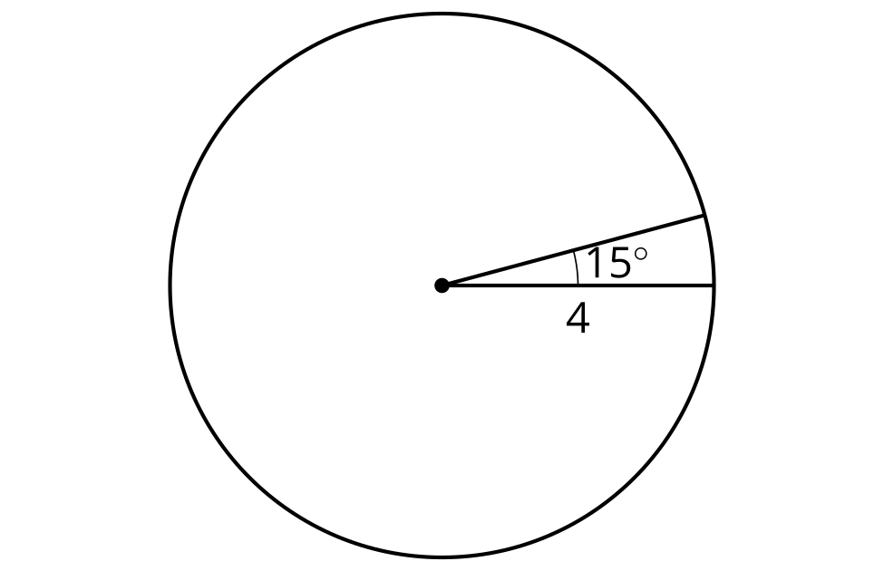

- circle B
- 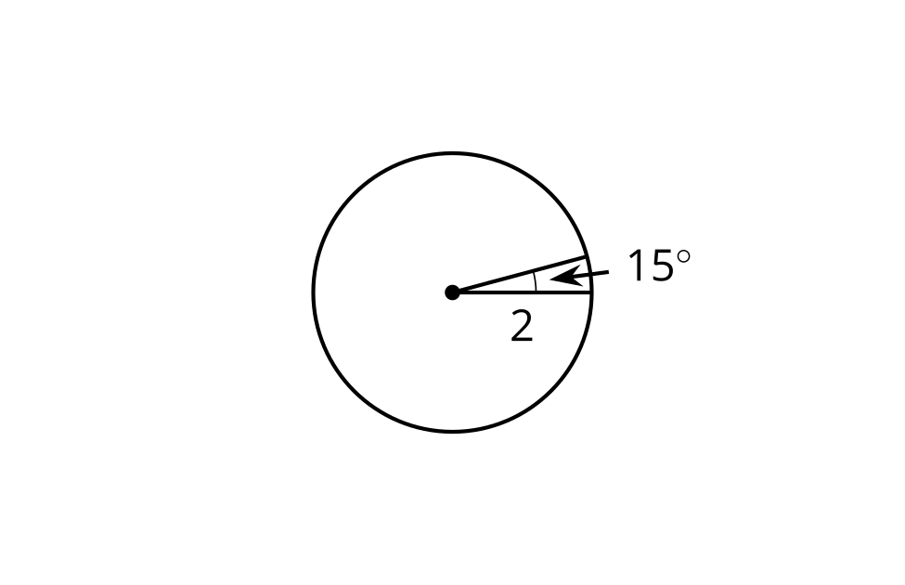
  - What is the scale factor?
  - What is the area of the 15 degree sector in circle A?
  - What is the area of the 15 degree sector in circle B?
  - What is the ratio of the areas of the sectors?
  - How does the ratio of areas of the sectors compare to the scale factor?
- (From Unit 7, Lesson 10.)
- Priya and Noah are riding different size Ferris wheels at a carnival. They started at the same time. The highlighted arcs show how far they have traveled.

- Noah’s Ferris wheel
- 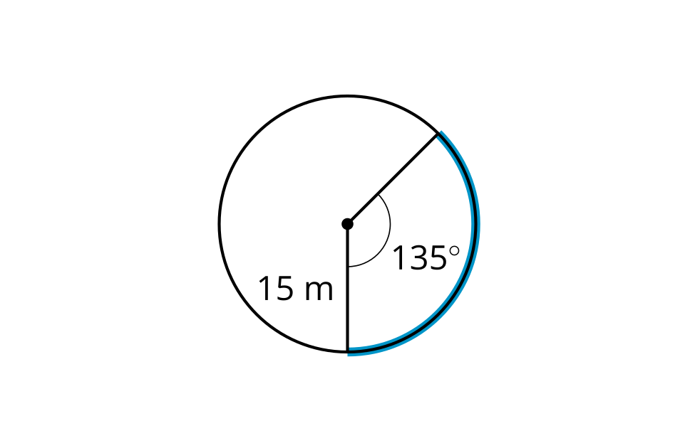

- Priya’s Ferris wheel
- 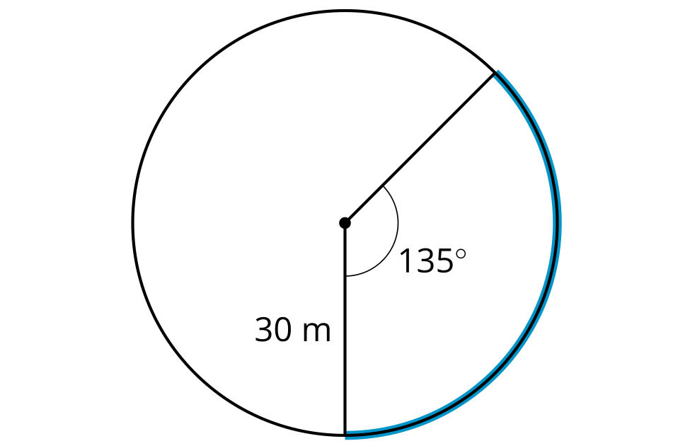
  - How far has Noah traveled?
  - How far has Priya traveled?
  - If the Ferris wheels will each complete 1 revolution, who do you think will finish first?
- (From Unit 7, Lesson 10.)
- A circle has radius 8 units, and a central angle is drawn in. The length of the arc defined by the central angle is $4π$ units. Find the area of the sector outlined by this arc.
- (From Unit 7, Lesson 9.)
- Clare is trying to explain how to find the area of a sector of a circle. She says, “First, you find the area of the whole circle. Then, you divide by the radius.“ Do you agree with Clare? Explain or show your reasoning.
- (From Unit 7, Lesson 8.)
- Line $BD$ is tangent to a circle with diameter $AB$. List 2 right angles.
- 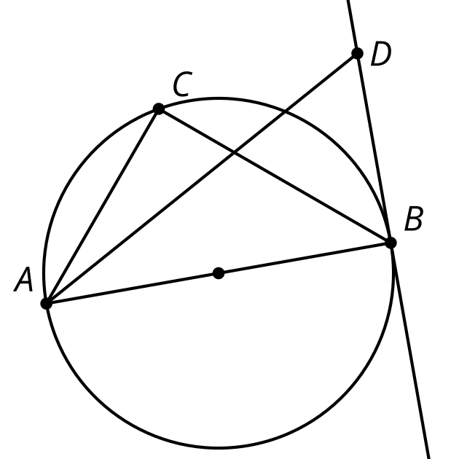
- (From Unit 7, Lesson 3.)
© CC BY 2019 by Illustrative Mathematics®

