Unit 2 Lesson 6: Relate Division and Multiplication

WU Number Talk: Multiply and Divide (Warm up)

Student Task Statement
Find the value of each expression mentally.
- $3×\frac{1}{2}$
- $3×\frac{2}{2}$
- $3×\frac{3}{2}$
- $5×\frac{3}{2}$

1 The Race

Student Task Statement
- Lin and Han ran a 3 mile relay race as a team. They each ran the same distance. Draw a diagram to represent the situation.
- Take turns describing to your partner how your diagrams represent the situation.
- How far did each person run?

2 Where Do You See It?

Student Task Statement
Diagram A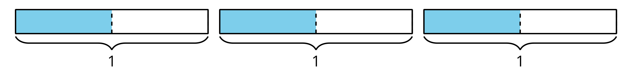
Diagram B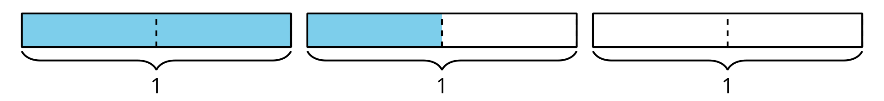
For each expression, choose one of the diagrams and describe how the diagram represents the expression. Be prepared to explain why you chose that diagram.
- $3×\frac{1}{2}$
- $3÷2$
- $\frac{1}{2}×3$
© CC BY 2021 Illustrative Mathematics®

