Lesson 18: Lots of Milk
- Let's make estimates with big numbers.

Warm-up: Estimation Exploration: How Big is the Milk Carton?
What is the volume of the milk carton in cubic inches?
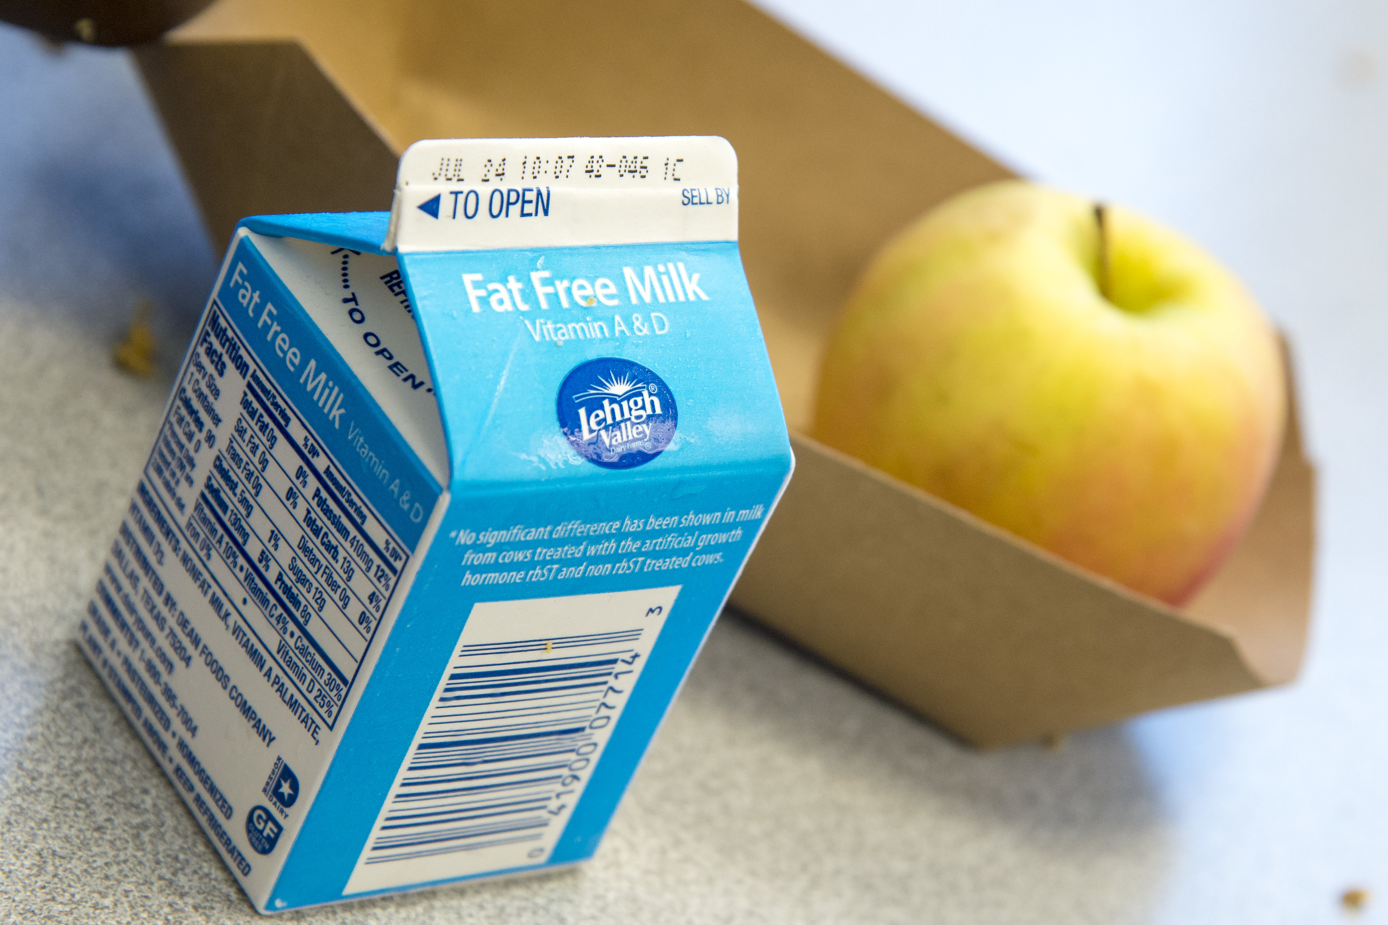
Record an estimate that is:
too low | about right | too high

18.1: Milk for Everyone
In each situation, estimate the volume of milk, in cubic inches, that you or the group would drink in one day. Explain your reasoning.
- you
- your class
- your grade
- your school
- 10 schools

18.2: How Big is 1,000,000?
Estimate the number of days it would take each group to drink 1,000,000 cubic inches of milk. Explain your reasoning.
- 10 local schools
- your school
- your grade
- your class
- you
© CC BY 2021 Illustrative Mathematics®

