Lesson 3: Unlabeled Tick Marks

Standards Alignments
Addressing | 2.MD.B.6, 2.NBT.A.2

Teacher-facing Learning Goals
- Represent a whole number on a number line and describe the point in terms of its length from 0.
- Use skip-counting patterns to locate numbers on a number line.

Student-facing Learning Goals
- Let’s locate numbers on the number line.

Lesson Purpose
The purpose of this lesson is for students to represent numbers within 100 on number lines that do not label each tick mark.
In a previous lesson, students were introduced to the number line and represented the location of numbers with labeled tick marks and points up to 20.
In this lesson, students use multiples of 5 and 10 to locate numbers up to 100 on the number line. Students leverage their understanding of skip counting by 5 and 10 to locate numbers and build on their understanding of the number line as a representation that includes all numbers. In future lessons, students will estimate numbers on a number line without any tick marks by approximating the location of the number relative to the position of represented numbers.

Access for:

Students with Disabilities
- Action and Expression (Activity 2)

English Learners
- MLR2 (Activity 1)

Instructional Routines
Notice and Wonder (Warm-up)

Lesson Timeline
Warm-up | 10 min
Activity 1 | 15 min
Activity 2 | 20 min
Lesson Synthesis | 10 min
Cool-down | 5 min

Teacher Reflection Question
How effective were your questions in supporting students’ thinking about the structure of the number line today? What did students say or do that showed they were effective?

Cool-down
(to be completed at the end of the lesson) 5min
What's Missing?

Standards Alignments
Addressing | 2.MD.B.6, 2.NBT.A.2

Student-facing Task Statement
Complete each number line by filling in the missing labels with the number the tick mark represents.

  - Locate and label 37 on the number line.

  - 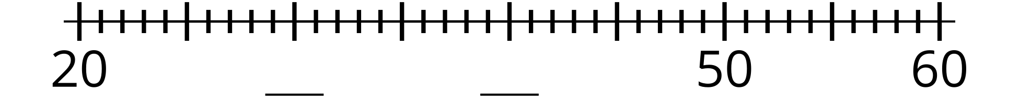
  - Locate and label 35 on the number line.

Student Responses
1.
2,

