Unit 3 Lesson 24: Relate Counting to Addition and Subtraction

WU Choral Count: Backward from 50 (Warm up)

Student Task Statement

1 Different Ways to Subtract

Student Task Statement
Yesterday, we saw Diego’s method to find the value of $15−8$.
Diego's way
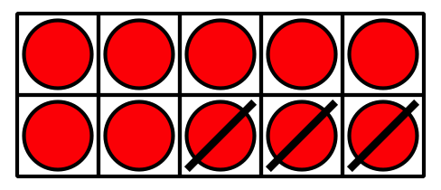
Tyler’s way
Find the value of each difference using Diego’s way, then using Tyler’s way.
Diego's Way
Tyler's Way
- $16−3$
- Diego's Way
- Tyler's Way
- $17−8$
- $18−15$

2 Find the Number That Makes Each Equation True

Student Task Statement
Find the number that makes each equation true.
Be sure you can explain your thinking in a way that others will understand.
Set A:
- 12–7=aaaiaaai
- 18−5=aaaiaaai
- aaaiaaai=14−6
- 15−12=aaaiaaai
- 13−4=aaaiaaai
Set B:
- 5+aaaiaaai=18
- 13=aaaiaaai+6
- 20=15+aaaiaaai
© CC BY 2021 Illustrative Mathematics®

