Unit 2 Lesson 13: Story Problems and Equations

WU Which One Doesn’t Belong: Diagrams (Warm up)

Student Task Statement
Which one doesn’t belong?

- 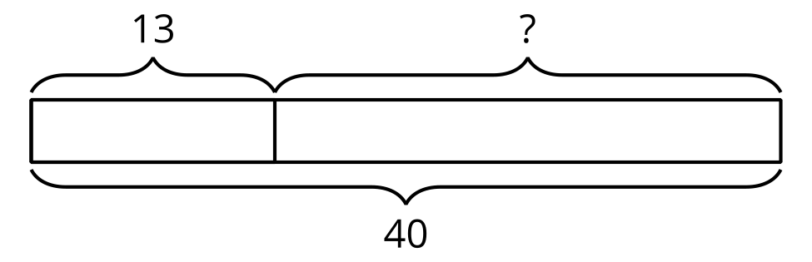

- 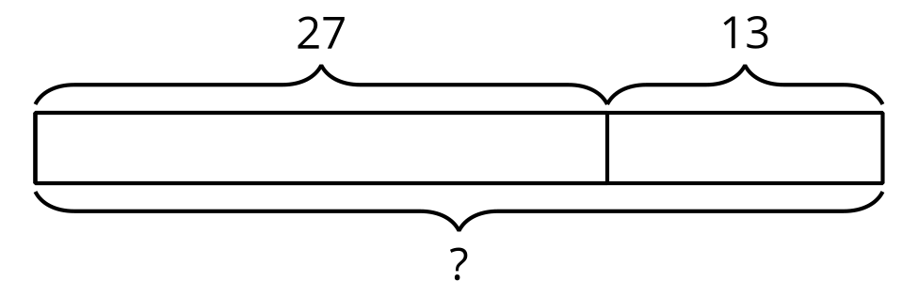
- 27+ _=40

- 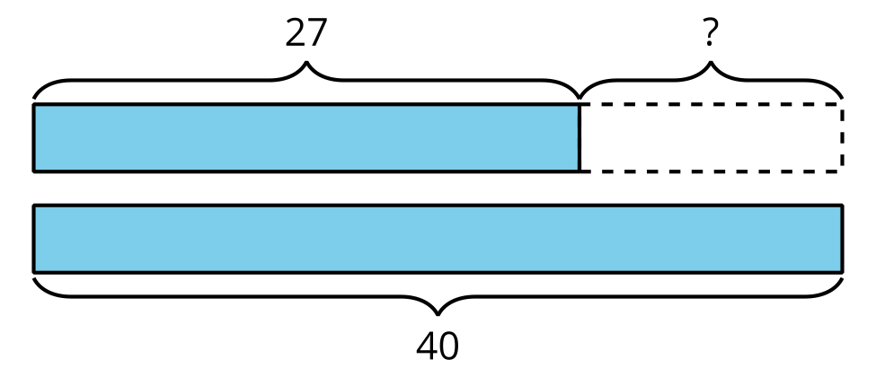

1 Card Sort: Story Problems and Equations

Student Task Statement
- Match each story problem with an equation. Explain why the cards match.
- Choose 2 story problems and solve them. Show your thinking.

2 Represent and Solve Story Problems

Student Task Statement
- 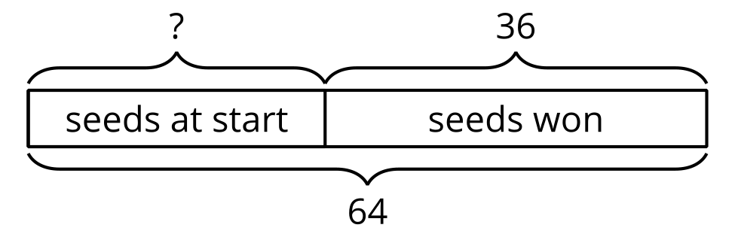
- Lin played a game with seeds. She started the game with some seeds. Then she won 36 seeds. Now she has 64 seeds. How many seeds did Lin have at first?
  - Write an equation using a question mark for the unknown value.
  - Solve. Show your thinking using drawings, numbers, or words.
- Andre started a game with 32 seeds. Then he won more seeds. Now he has 57 seeds. How many seeds did Andre win?
  - Label the diagram to represent the story.
  - 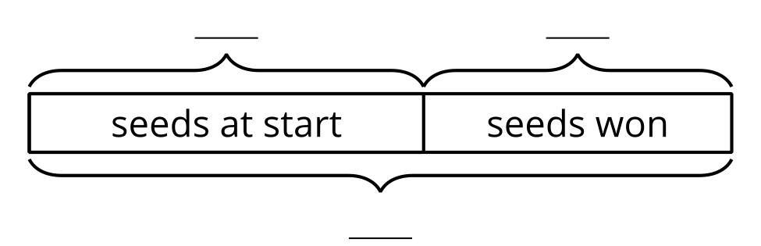
  - Write an equation using a question mark for the unknown value.
  - Solve. Show your thinking using drawings, numbers, or words.
- Diego gathered 22 seeds from yellow flowers and 48 seeds from blue flowers. How many seeds did he gather in all?
  - Label the diagram to represent the story.
  - 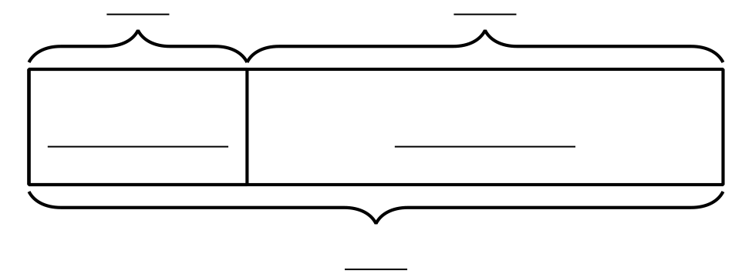
  - Write an equation using a question mark for the unknown value.
  - Solve. Show your thinking using drawings, numbers, or words.
- Noah and Kiran gathered 92 pumpkin seeds. Noah gathered 53 pumpkin seeds. How many seeds did Kiran gather?
  - Draw a diagram to represent the story.
  - Write an equation using a question mark for the unknown value.
  - Solve. Show your thinking using drawings, numbers, or words.
© CC BY 2021 Illustrative Mathematics®

