Unit 1 Lesson 16 Cumulative Practice Problems
- Match each quantity with an appropriate unit of measurement.
  - The surface area of a tissue box
  - The amount of soil in a planter box
  - The area of a parking lot
  - The length of a soccer field
  - The volume of a fish tank
  - Square meters
  - Yards
  - Cubic inches
  - Cubic feet
  - Square centimeters
- Here is a figure built from snap cubes.
- 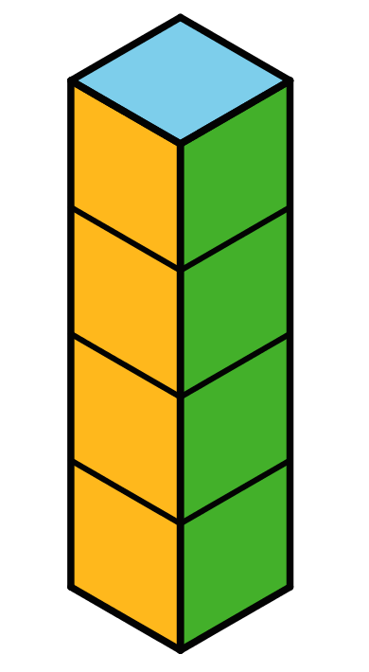
  - Find the volume of the figure in cubic units.
  - Find the surface area of the figure in square units.
  - True or false: If we double the number of cubes being stacked, both the volume and surface area will double. Explain or show how you know.
- Lin said, “Two figures with the same volume also have the same surface area.”
  - Which two figures suggest that her statement is true?
  - Which two figures could show that her statement is not true?
- 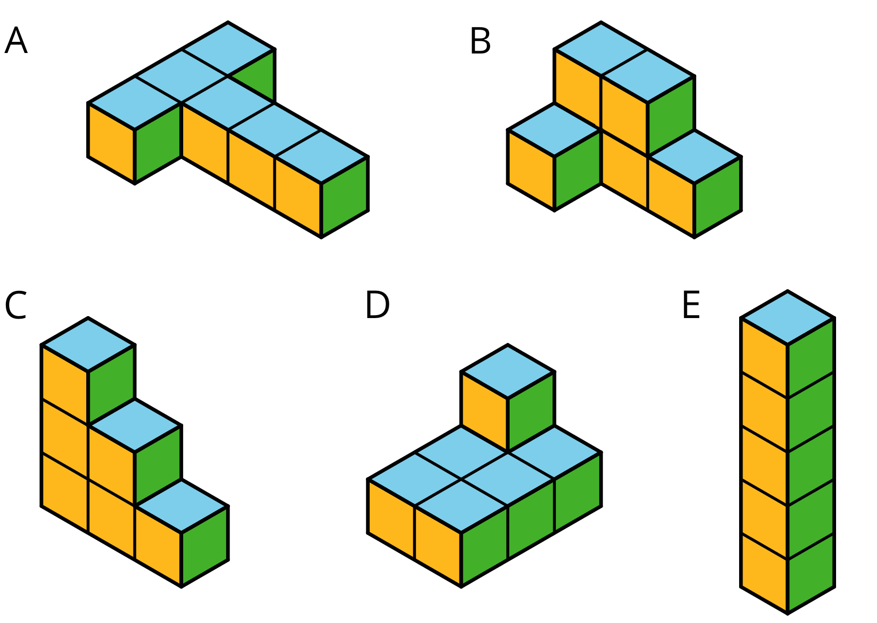
- Draw a pentagon (five-sided polygon) that has an area of 32 square units. Label all relevant sides or segments with their measurements, and show that the area is 32 square units.
- (From Unit 1, Lesson 11.)
  - Draw a net for this rectangular prism.
  - 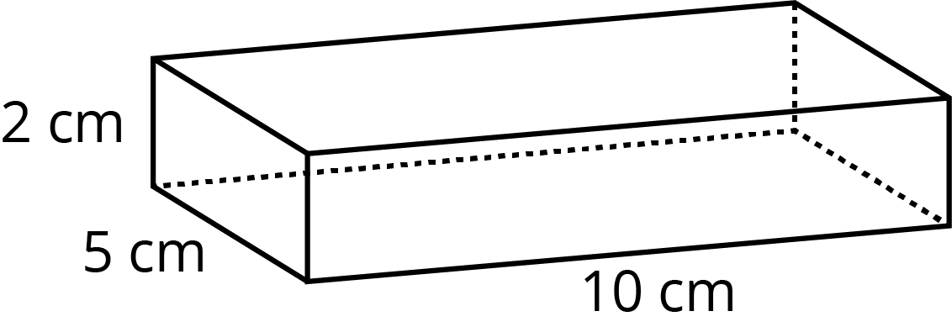
  - Find the surface area of the rectangular prism.
- (From Unit 1, Lesson 15.)
© CC BY Open Up Resources. Adaptations CC BY IM.

