Lesson 11: Hagamos que sean iguales

Standards Alignments
Addressing | 1.OA.A.1
Building Towards | 1.OA.A.1

Teacher-facing Learning Goals
- Solve Compare, Difference Unknown problems, in a way that makes sense to them.

Student-facing Learning Goals
- Hagamos que las torres tengan el mismo número de cubos.

Lesson Purpose
The purpose of this lesson is for students to represent and solve Compare, Difference Unknown problems, in a way that makes sense to them.
In kindergarten, students compared quantities and answered “Are there enough?” questions. In this lesson, students interpret and solve Compare problems for the first time. Compare problems can be tricky for students because until now, they have only interpreted subtraction as taking apart or taking from. These problems require students to find the difference between quantities. In this lesson, students compare the number of connecting cubes in two towers so they can see the difference as they add or subtract cubes to make both towers have the same number of cubes.
As students explain their thinking, write equations to support connections between Compare problems and addition and subtraction. Building on the work of the previous section, include a box around the difference.

Access for:

Students with Disabilities
- Engagement (Activity 2)

English Learners
- MLR8 (Activity 2)

Instructional Routines
Notice and Wonder (Warm-up)

Materials to Gather
- Connecting cubes in towers of 10 and singles: Activity 1, Activity 2

Required Preparation

Lesson Timeline
Warm-up | 10 min
Activity 1 | 15 min
Activity 2 | 20 min
Lesson Synthesis | 10 min
Cool-down | 5 min

Teacher Reflection Question
If you were to teach this lesson over again, what activity would you redo? How would your proposed changes support student learning?

Cool-down
(to be completed at the end of the lesson) 5min
El mismo número de cubos

Standards Alignments
Addressing | 1.OA.A.1

Student-facing Task Statement
Andre tiene 3 cubos.
Clare tiene 10 cubos.
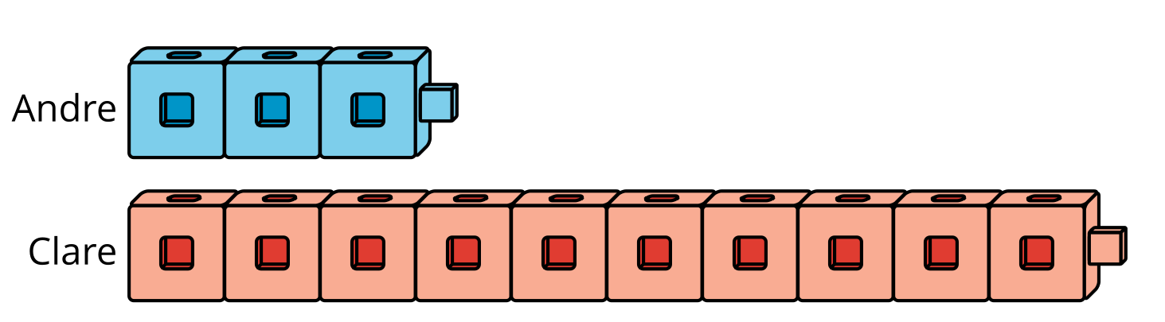
¿Cómo pueden Andre y Clare hacer que sus torres tengan el mismo número de cubos?
Muestra cómo pensaste. Usa dibujos, números o palabras.

Student Responses
Sample response:
Andre can add 7 cubes.
