Lesson 16: Suma y resta

Standards Alignments
Addressing | 5.NBT.B.7

Teacher-facing Learning Goals
- Add and subtract decimals to the hundredths using strategies based on place value.

Student-facing Learning Goals
- Usemos estrategias de valor posicional para sumar y restar números decimales.

Lesson Purpose
The purpose of this lesson is for students to add and subtract decimals.
In previous lessons students have found sums and differences of decimals using a variety of strategies. They have used place value reasoning, with words or equations, and have seen that the standard addition and subtraction algorithms also work just like they did for whole numbers as long as the same place values in the two numbers are added or subtracted. In this lesson, students add and subtract decimals with no method suggested. Students can use their favorite method or they can think strategically about the given numbers and adapt their strategy. The sums and differences encourage a variety of approaches such as adding on or adding or subtracting by place value.
The lesson also includes an optional activity where students find differences of more complex numbers and think strategically about which method to use. Whether they choose to use the standard algorithm or a different method using place value understanding, these problems help build fluency working with decimals.
This lesson has a Student Section Summary.

Access for:

Students with Disabilities
- Action and Expression (Activity 1)

Instructional Routines
Number Talk (Warm-up)

Lesson Timeline
Warm-up | 10 min
Activity 1 | 15 min
Activity 2 | 10 min
Activity 3 | 20 min
Lesson Synthesis | 10 min
Cool-down | 5 min

Teacher Reflection Question
What connections did students make between the different strategies shared? What questions did you ask to help make the connections more visible?

Cool-down
(to be completed at the end of the lesson) 5min
Suma y resta números decimales

Standards Alignments
Addressing | 5.NBT.B.7

Student-facing Task Statement
- Encuentra el valor de cada expresión. Muestra o explica cómo razonaste.
  - $75.2−4.37$
  - $236.87+5.15$

Student Responses
- 70.83. Sample response:
- 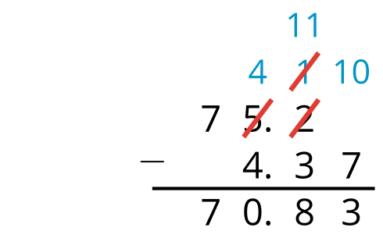
- 242.02. Sample response: $236.87+0.13=237$, $237+5.02=242.02$

