Lesson 7 Practice Problems
- A scale drawing of a car is presented in the following three scales. Order the scale drawings from smallest to largest. Explain your reasoning. (There are about 1.1 yards in a meter, and 2.54 cm in an inch.)
  - 1 in to 1 ft
  - 1 in to 1 m
  - 1 in to 1 yd
- Elena finds that the area of a house on a scale drawing is 25 square inches. The actual area of the house is 2,025 square feet. What is the scale of the drawing?
- Which scales are equivalent to 1 inch to 1 foot? Select all that apply.
  - 1 to 12
  - $\frac{1}{12}\text{ to }1$
  - 100 to 0.12
  - 5 to 60
  - 36 to 3
  - 9 to 108
- Which of these scales are equivalent to 3 cm to 4 km? Select all that apply. Recall that 1 inch is 2.54 centimeters.
  - 0.75 cm to 1 km
  - 1 cm to 12 km
  - 6 mm to 2 km
  - 0.3 mm to 40 m
  - 1 inch to 7.62 km
- These two triangles are scaled copies of one another. The area of the smaller triangle is 9 square units. What is the area of the larger triangle? Explain or show how you know.
- 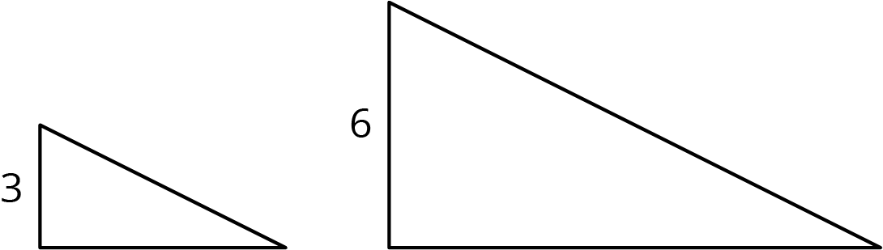

- Figures R, S, and T are all scaled copies of one another. Figure S is a scaled copy of R using a scale factor of 3. Figure T is a scaled copy of S using a scale factor of 2. Find the scale factors for each of the following:
  - From T to S
  - From S to R
  - From R to T
  - From T to R
- (From Unit 2, Lesson 3.)
© CC BY Open Up Resources. Adaptations CC BY IM.

