Unit 5 Lesson 13: Make 10

WU How Many Do You See: Fingers Up and Down (Warm up)

Student Task Statement
How many do you see?
How do you see them?
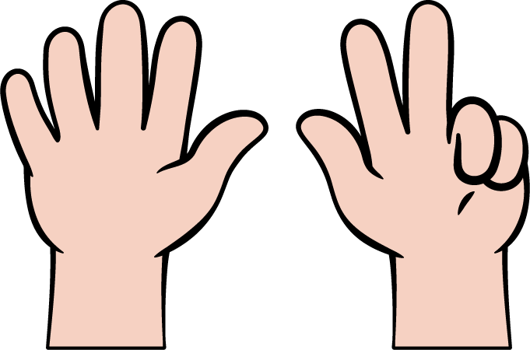

1 Introduce Math Fingers, Make 10

Student Task Statement

2 Make 10

Student Task Statement
3
_______________
$10=\underset{_}{}+\underset{_}{}$
9
_______________
$10=\underset{_}{}+\underset{_}{}$
2
_______________
$10=\underset{_}{}+\underset{_}{}$
5
_______________
$10=\underset{_}{}+\underset{_}{}$
7
_______________
$10=\underset{_}{}+\underset{_}{}$
6
_______________
$10=\underset{_}{}+\underset{_}{}$
8
_______________
$10=\underset{_}{}+\underset{_}{}$
4
_______________
$10=\underset{_}{}+\underset{_}{}$

3 Centers: Choice Time

Student Task Statement
Choose a center.
Math Fingers
Shake and Spill
Counting Collections
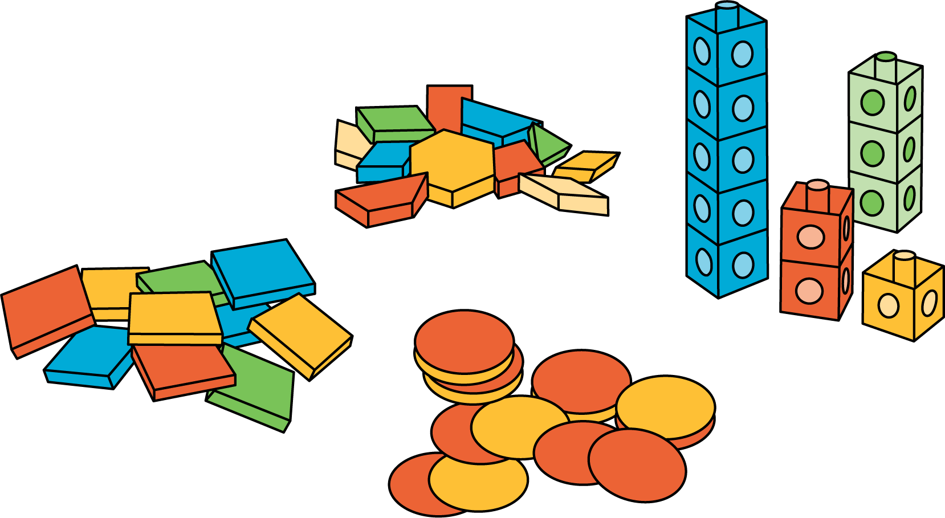
Roll and Add
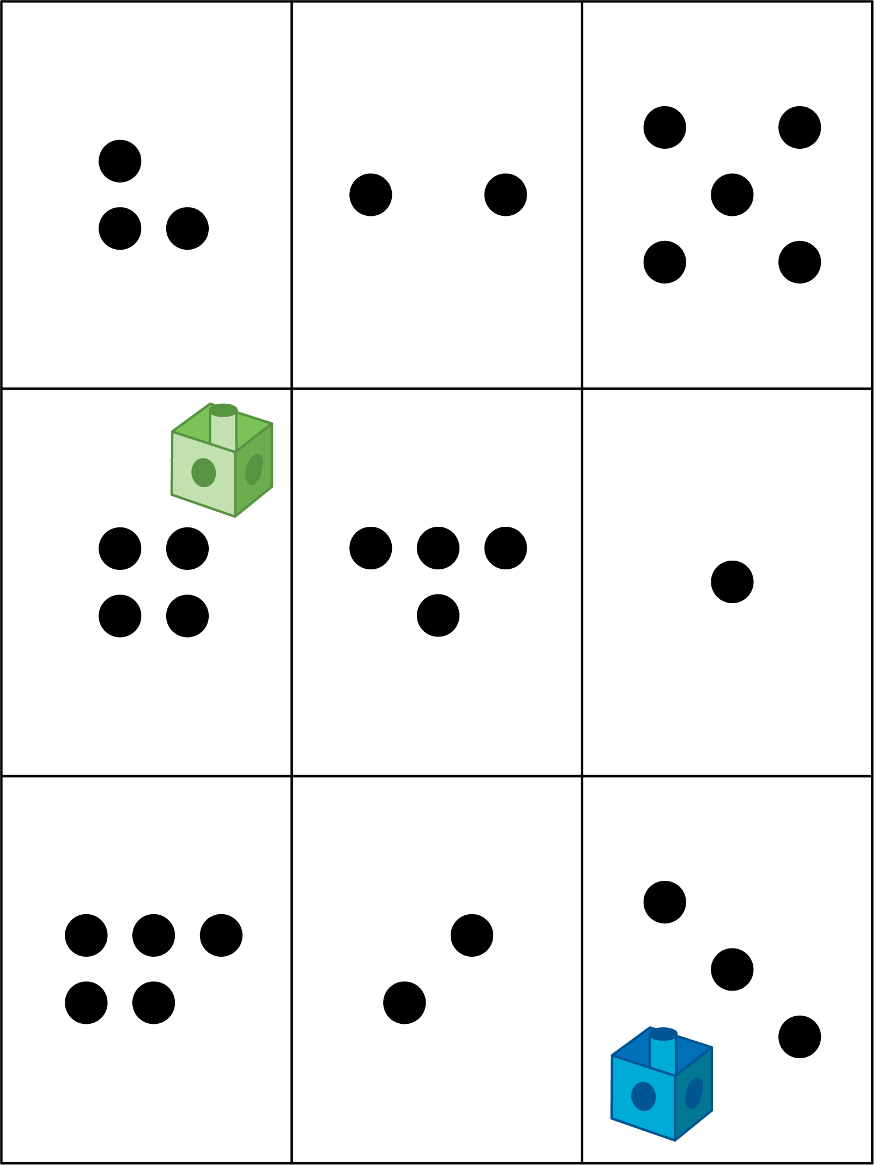
© CC BY 2021 Illustrative Mathematics®

