Unit 1 Lesson 14: Alternate Interior Angles

1 Angle Pairs (Warm up)

Student Task Statement
- Find the measure of angle $JGH$. Explain or show your reasoning.
- 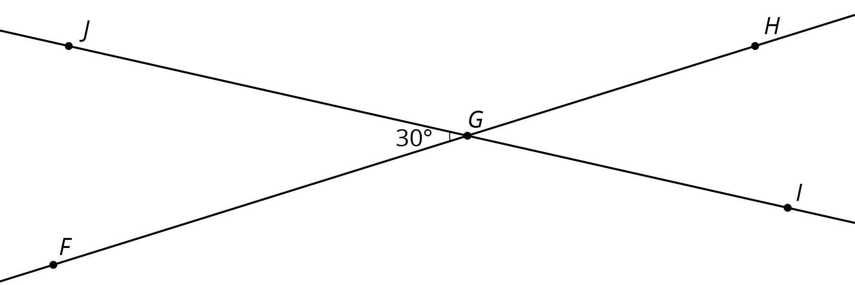
- Find and label a second ${30}^{∘}$ degree angle in the diagram. Find and label an angle congruent to angle $JGH$.

2 Cutting Parallel Lines with a Transversal

Images for Launch
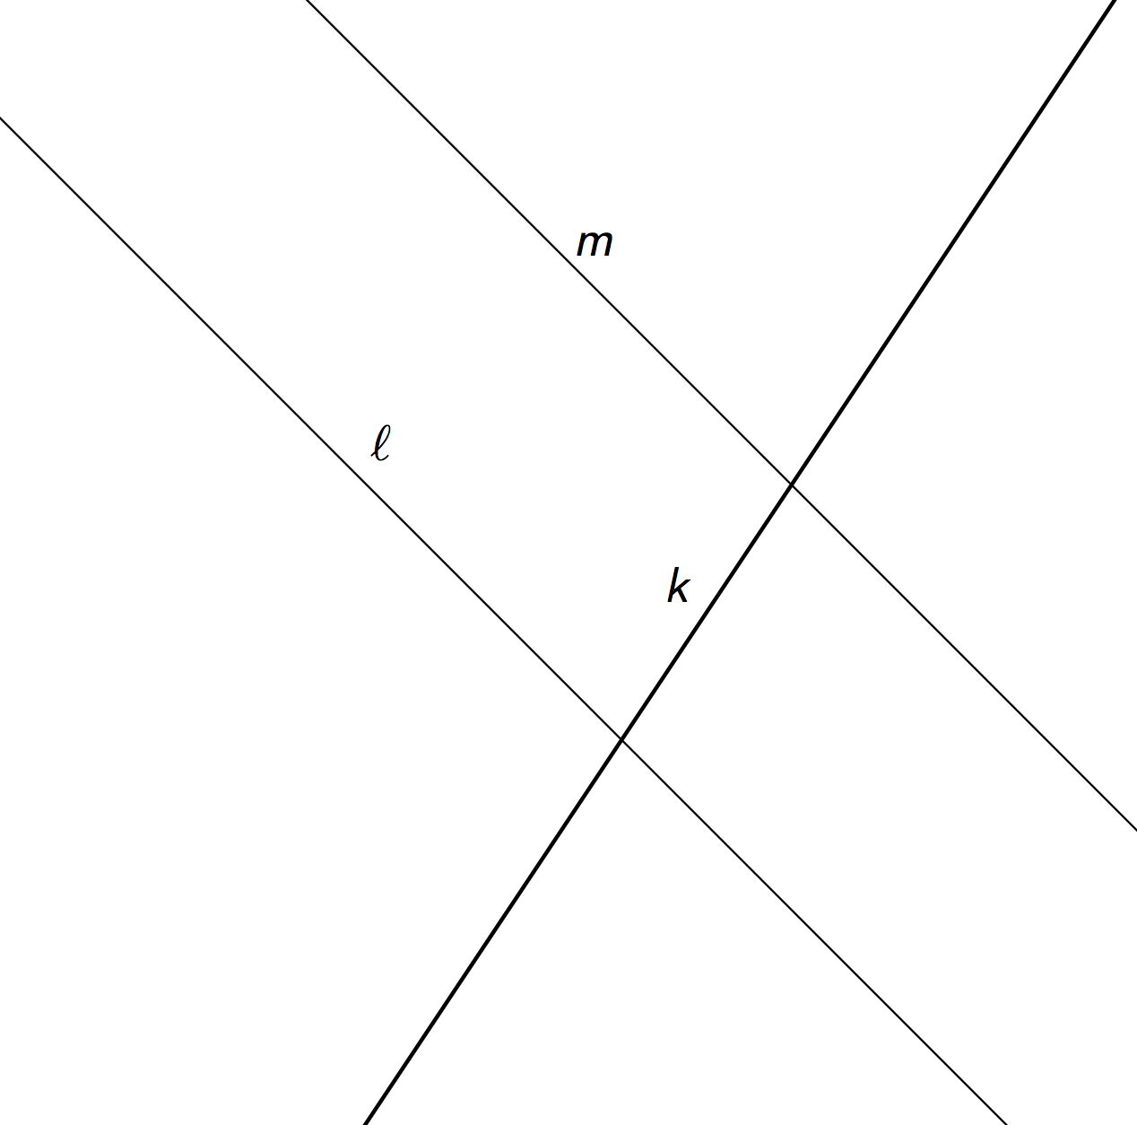

Student Task Statement
Lines $AC$ and $DF$ are parallel. They are cut by transversal $HJ$.
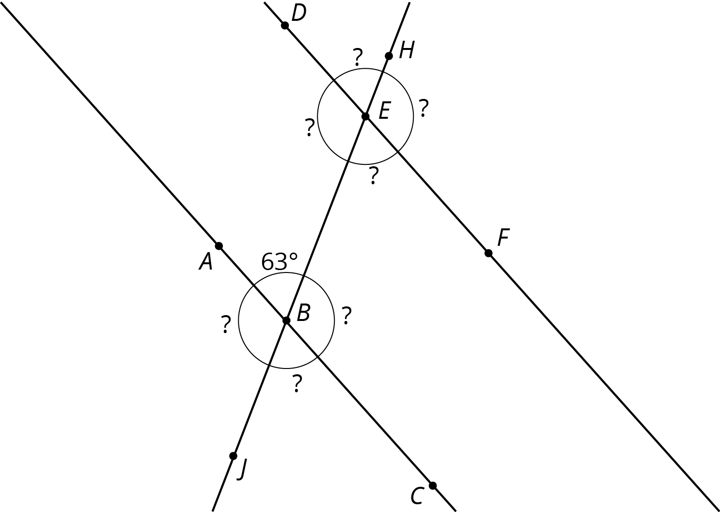
- With your partner, find the seven unknown angle measures in the diagram. Explain your reasoning.
- What do you notice about the angles with vertex $B$ and the angles with vertex $E$?
- Using what you noticed, find the measures of the four angles at point $B$ in the second diagram. Lines $AC$ and $DF$ are parallel.
- 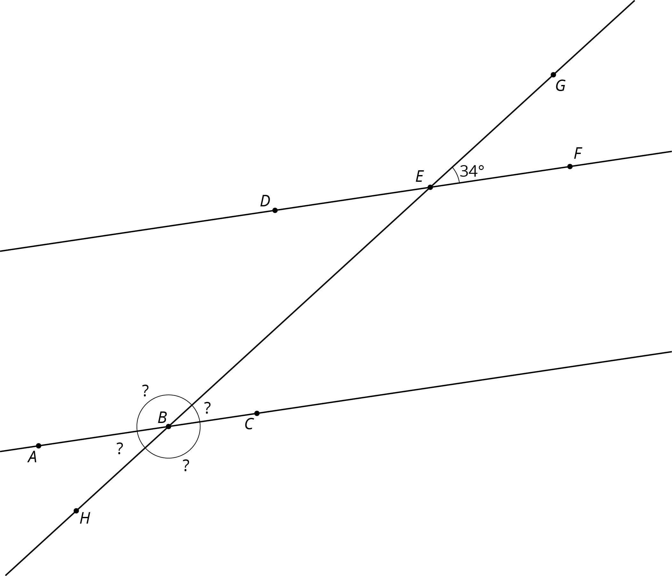
- The next diagram resembles the first one, but the lines form slightly different angles. Work with your partner to find the six unknown angles with vertices at points $B$ and $E$.
- 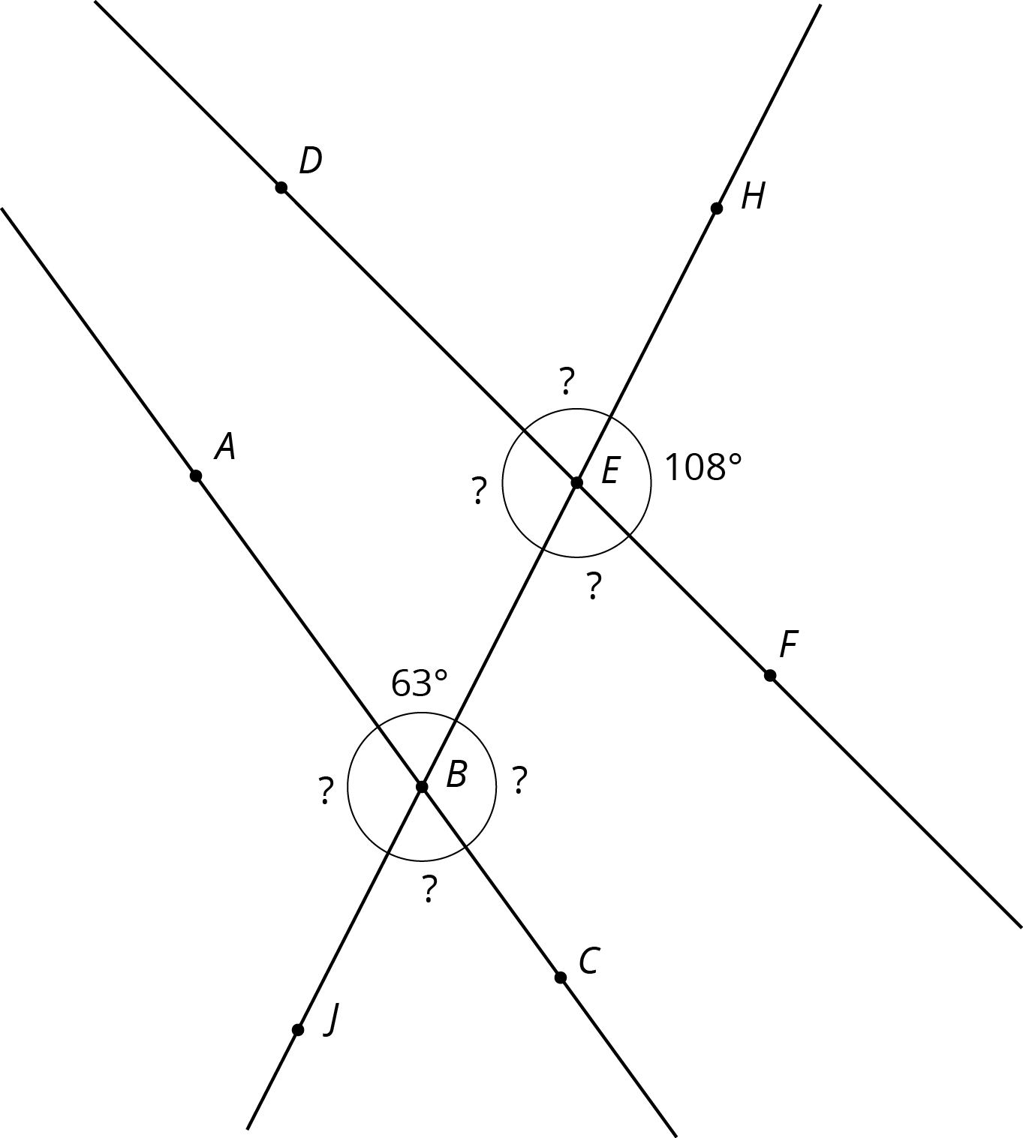
- What do you notice about the angles in this diagram as compared to the earlier diagram? How are the two diagrams different? How are they the same?

3 Alternate Interior Angles Are Congruent

Student Task Statement
- Lines $ℓ$ and $k$ are parallel and $t$ is a transversal. Point $M$ is the midpoint of segment $PQ$.
- 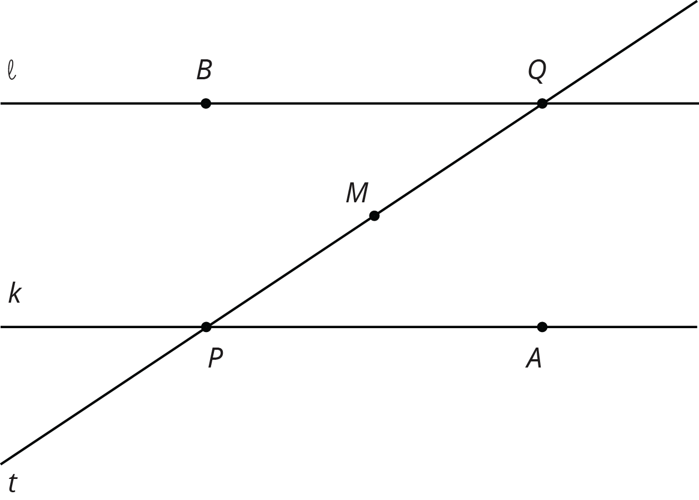
- Find a rigid transformation showing that angles $MPA$ and $MQB$ are congruent.
- In this picture, lines $ℓ$ and $k$ are no longer parallel. $M$ is still the midpoint of segment $PQ$.
- 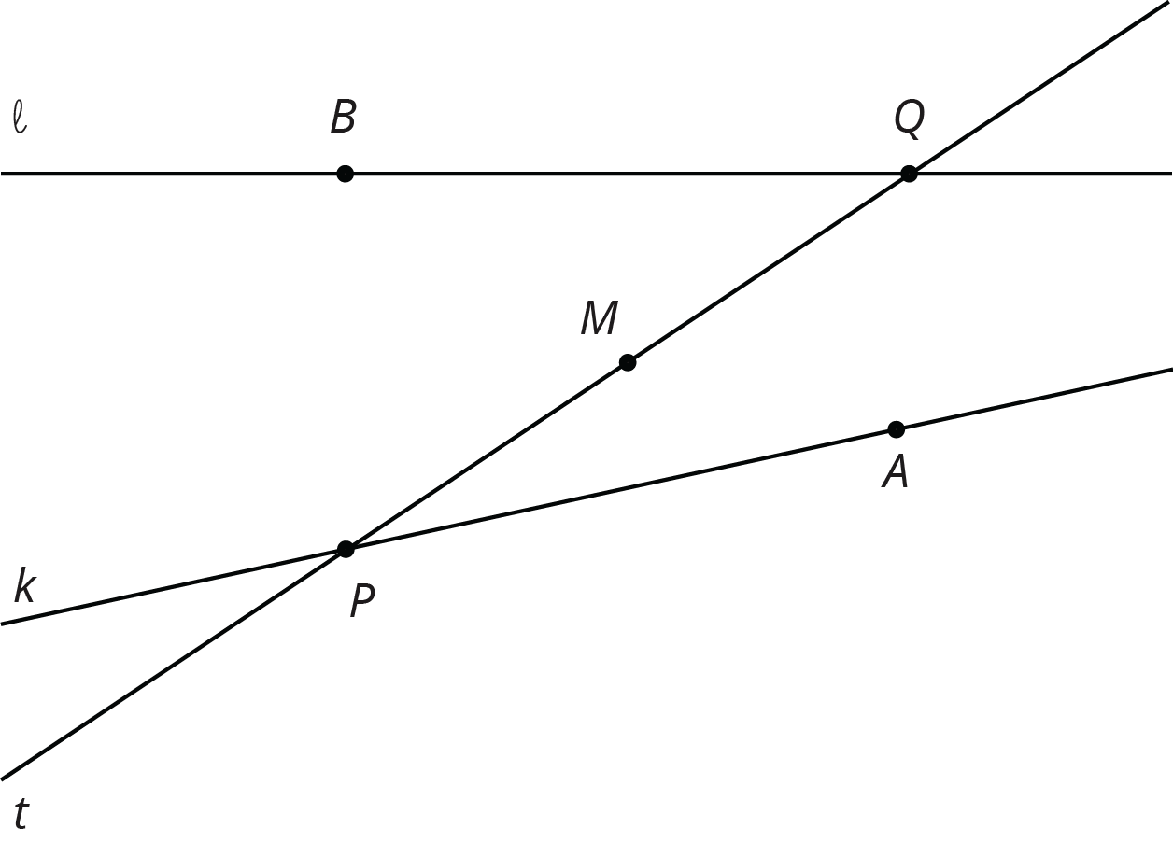
- Does your argument in the earlier problem apply in this situation? Explain.

Images for Activity Synthesis
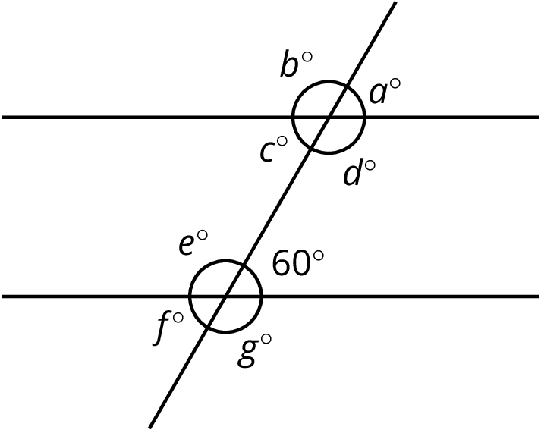
© CC BY Open Up Resources. Adaptations CC BY IM.

