Unit 2 Lesson 7: Divide to Multiply Unit Fractions

WU Estimation Exploration: Number Line (Warm up)

Student Task Statement
What number is marked on the number line?
Record an estimate that is:
too low | about right | too high

Activity Synthesis

1 How Far Did They Run?

Student Task Statement
Solve each problem. Draw a diagram if it is helpful.
- Mai ran $\frac{1}{4}$ the length of her road, which is 9 miles long. How far did Mai run?
- Han ran $\frac{1}{4}$ the length of his road, which is 7 miles long. How far did Han run?

2 Match the Situation

Student Task Statement
Han, Lin, Kiran, and Jada together ran a 3 mile relay race. They each ran the same distance.
- Find the expressions and diagrams that match this situation. Be prepared to explain your reasoning.
- How far did each person run?

Activity Synthesis
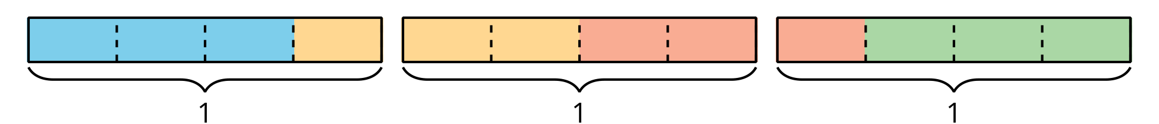
© CC BY 2021 Illustrative Mathematics®

