Unit 2 Lesson 14: Solve It Your Way

WU Number Talk: Multiple Addends (Warm up)

Student Task Statement
Find the value of each expression mentally.
- $5+9+5$
- $25+9+5$
- $25+15+19$
- $25+30+15+19$

1 Put It All Together

Student Task Statement
- Andre gathered seeds. He has 25 sunflower seeds and 17 squash seeds. How many seeds does he have? Show your thinking.
- Andre gathered more seeds. He has 35 cucumber seeds. How many seeds does Andre have altogether? Show your thinking.
- Compare your thinking with your partner.
- 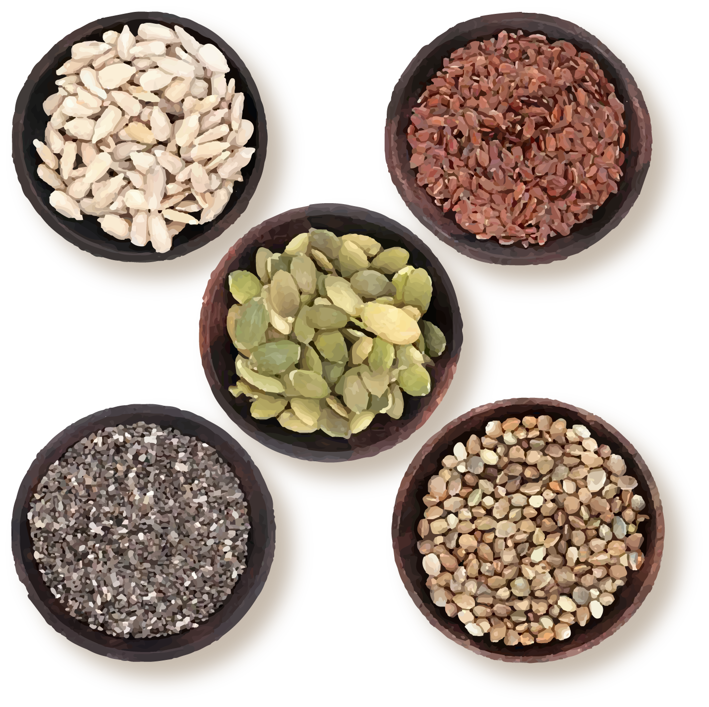

2 Select, Solve, and Share

Student Task Statement
- Decide which problem each member of your group will solve.
  - Priya has 24 fewer seeds than Tyler. Tyler has 53 seeds. How many seeds does Priya have?
  - Jada and Mai have 61 seeds. Jada has 39 seeds. How many seeds does Mai have?
  - Kiran started the game with 24 seeds. He won 17 seeds on his turn. How many seeds does he have now?
- Solve the problem. Show your thinking.
- Share your thinking with your group. After everyone has shared, complete the sentences with your answers. Then solve the story problem together.
  - Priya has ____________ seeds.
  - Mai has ____________ seeds.
  - Kiran has ____________ seeds.
  - How many seeds do they have in all?
© CC BY 2021 Illustrative Mathematics®

