Lesson 1: Sumemos y restemos hasta 10

Standards Alignments
Building On | 1.OA.C.6
Addressing | 2.OA.B.2
Building Towards | 2.OA.B.2

Teacher-facing Learning Goals
- Add and subtract within 10.

Student-facing Learning Goals
- Sumemos y restemos hasta 10.

Lesson Purpose
The purpose of this lesson is for students to add and subtract within 10.
Students develop fluency with addition and subtraction within 10 in grade 1. This lesson provides an opportunity for formative assessment of students' fluency within 10, including recognizing sums with a value of 10. Throughout the lesson, monitor for the ways students find the values of sums and differences and how they describe their methods to others. There may be sums and differences students say they "just know." In this case, do not require students to explain how they got their answer every time, and take note of the expressions that many students already know from memory. Counters or connecting cubes should be made available for students to use, however encourage students not to use them if they don’t need them.
Math Community
In the lesson synthesis, students discuss what it means to be a part of a mathematical community. Prepare a space, such as a piece of poster paper, titled “Comunidad matemática” // “Math Community”​ ​and a T-chart with the header “Hacer matemáticas” // “Doing Math” and “Normas” // "Norms".​ ​Partition the columns into two sections: students and teacher. The two sections encourage the students and teacher to be mindful that both respective parties are responsible for the way math is being done in the classroom. In the synthesis of this lesson, students will add their ideas to the "Doing Math" section. In upcoming lessons, students will add to and revise their contributions, including drafting classroom norms.
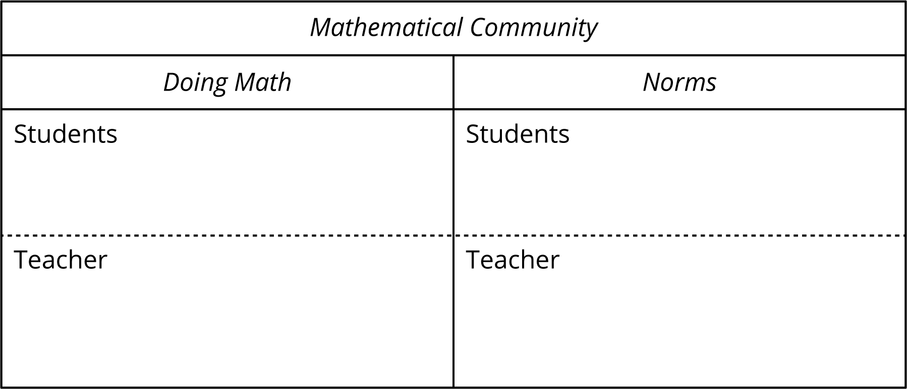

Access for:

Students with Disabilities
- Representation (Activity 1)

English Learners
- MLR8 (Activity 1)

Instructional Routines
What Do You Know About _____? (Warm-up)

Materials to Gather
- Connecting cubes or counters: Activity 1, Activity 2

Materials to Copy
- Number Cards (0-10) (groups of 2): Activity 1

Lesson Timeline
Warm-up | 15 min
Activity 1 | 20 min
Activity 2 | 10 min
Lesson Synthesis | 10 min
Cool-down | 5 min

Teacher Reflection Question
What do you love most about math? How are you sharing that joy with your students and encouraging them to think about what they love about math?

Cool-down
(to be completed at the end of the lesson) 5min
Sumas y diferencias

Standards Alignments
Addressing | 2.OA.B.2

Student-facing Task Statement
- $4+2=\underset{_}{​}$
- $9−3=\underset{_}{​}$
- Marca las expresiones que tienen un valor de 10.
$4+6$
$2+7$
$8+1$
$5+5$
$7+3$

Student Responses
- 6
- 6
- Circles $4+6$, $5+5$, and $7+3$.

