Lesson 8 Practice Problems
- Rectangle $A$ measures 12 cm by 3 cm. Rectangle $B$ is a scaled copy of Rectangle $A$. Select all of the measurement pairs that could be the dimensions of Rectangle $B$.
  - 6 cm by 1.5 cm
  - 10 cm by 2 cm
  - 13 cm by 4 cm
  - 18 cm by 4.5 cm
  - 80 cm by 20 cm
- Rectangle $A$ has length 12 and width 8. Rectangle $B$ has length 15 and width 10. Rectangle $C$ has length 30 and width 15.
  - Is Rectangle $A$ a scaled copy of Rectangle $B$? If so, what is the scale factor?
  - Is Rectangle $B$ a scaled copy of Rectangle $A$? If so, what is the scale factor?
  - Explain how you know that Rectangle $C$ is not a scaled copy of Rectangle $B$.
  - Is Rectangle $A$ a scaled copy of Rectangle $C$? If so, what is the scale factor?
- Here are three polygons.
- 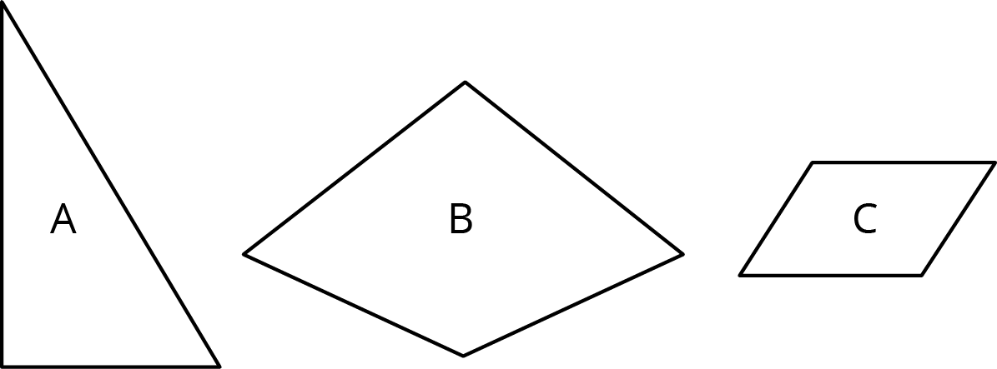
  - Draw a scaled copy of Polygon A with scale factor $\frac{1}{2}$.
  - Draw a scaled copy of Polygon B with scale factor 2.
  - Draw a scaled copy of Polygon C with scale factor $\frac{1}{4}$.
- In the picture lines $AB$ and $CD$ are parallel. Find the measures of the following angles. Explain your reasoning.
- 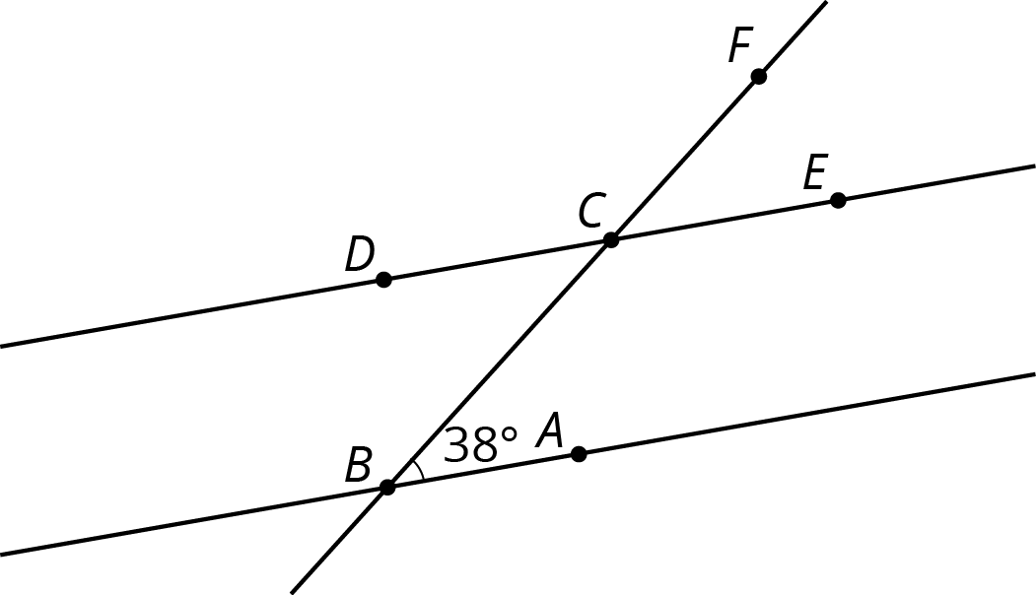
  - $∠BCD$
  - $∠ECF$
  - $∠DCF$
- (From Unit 1, Lesson 12.)
- Which of these sets of angle measures could be the three angles in a triangle?
  - ${40}^{∘}$, ${50}^{∘}$, ${60}^{∘}$
  - ${50}^{∘}$, ${60}^{∘}$, ${70}^{∘}$
  - ${60}^{∘}$, ${70}^{∘}$, ${80}^{∘}$
  - ${70}^{∘}$, ${80}^{∘}$, ${90}^{∘}$
- (From Unit 1, Lesson 13.)
- Quadrilateral A has side lengths 3, 6, 6, and 9. Quadrilateral B is a scaled copy of A with a shortest side length equal to 2. Jada says, “Since the side lengths go down by 1 in this scaling, the perimeter goes down by 4 in total.” Do you agree with Jada? Explain your reasoning.
- (From Unit 2, Lesson 2.)
© CC BY Open Up Resources. Adaptations CC BY IM.

