Lesson 3: Adding and Subtracting Decimals with Few Non-Zero Digits

3.1: Do the Zeros Matter?
- Evaluate mentally: $1.009+0.391$
- Decide if each equation is true or false. Be prepared to explain your reasoning.
  - $34.56000=34.56$
  - $25=25.0$
  - $2.405=2.45$

3.2: Calculating Sums
- Andre and Jada drew base-ten diagrams to represent $0.007+0.004$. Andre drew 11 small rectangles. Jada drew only two figures: a square and a small rectangle.
  - If both students represented the sum correctly, what value does each small rectangle represent? What value does each square represent?
  - Draw or describe a diagram that could represent the sum $0.008+0.07$.
- Here are two calculations of $0.2+0.05$. Which is correct? Explain why one is correct and the other is incorrect.
- Compute each sum. If you get stuck, consider drawing base-ten diagrams to help you.

  - 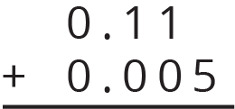
  - $0.209+0.01$
  - $10.2+1.1456$

3.3: Subtracting Decimals of Different Lengths
Diego and Noah drew different diagrams to represent $0.4−0.03$. Each rectangle represents 0.1. Each square represents 0.01.
- Diego started by drawing 4 rectangles to represent 0.4. He then replaced 1 rectangle with 10 squares and crossed out 3 squares to represent subtraction of 0.03, leaving 3 rectangles and 7 squares in his diagram.
- 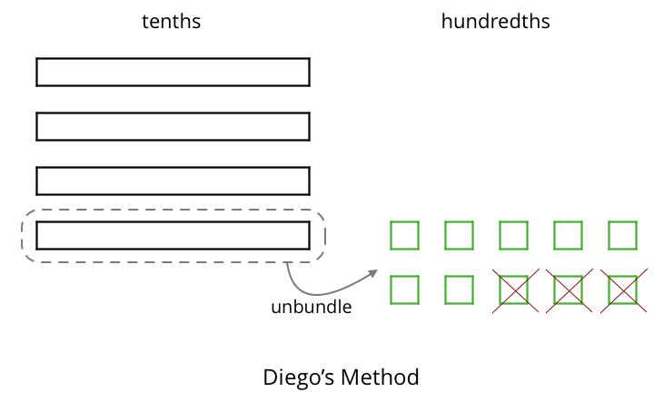
- Noah started by drawing 4 rectangles to represent 0.4. He then crossed out 3 rectangles to represent the subtraction, leaving 1 rectangle in his diagram.
- 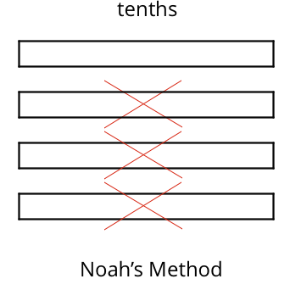
- Do you agree that either diagram correctly represents $0.4−0.03$? Discuss your reasoning with a partner.
- Elena also drew a diagram to represent $0.4−0.03$. She started by drawing 4 rectangles. She then replaced all 4 rectangles with 40 squares and crossed out 3 squares to represent subtraction of 0.03, leaving 37 squares in her diagram. Is her diagram correct? Discuss your reasoning with a partner.
- 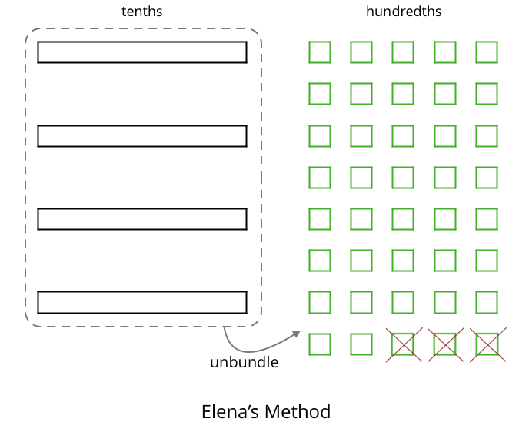
- Find each difference. Explain or show your reasoning.
  - $0.3−0.05$
  - $2.1−0.4$
  - $1.03−0.06$
  - $0.02−0.007$

Are you ready for more?
A distant, magical land uses jewels for their bartering system. The jewels are valued and ranked in order of their rarity. Each jewel is worth 3 times the jewel immediately below it in the ranking. The ranking is red, orange, yellow, green, blue, indigo, and violet. So a red jewel is worth 3 orange jewels, a green jewel is worth 3 blue jewels, and so on.
At the Auld Shoppe, a shopper buys items that are worth 2 yellow jewels, 2 green jewels, 2 blue jewels, and 1 indigo jewel. If they came into the store with 1 red jewel, 1 yellow jewel, 2 green jewels, 1 blue jewel, and 2 violet jewels, what jewels do they leave with? Assume the shopkeeper gives them their change using as few jewels as possible.

Lesson 3 Summary
Base-ten diagrams can help us understand subtraction as well. Suppose we are finding $0.23−0.07$. Here is a diagram showing 0.23, or 2 tenths and 3 hundredths.
Subtracting 7 hundredths means removing 7 small squares, but we do not have enough to remove. Because 1 tenth is equal to 10 hundredths, we can “unbundle” (or decompose) one of the tenths (1 rectangle) into 10 hundredths (10 small squares).
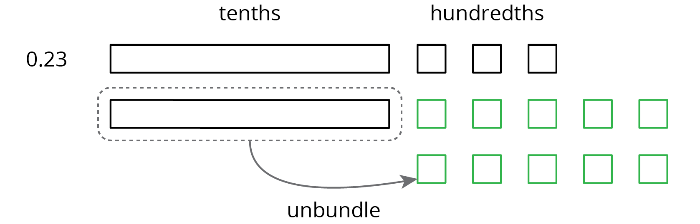
We now have 1 tenth and 13 hundredths, from which we can remove 7 hundredths.
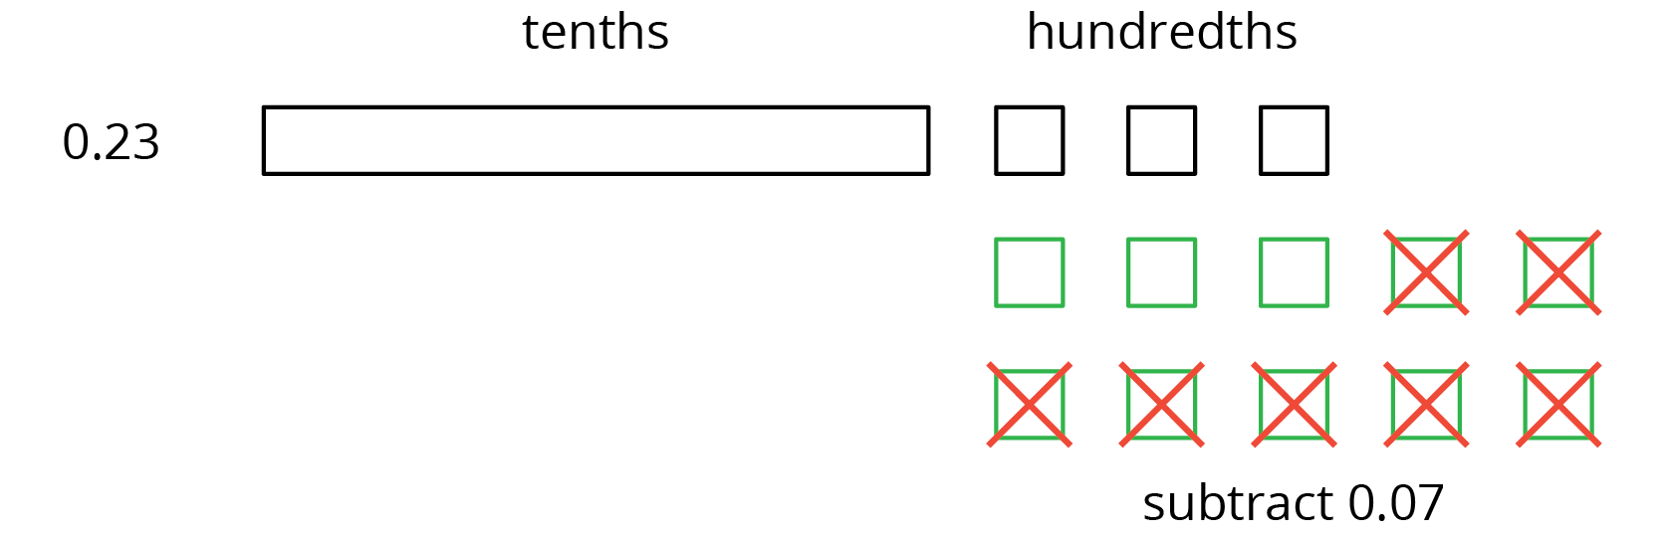
We have 1 tenth and 6 hundredths remaining, so $0.23−0.07=0.16$.
Here is a vertical calculation of $0.23−0.07$.
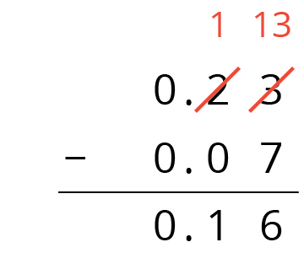
Notice how this representation also shows a tenth is unbundled (or decomposed) into 10 hundredths in order to subtract 7 hundredths.
This works for any decimal place. Suppose we are finding $0.023−0.007$. Here is a diagram showing 0.023.
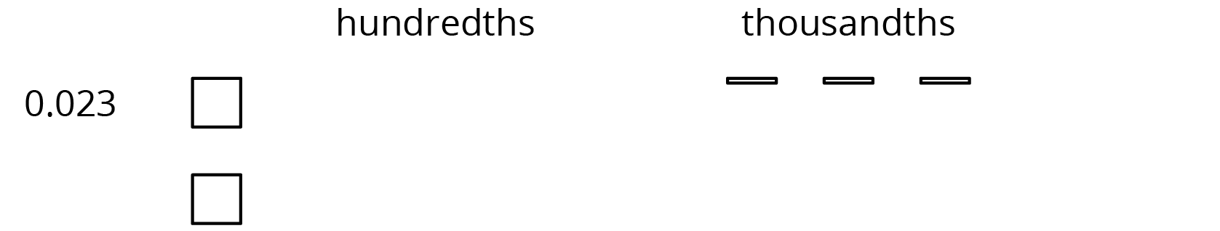
We want to remove 7 thousandths (7 small rectangles). We can “unbundle” (or decompose) one of the hundredths into 10 thousandths.
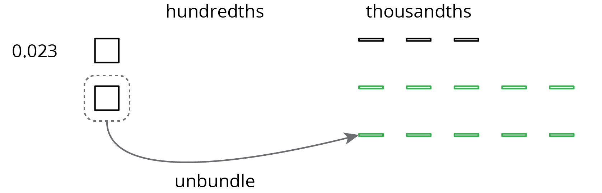
Now we can remove 7 thousandths.
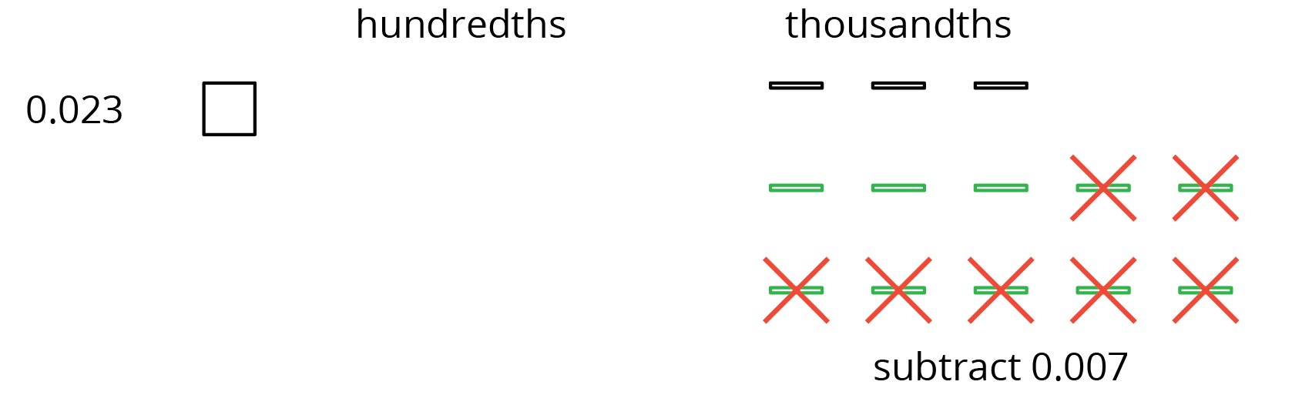
We have 1 hundredth and 6 thousandths remaining, so $0.023−0.007=0.016$.
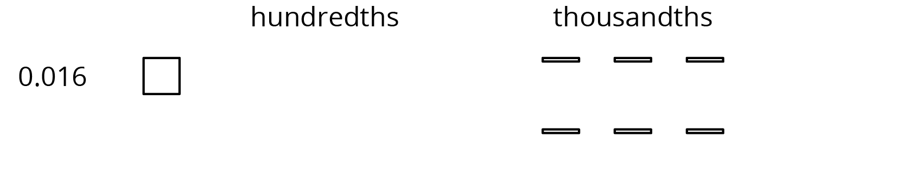
Here is a vertical calculation of $0.023−0.007$.
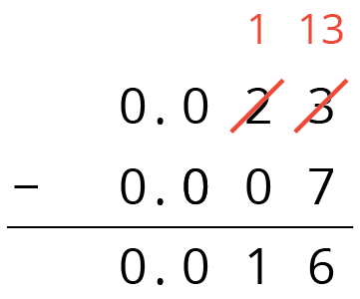
© CC BY Open Up Resources. Adaptations CC BY IM.

