Lesson 10: What Are Percentages?

10.1: Dollars and Cents
Find each answer mentally.
- A sticker costs 25 cents. How many dollars is that?
- A pen costs 1.50 dollars. How many cents is that?
- How many cents are in one dollar?
- How many dollars are in one cent?

10.2: Coins
- Complete the table to show the values of these U.S. coins.
- 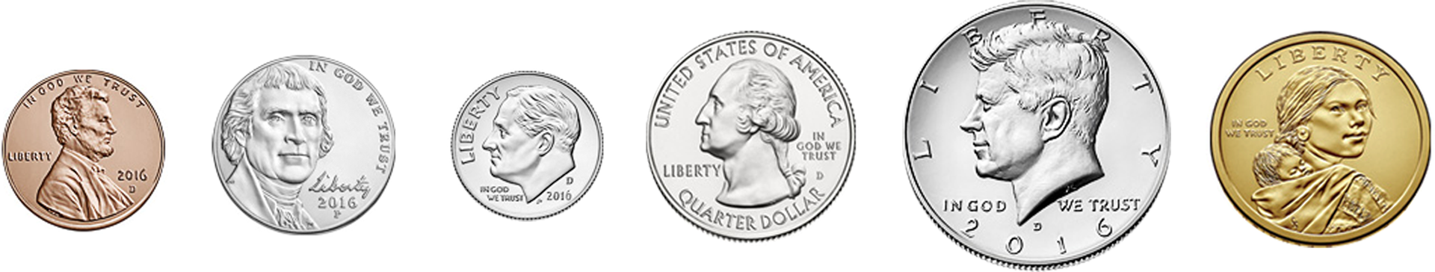
- ​
- coin | - penny | - nickel | - dime | - quarter | - half dollar | - dollar
- value (cents)

- The value of a quarter is 25% of the value of a dollar because there are 25 cents for every 100 cents.
- 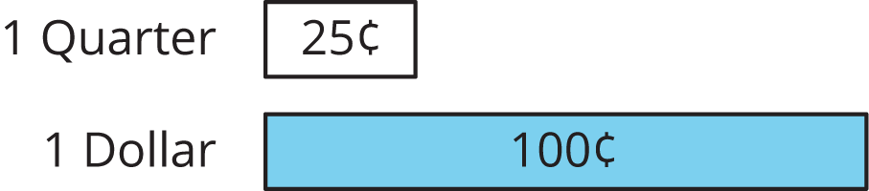
- Write the name of the coin that matches each expression.
  - 25% of a dollar
  - 5% of a dollar
  - 1% of a dollar
  - 100% of a dollar
  - 10% of a dollar
  - 50% of a dollar
- The value of 6 dimes is what percent of the value of a dollar?
- The value of 6 quarters is what percent of the value of a dollar?

Are you ready for more?
Find two different sets of coins that each make 120% of a dollar, where no type of coin is in both sets.

10.3: Coins on a Number Line
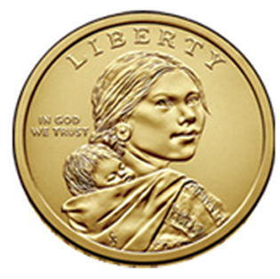
A $1 coin is worth 100% of the value of a dollar. Here is a double number line that shows this.
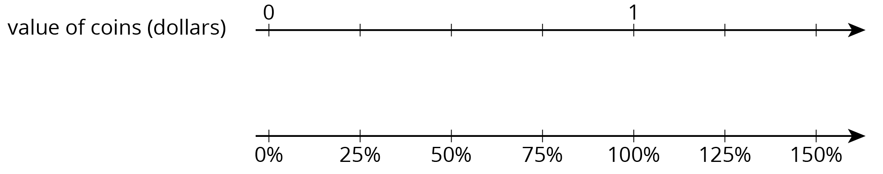
- The coins in Jada’s pocket are worth 75% of a dollar. How much are they worth (in dollars)?
- The coins in Diego’s pocket are worth 150% of a dollar. How much are they worth (in dollars)?
- Elena has 3 quarters and 5 dimes. What percentage of a dollar does she have?

Lesson 10 Summary
A percentage is a rate per 100.
We can find percentages of $10 using a double number line where 10 and 100% are aligned, as shown here:
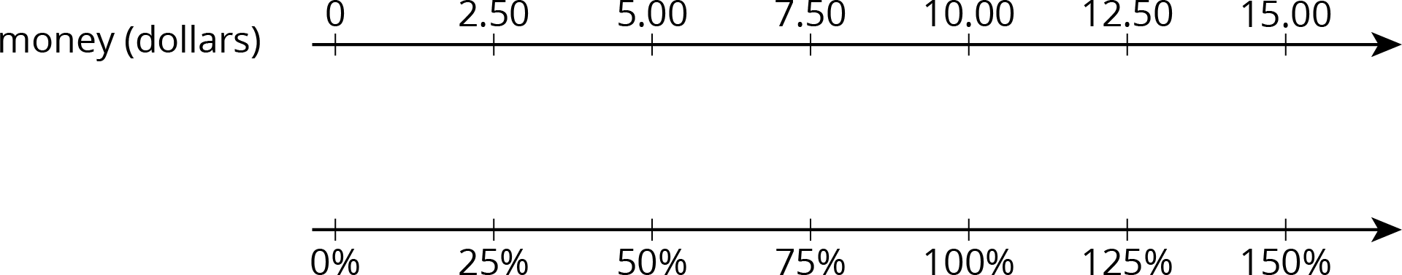
Looking at the double number line, we can see that $5.00 is 50% of $10.00 and that $12.50 is 125% of $10.00.
© CC BY Open Up Resources. Adaptations CC BY IM.

