Unit 7 Lesson 7: Flat and Solid Shapes

WU Which One Doesn’t Belong: Flat Shapes (Warm up)

Student Task Statement
Which one doesn’t belong?
A
B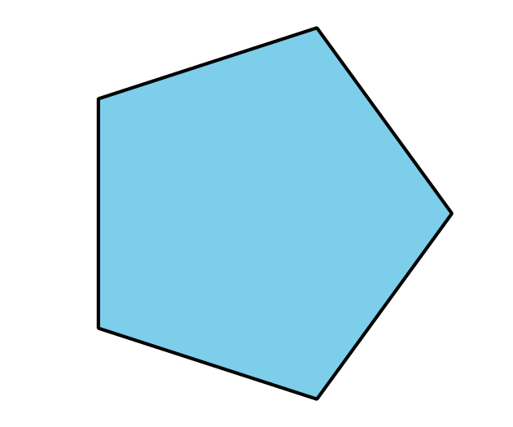
C
D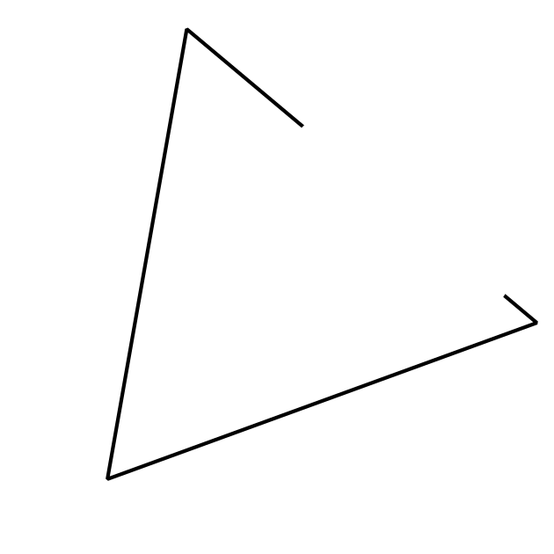

1 Create Shapes with Clay

Student Task Statement

2 Sort Flat and Solid Shapes

Student Task Statement
_______________
_______________

3 Centers: Choice Time

Student Task Statement
Choose a center.
Counting Collections
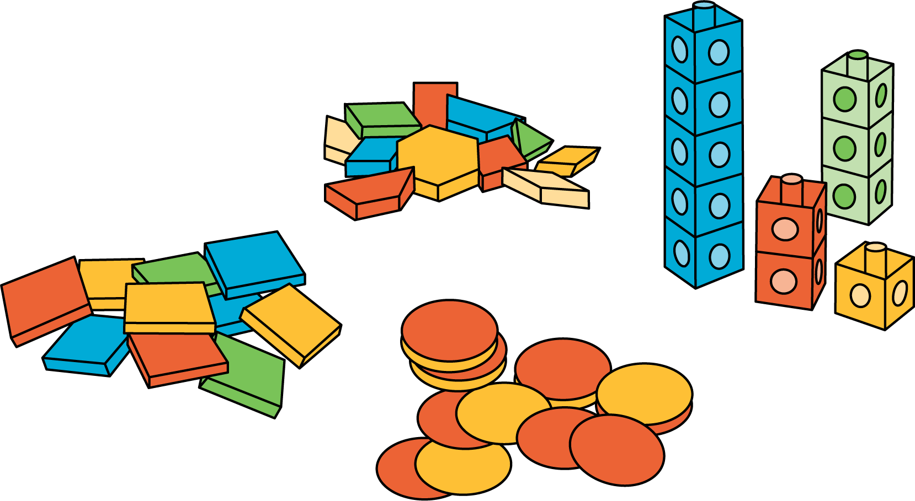
Match Mine
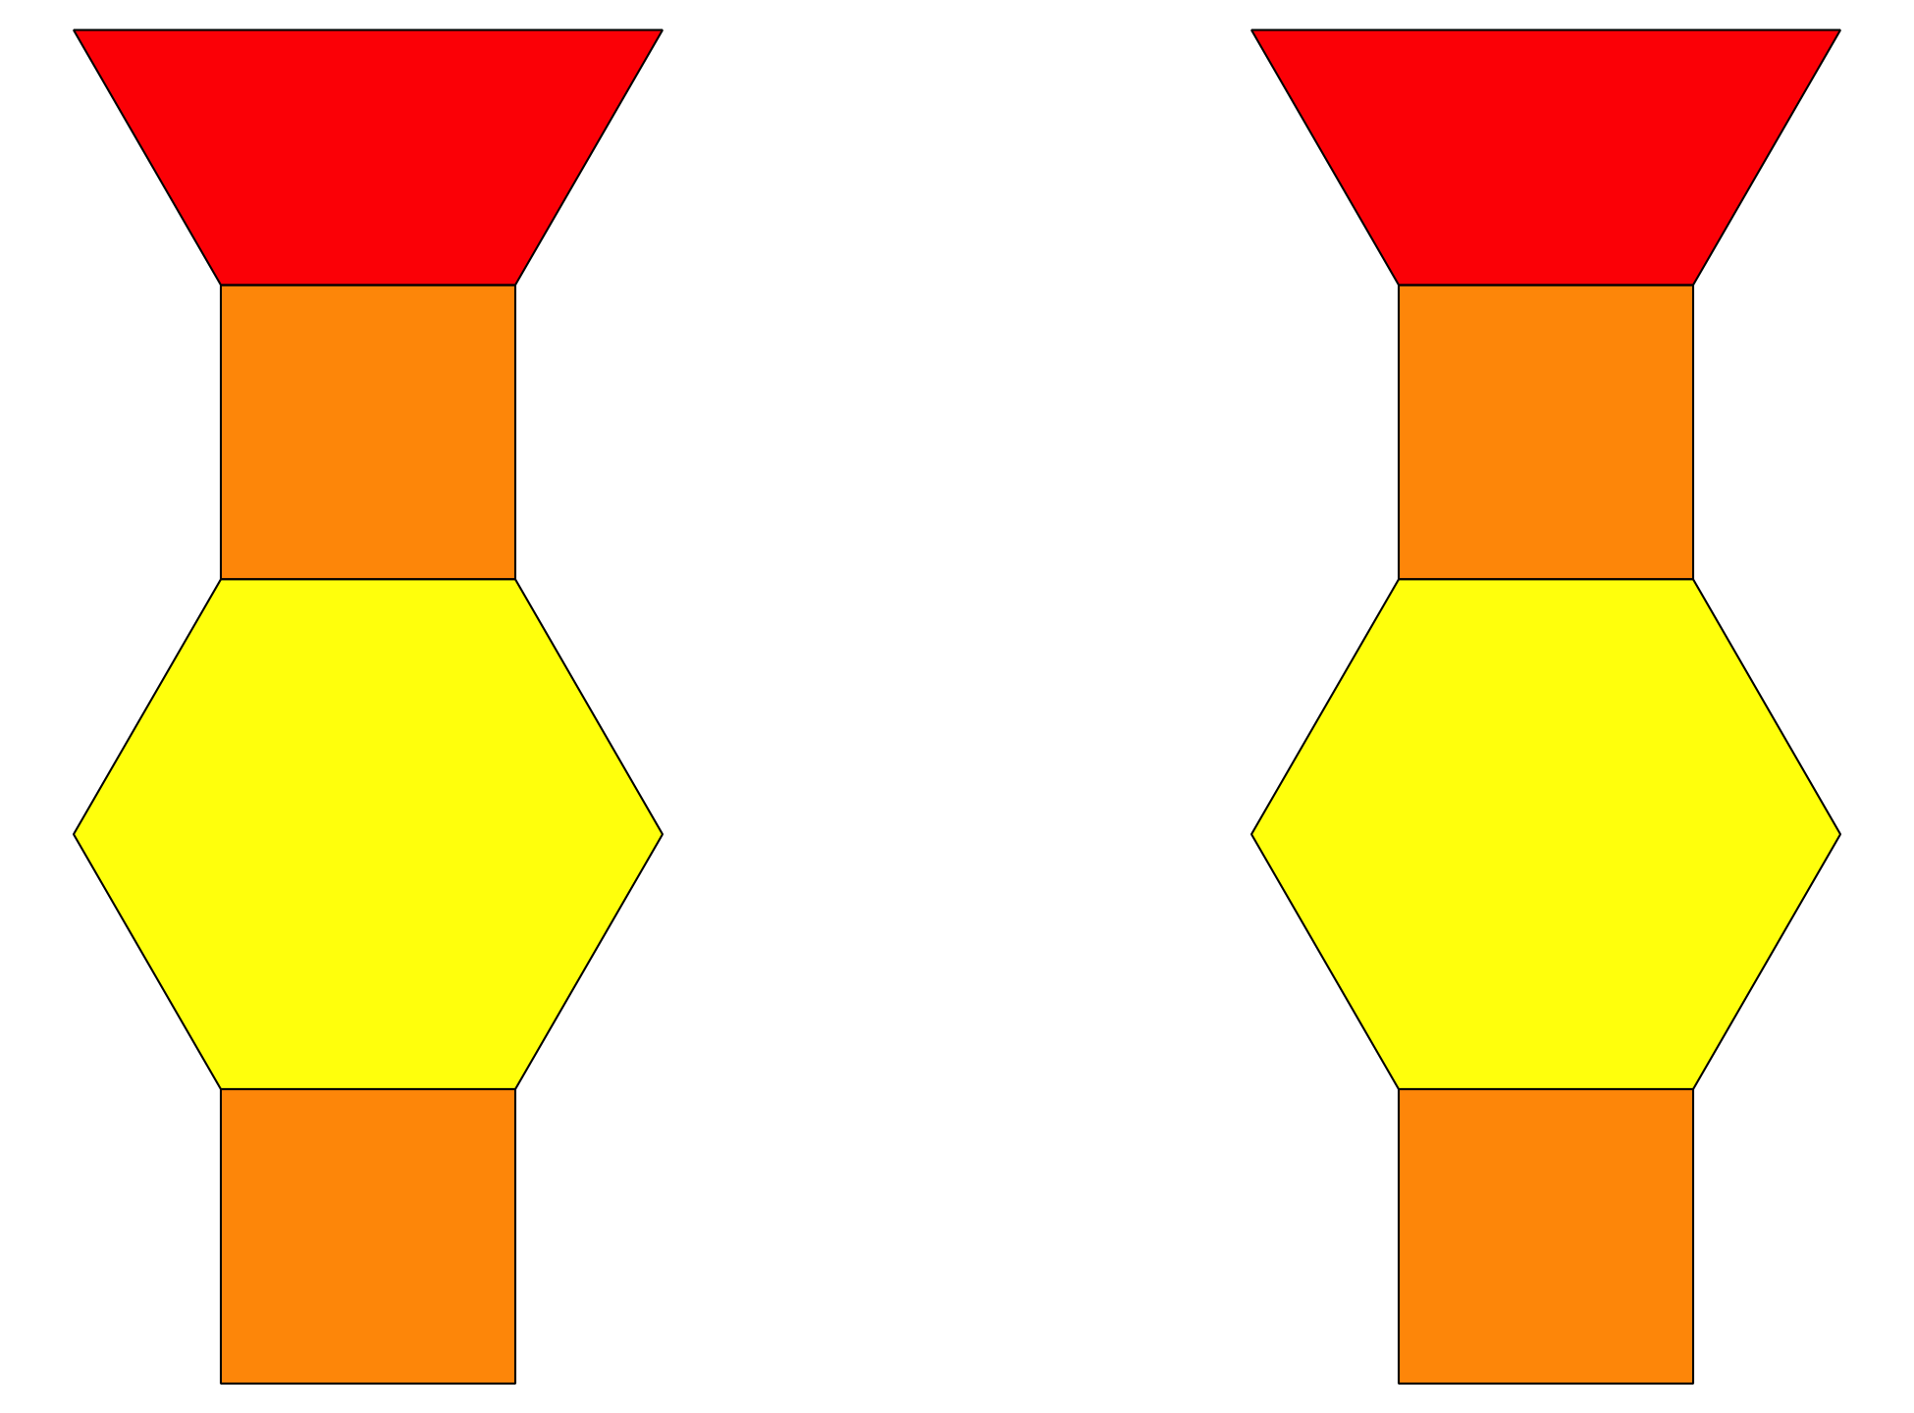
Shake and Spill
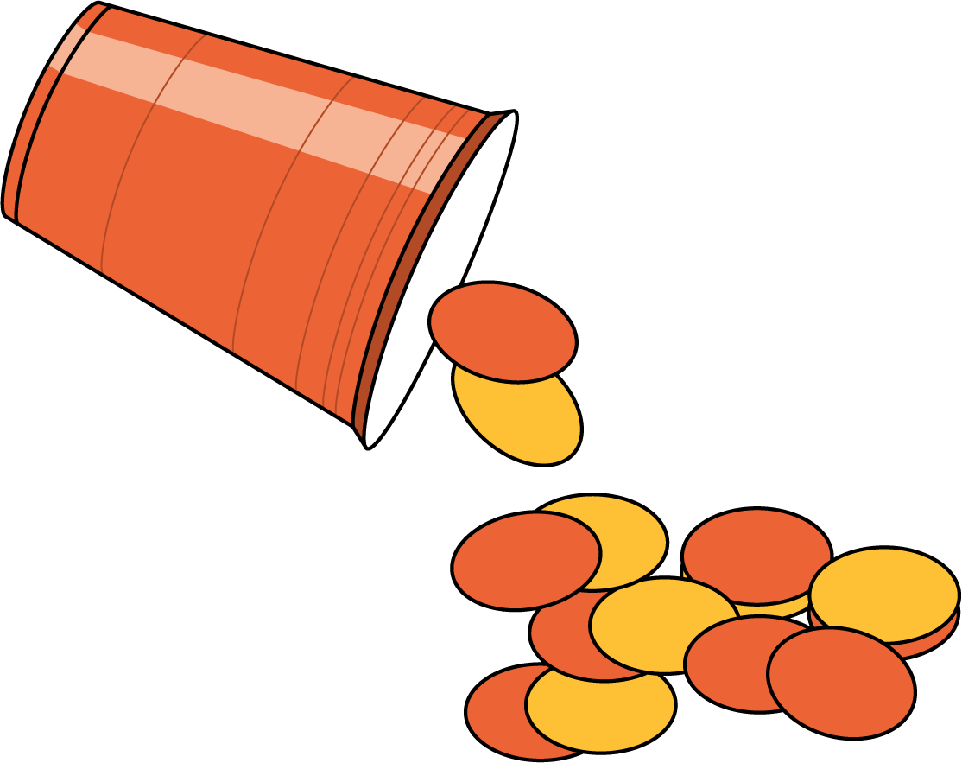

Activity Synthesis
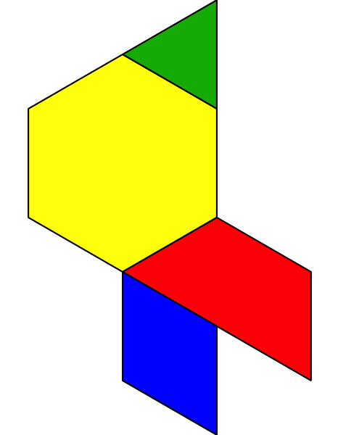
© CC BY 2021 Illustrative Mathematics®

