Unit 5 Lesson 2: Changing Temperatures

1 Which One Doesn’t Belong: Arrows (Warm up)

Student Task Statement
Which pair of arrows doesn't belong?

- 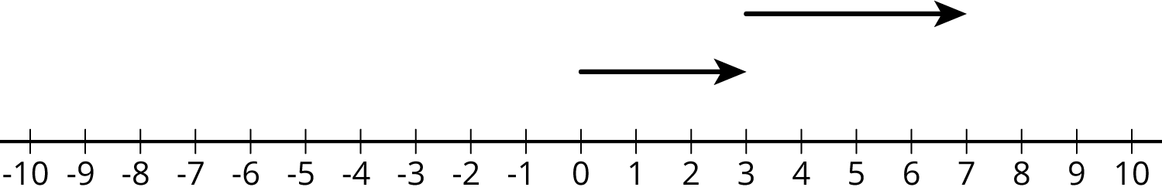

- 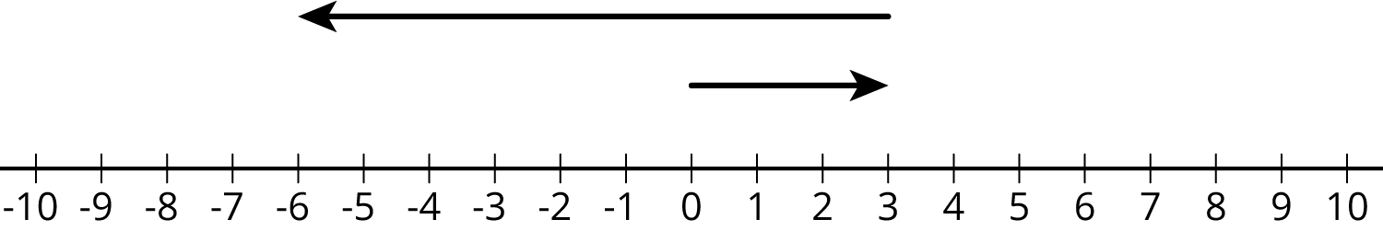

- 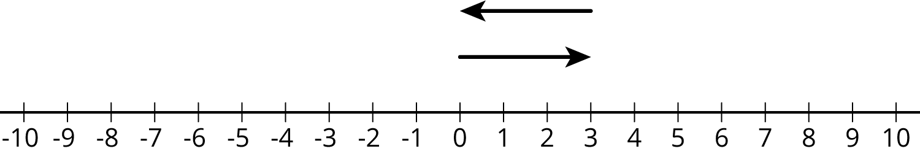

- 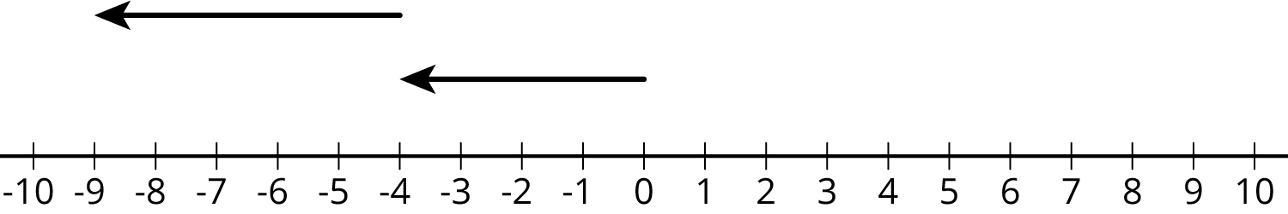

2 Warmer and Colder

Images for Launch
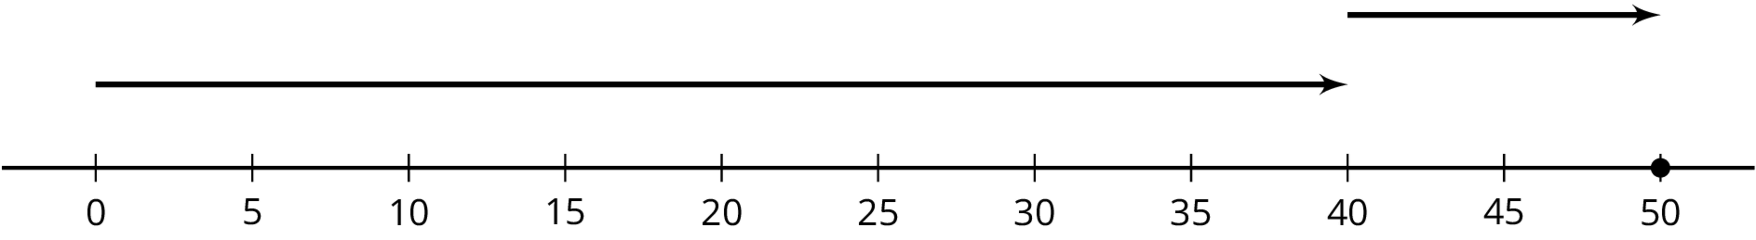

Student Task Statement
- Complete the table and draw a number line diagram for each situation.
 | - start ($​^{∘}\text{C}$) | - change ($​^{∘}\text{C}$) | - final ($​^{∘}\text{C}$) | - addition equation
- a | - +40 | - 10 degrees warmer | - +50 | - $40+10=50$
- b | - +40 | - 5 degrees colder
- c | - +40 | - 30 degrees colder
- d | - +40 | - 40 degrees colder
- e | - +40 | - 50 degrees colder

- Complete the table and draw a number line diagram for each situation.
 | - start ($​^{∘}\text{C}$) | - change ($​^{∘}\text{C}$) | - final ($​^{∘}\text{C}$) | - addition equation
- a | - -20 | - 30 degrees warmer
- b | - -20 | - 35 degrees warmer
- c | - -20 | - 15 degrees warmer
- d | - -20 | - 15 degrees colder

3 Winter Temperatures

Student Task Statement
One winter day, the temperature in Houston is $8^{∘}$ Celsius. Find the temperatures in these other cities. Explain or show your reasoning.
- In Orlando, it is ${10}^{∘}$ warmer than it is in Houston.
- In Salt Lake City, it is $8^{∘}$ colder than it is in Houston.
- In Minneapolis, it is ${20}^{∘}$ colder than it is in Houston.
- In Fairbanks, it is ${10}^{∘}$ colder than it is in Minneapolis.
- Write an addition equation that represents the relationship between the temperature in Houston and the temperature in Fairbanks.

Activity Synthesis
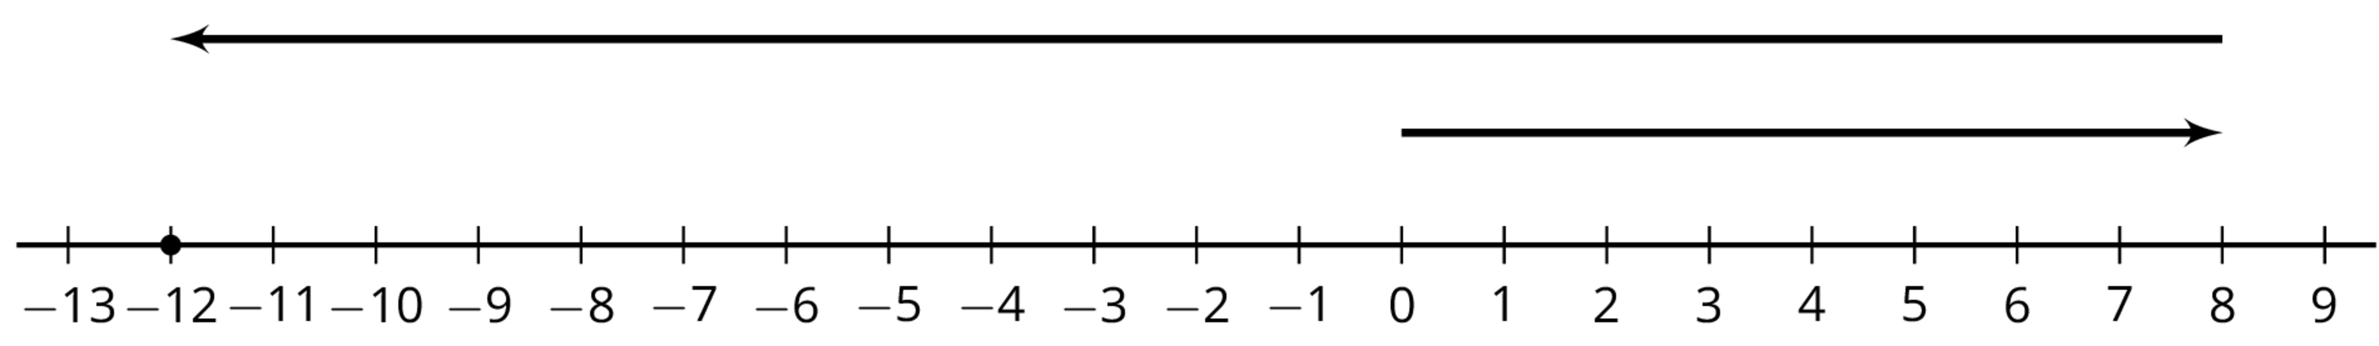
© CC BY Open Up Resources. Adaptations CC BY IM.

