Lesson 4: Midamos y ubiquemos

Standards Alignments
Addressing | 2.MD.A.1, 2.MD.D, 2.MD.D.9, 2.NBT.B.5, 2.OA.B.2

Teacher-facing Learning Goals
- Fluently add and subtract within 20.
- Measure lengths in centimeters.
- Represent measurement data in a line plot.

Student-facing Learning Goals
- Hagamos diagramas de puntos, y sumemos y restemos medidas de longitud.

Lesson Purpose
The purpose of this lesson is for students to add and subtract within 20. Students measure lengths of objects and represent measurement data in line plots and answer questions about the data.
In this lesson, students continue to practice fluency with addition and subtraction within 20 with an emphasis on knowing from memory single-digit addition facts. Students revisit line plots, which they worked with in a previous unit. They measure the length of objects and use measurement data to create line plots.

Access for:

Students with Disabilities
- Action and Expression (Activity 1)

English Learners
- MLR2 (Activity 2)

Instructional Routines
Notice and Wonder (Warm-up)

Materials to Gather
- Pencils: Activity 1
- Rulers (centimeters): Activity 1

Lesson Timeline
Warm-up | 10 min
Activity 1 | 20 min
Activity 2 | 15 min
Lesson Synthesis | 10 min
Cool-down | 5 min

Teacher Reflection Question
Reflect on the development of students’ fluency with addition and subtraction within 20. What activities or discussions particularly helped students during the year? What will you do differently next year to foster your students’ fluency with addition and subtraction?

Cool-down
(to be completed at the end of the lesson) 5min
Pedido de útiles

Standards Alignments
Addressing | 2.MD.D, 2.OA.B.2

Student-facing Task Statement
- ¿Cuál es la diferencia entre la longitud del lápiz más corto y la del lápiz más largo de la clase 1?
- 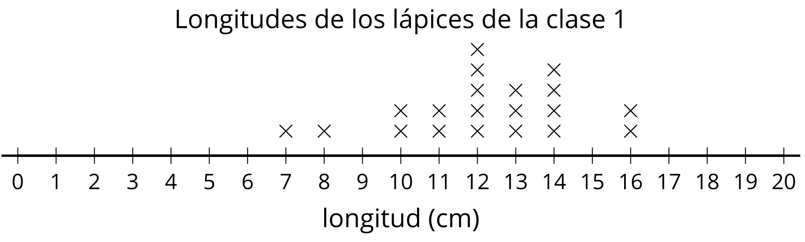
- Escribe una ecuación que represente la diferencia.
- ¿Cuál es la diferencia entre la longitud del lápiz más corto y la del lápiz más largo de la clase 2?
- 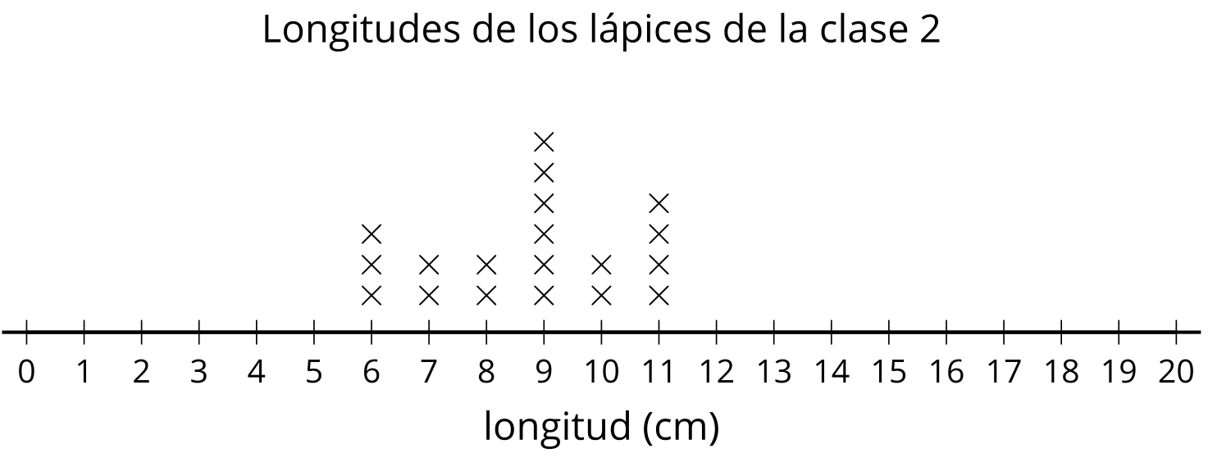
- Escribe una ecuación que represente la diferencia.

Student Responses
- 9 cm ($16−7=9$)
- 5 cm ($11−6=5$)

