Lesson 8: Figuras hechas de prismas

Standards Alignments
Building On | 5.MD.C.5.a
Addressing | 5.MD.C.5.c

Teacher-facing Learning Goals
- Explain that the volume of a figure composed of rectangular prisms is the sum of the volumes of the prisms.
- Find the volume of a figure composed of rectangular prisms in which unit cubes are visible.

Student-facing Learning Goals
- Encontremos el volumen de figuras hechas de prismas.

Lesson Purpose
The purpose of this lesson is for students to recognize the structure of a solid figure made up of two non-overlapping right rectangular prisms and understand that its volume is the sum of the volumes of the two rectangular prisms.
In previous lessons, students found the volume of right rectangular prisms represented in images where the cubes were shown or not shown. In this lesson, they build separate rectangular prisms and put them together to emphasize the relationship between the volume of the individual smaller prisms and the volume of the whole figure. Then they find volumes of figures made from two rectangular prisms without first building each part. Students recognize that when the figure composed of two rectangular prisms is given, there are different ways to decompose the figure, leading to different calculations of the same volume.

Access for:

Students with Disabilities
- Engagement (Activity 1)

English Learners
- MLR7 (Activity 2)

Instructional Routines
Which One Doesn’t Belong? (Warm-up)

Materials to Gather
- Connecting cubes: Activity 1

Lesson Timeline
Warm-up | 10 min
Activity 1 | 20 min
Activity 2 | 15 min
Lesson Synthesis | 10 min
Cool-down | 5 min

Teacher Reflection Question
What language did students use to demonstrate their understanding that the figures they worked with today were composed of rectangular prisms?

Cool-down
(to be completed at the end of the lesson) 5min
Volumen de una figura hecha de prismas

Standards Alignments
Addressing | 5.MD.C.5.c

Student-facing Task Statement
Encuentra el volumen de la figura. Explica o muestra tu razonamiento.
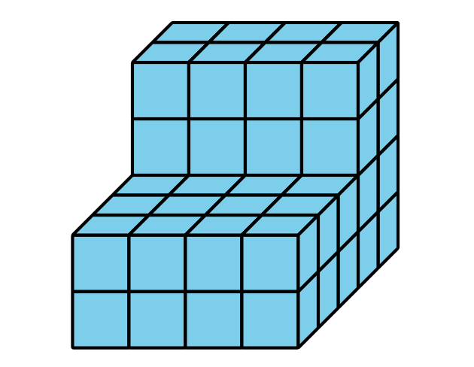

Student Responses
56 cubic units
Sample response: I cut the shape horizontally to make a 2 by 2 by 4 set of cubes and a 4 by 2 by 5 set of cubes. So that’s 16 and 40 more, making 56 cubes altogether.

