Unit 7 Lesson 4: Pattern Block Puzzles and Equations

WU Which One Doesn’t Belong: Equations (Warm up)

Student Task Statement
Which one doesn’t belong?
A
$3+3=6$
B
$6=4+2$
C
$4+3=7$
D
$4+2=6$

1 Match Equations to Pattern Block Puzzles

Student Task Statement
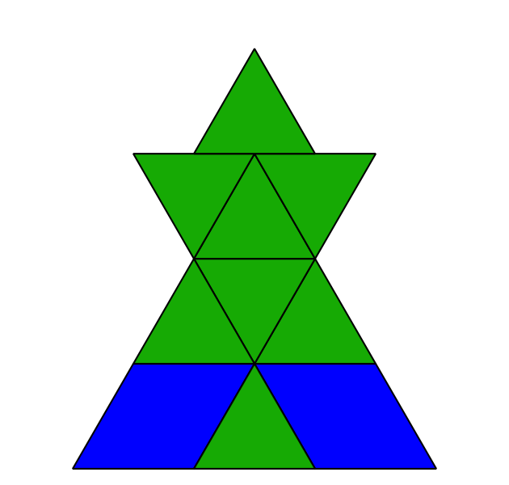
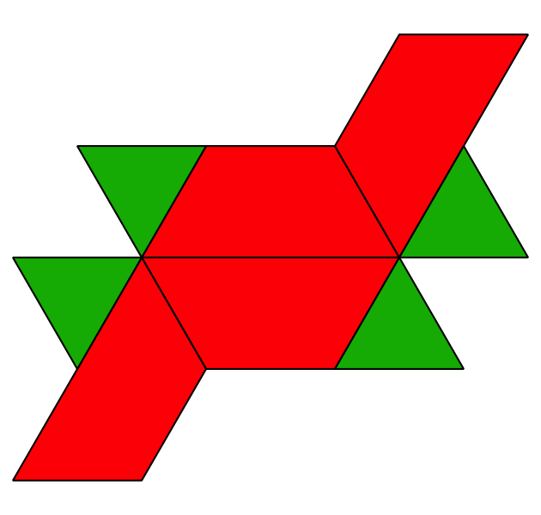
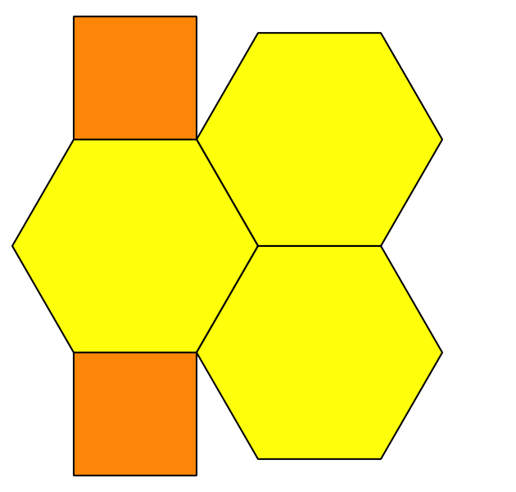
$8=4+4$
$6+1=7$
$10=2+8$
$7=6+1$
$2+3=5$
​$9=6+3$
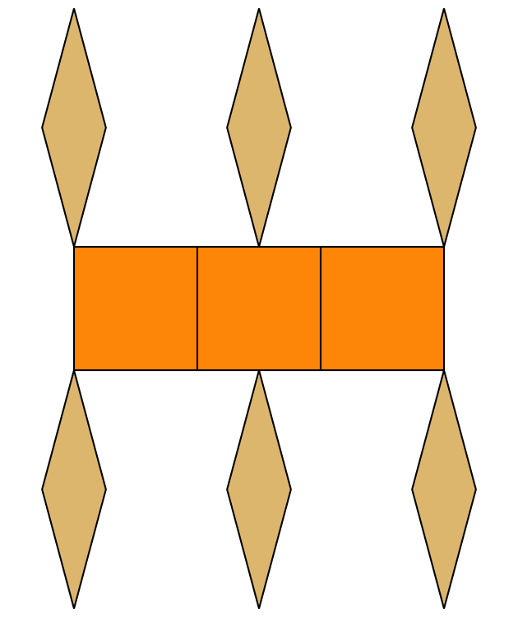
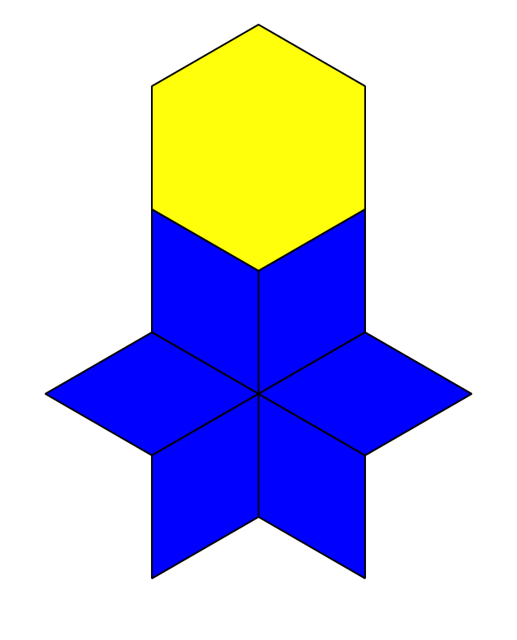

2 Make Shapes to Represent Equations

Student Task Statement
$4=1+3$
$10+0=10$
$5+4=9$
$8=2+6$
$3+3=6$
$7=2+5$

3 Centers: Choice Time

Student Task Statement
Choose a center.
Pattern Blocks
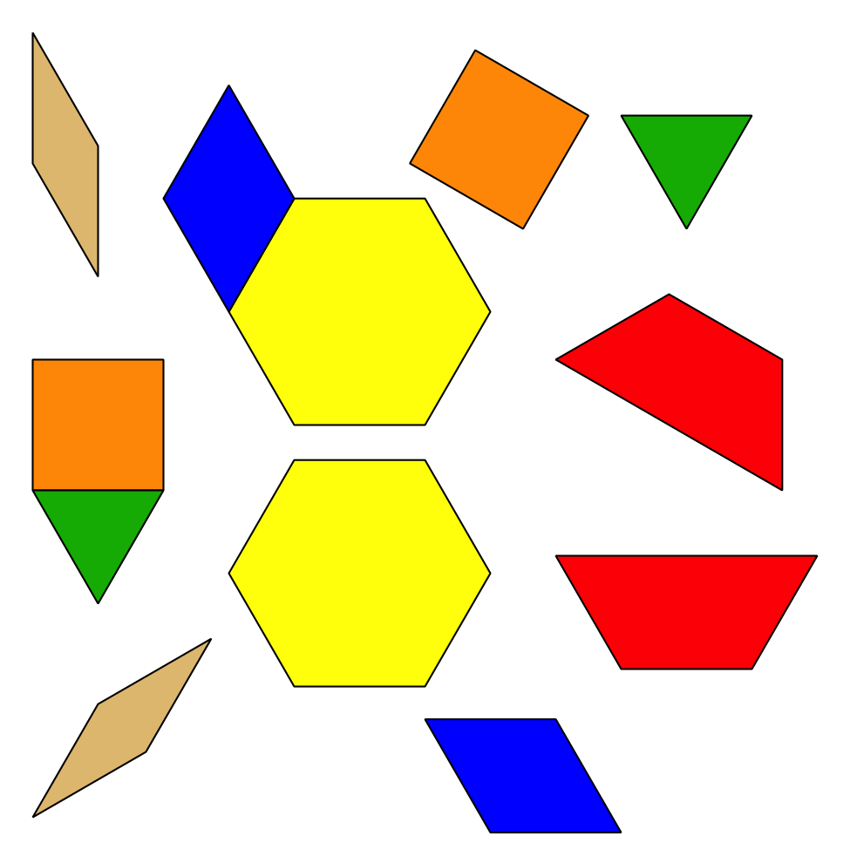
Geoblocks
Grab and Count
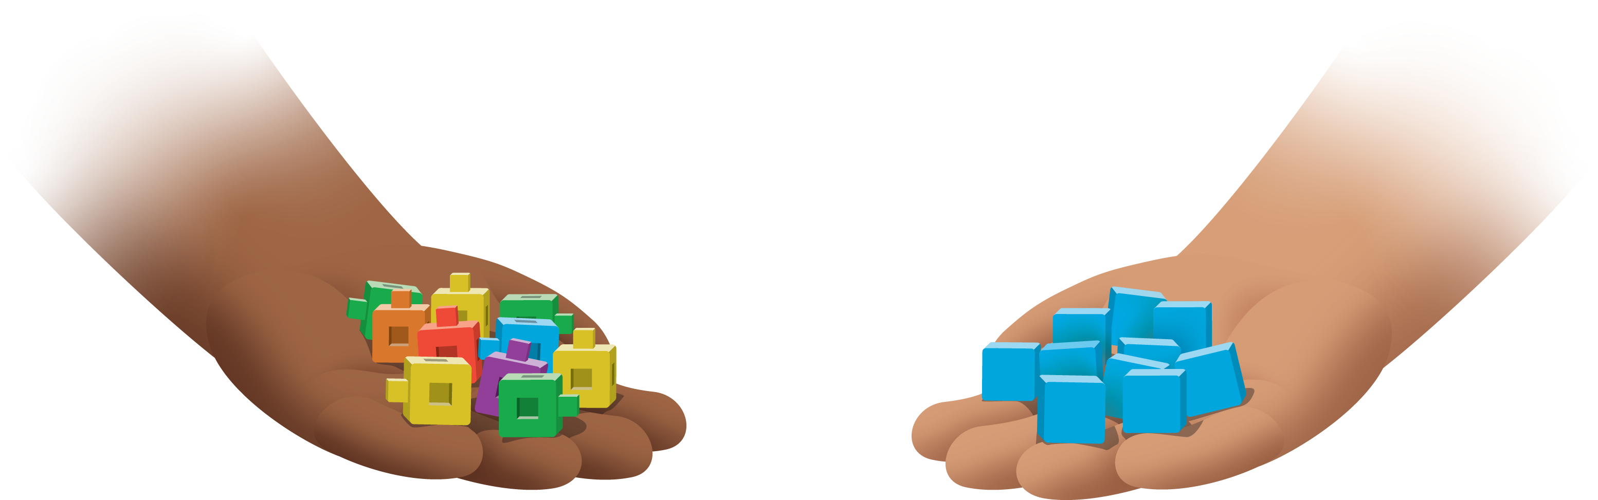
Find the Pair
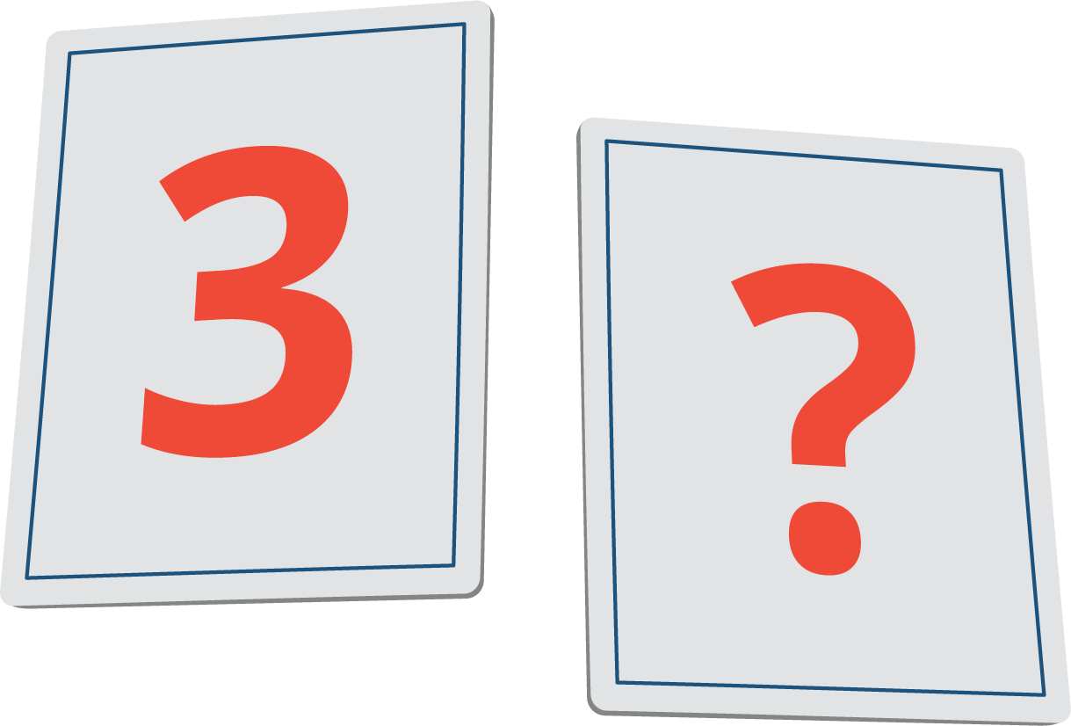
© CC BY 2021 Illustrative Mathematics®

