Lesson 15 Practice Problems
- Solve each equation and write the solutions using $±$ notation.
  - $x^{2}=144$
  - $x^{2}=5$
  - $4x^{2}=28$
  - $x^{2}=\frac{25}{4}$
  - $2x^{2}=22$
  - $7x^{2}=16$
- Match each expression to an equivalent expression.
  - $4±1$
  - $10±\sqrt{4}$
  - $\text{-}6±11$
  - $4±\sqrt{1}0$
  - $\sqrt{1}6±\sqrt{2}$
  - -17 and 5
  - $4+\sqrt{2}$ and $4−\sqrt{2}$
  - 8 and 12
  - 3 and 5
  - $4+\sqrt{1}0$ and $4−\sqrt{1}0$

  - Is $\sqrt{4}$ a positive or negative number? Explain your reasoning.
  - Is $\sqrt{5}$ a positive or negative number? Explain your reasoning.
  - Explain the difference between $\sqrt{9}$ and the solutions to $x^{2}=9$.
- Technology required. For each equation, find the exact solutions by completing the square and the approximate solutions by graphing. Then, verify that the solutions found using the two methods are close.
- $x^{2}+10x+8=0$
- $x^{2}−4x−11=0$

- Jada is working on solving a quadratic equation, as shown here.
- $\begin{matrix}p^{2}−5p & =0 \\ p\left(p−5\right) & =0 \\ p−5 & =0 \\ p & =5\end{matrix}$
- She thinks that her solution is correct because substituting 5 for $p$ in the original expression $p^{2}−5p$ gives $5^{2}−5\left(5\right)$, which is $25−25$ or 0.
- Explain the mistake that Jada made and show the correct solutions.
- (From Unit 7, Lesson 9.)
- Which expression in factored form is equivalent to $30x^{2}+31x+5$?
  - $\left(6x+5\right)\left(5x+1\right)$
  - $\left(5x+5\right)\left(6x+1\right)$
  - $\left(10x+5\right)\left(3x+1\right)$
  - $\left(30x+5\right)\left(x+1\right)$
- (From Unit 7, Lesson 10.)
- Two rocks are launched straight up in the air. The height of Rock A is given by the function $f$, where $f\left(t\right)=4+30t−16t^{2}$. The height of Rock B is given by $g$, where $g\left(t\right)=5+20t−16t^{2}$. In both functions, $t$ is time measured in seconds after the rocks are launched and height is measured in feet above the ground.
  - Which rock is launched from a higher point?
  - Which rock is launched with a greater velocity?
- (From Unit 6, Lesson 6.)

  - Describe how the graph of $f\left(x\right)=\left|x\right|$ has to be shifted to match the given graph.
  - 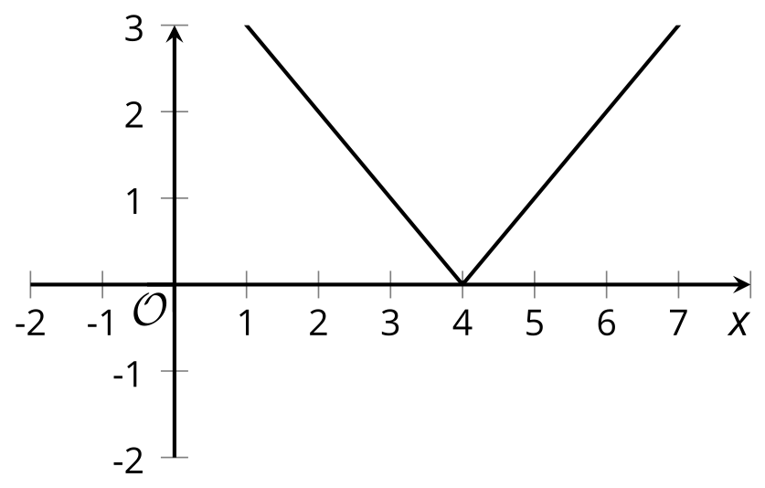
  - ​​​​​

  - Find an equation for the function represented by the graph.
- (From Unit 4, Lesson 14.)
© CC BY 2019 by Illustrative Mathematics®

