Lesson 5 Practice Problems
- Match each sequence with one of the definitions. Note that only the part of the definition showing the relationship between the current term and the previous term is given so as not to give away the solutions.
  - 6, 12, 18, 24
  - 2, 14, 98, 686
  - 160, 80, 40, 20
  - $a\left(n\right)=7⋅a\left(n−1\right)$
  - $b\left(n\right)=\frac{1}{2}⋅b\left(n−1\right)$
  - $c\left(n\right)=c\left(n−1\right)+6$
- Write the first five terms of each sequence. Determine whether each sequence is arithmetic, geometric, or neither.
  - $a\left(1\right)=7,a\left(n\right)=a\left(n−1\right)−3$ for $n≥2$.
  - $b\left(1\right)=2,b\left(n\right)=2⋅b\left(n−1\right)−1$ for $n≥2$.
  - $c\left(1\right)=3,c\left(n\right)=10⋅c\left(n−1\right)$ for $n≥2$.
  - $d\left(1\right)=1,d\left(n\right)=n⋅d\left(n−1\right)$ for $n≥2$.
- The first 5 terms of some sequences are given. State a rule that each sequence could follow.
  - 2, 4, 6, 8, 10
  - 5, 7, 9, 11, 13
  - 50, 25, 0, -25, -50
  - $\frac{1}{3}$, 1, 3, 9, 27
- (From Unit 1, Lesson 1.)
- Function $f$ is defined by $f\left(x\right)=2x−7$ and $g$ is defined by $g\left(x\right)=5^{x}$.
  - Find $f\left(3\right),f\left(2\right),f\left(1\right),f\left(0\right),$ and $f\left(\text{-}1\right)$.
  - Find $g\left(3\right),g\left(2\right),g\left(1\right),g\left(0\right),$ and $g\left(\text{-}1\right)$.
- (From Unit 1, Lesson 3.)
- Here is the graph of two sequences.
- 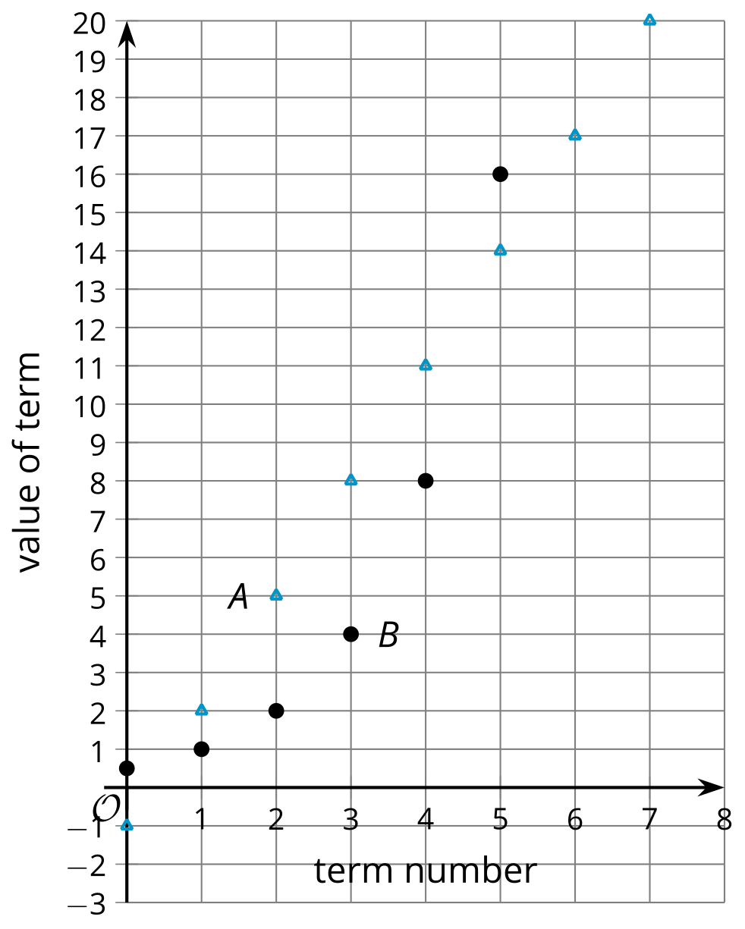
- term number | - Sequence A | - Sequence B
- 0 | - -1 | - $\frac{1}{2}$
- 1
- 2
- 3
- 4
- 5
- 6
  - Complete the table for each sequence.
  - For Sequence A, describe a way to produce a new term from the previous term.
  - For Sequence B, describe a way to produce a new term from the previous term.
  - Which of these is a geometric sequence? Explain how you know.
- (From Unit 1, Lesson 3.)
© CC BY 2019 by Illustrative Mathematics®

