Lesson 3 Practice Problems
- Write a multiplication equation and a division equation that this diagram could represent.
- 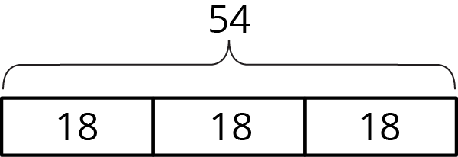
- Consider the problem: Mai has $36 to spend on movie tickets. Each movie ticket costs $4.50. How many tickets can she buy?
  - Write a multiplication equation and a division equation to represent this situation.
  - Find the answer. Draw a diagram, if needed.
  - Use the multiplication equation to check your answer.
- Kiran said that this diagram can show the solution to $16÷8=?$ or $16÷2=?$, depending on how we think about the equations and the “?”.
- Explain or show how Kiran is correct.
- 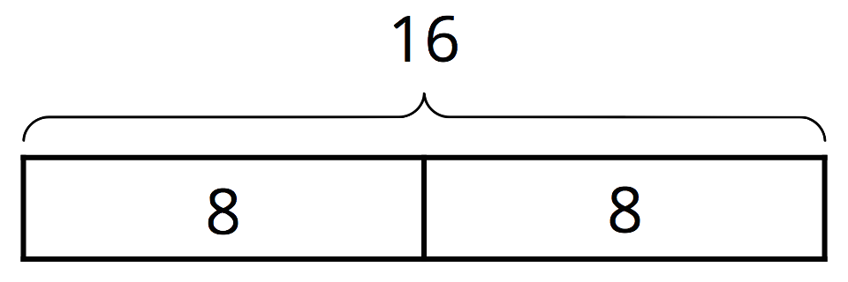
- Write a sentence describing a situation that could be represented by the equation $4÷1\frac{1}{3}=?$.
- (From Unit 4, Lesson 2.)
- Noah said, “When you divide a number by a second number, the result will always be smaller than the first number.”
- Jada said, “I think the result could be larger or smaller, depending on the numbers.”
- Do you agree with either of them? Explain or show your reasoning.
- (From Unit 4, Lesson 1.)
- Mini muffins cost $3.00 per dozen.
  - Andre says, “I have $2.00, so I can afford 8 muffins.”
  - Elena says, “I want to get 16 muffins, so I’ll need to pay $4.00."
- Do you agree with either of them? Explain your reasoning.
- (From Unit 3, Lesson 7.)
- A family has a monthly budget of $2,400. How much money is spent on each category?
  - 44% is spent on housing.
  - 23% is spent on food.
  - 6% is spent on clothing.
  - 17% is spent on transportation.
  - The rest is put into savings.
- (From Unit 3, Lesson 15.)
© CC BY Open Up Resources. Adaptations CC BY IM.

