Lesson 5: Standard Algorithm: Multi-digit Numbers without Composing
- Let’s use the standard algorithm to multiply two-digit numbers and three-digit numbers.

Warm-up: Number Talk: Partial Products
Find the value of each product mentally.
- $20×3$
- $24×3$
- $120×3$
- $140×3$

5.1: Compare Two Algorithms
Two algorithms for finding the value of $413×21$ are shown.
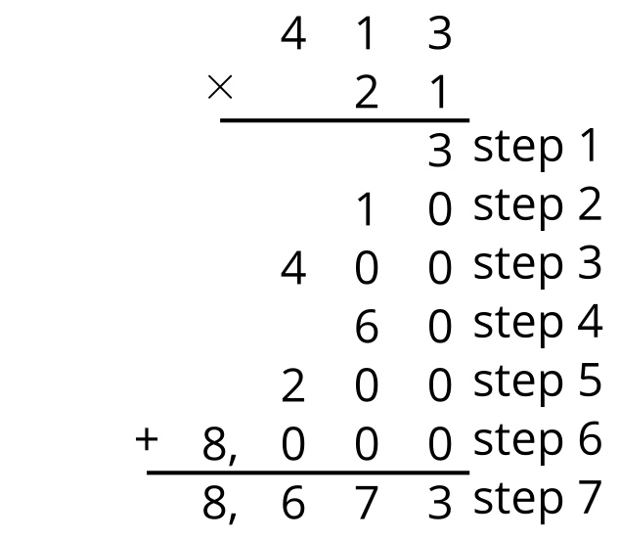
step 1
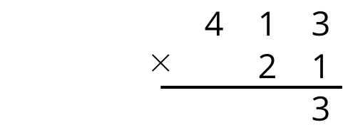
step 2
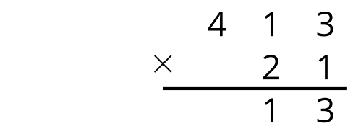
step 3
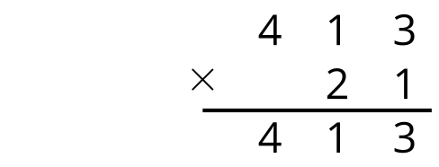
step 4
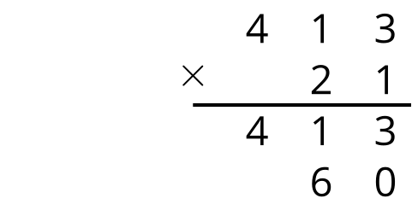
step 5
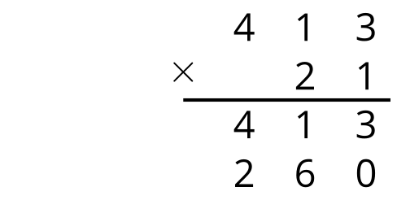
step 6
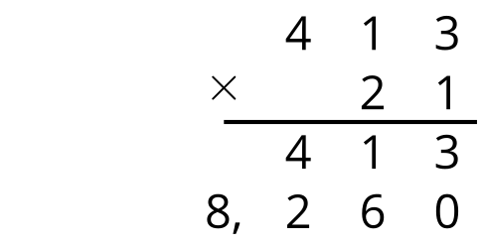
step 7
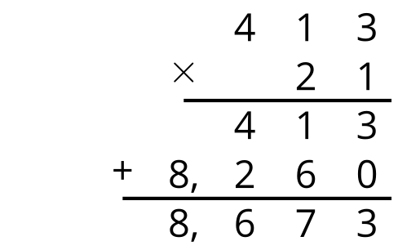
- How are the two algorithms the same? How are they different?
- Explain or show where you see each step from the first algorithm in the second algorithm.
- How do the final steps in the two algorithms compare?

5.2: Use the Standard Algorithm
Use the standard algorithm to find the value of each expression.
- $202×12$
- $122×33$
- $321×24$
- Diego found the value of $301×24$. Here is his work. Why doesn’t Diego’s answer make sense?
- 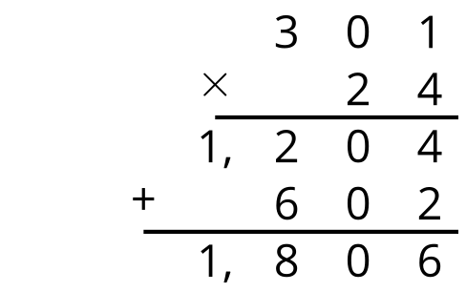
© CC BY 2021 Illustrative Mathematics®

