Lesson 12: Saree Silk Stories: Friendship Bracelets
- Let’s solve two-step story problems about length.

Warm-up: True or False: Place Value Comparisons
Decide if each statement is true or false. Be prepared to explain your reasoning.
- $24=10+14$
- $15+12=27$
- $26=10+6+10$
- $58=20+20+8$

12.1: Share Ribbon with Friends
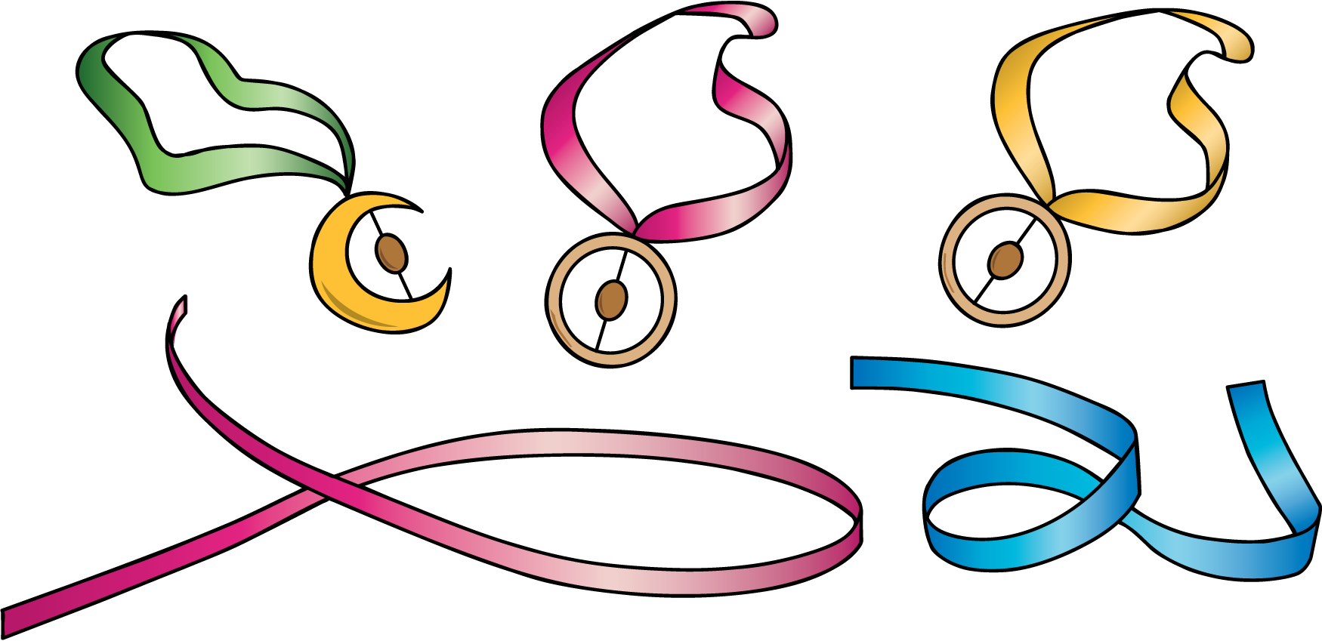
- Solve. Show your thinking. Use a diagram if it helps. Don’t forget the units.
  - Lin found a piece of ribbon that is 92 cm long. She cut a piece for Noah that is 35 cm. How much ribbon does Lin have left?
  - Then, Lin cut off 28 cm of ribbon for Jada. How much ribbon does Lin have left now?

12.2: Friendship Bracelets and Gifts
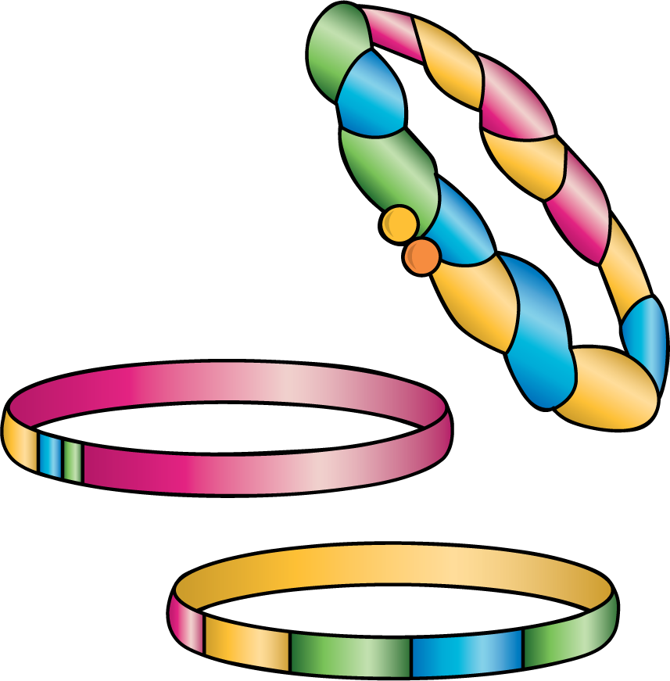
- Solve. Show your thinking. Don’t forget the units. Use a diagram if it helps.
  - Han has 82 inches of ribbon. He only needs 48 inches. How much should he cut off?
  - Han gives the ribbon he doesn’t need to Clare. Clare uses it to make her ribbon longer. Her ribbon was 27 inches. How long is Clare’s ribbon now?
- Solve. Show your thinking. Don’t forget the units. Use a diagram if it helps.
  - Andre’s ribbon is too short. He has 28 inches of ribbon, but he needs it to be 50 inches long. How much more ribbon does he need?
  - Andre got the ribbon he needed from Mai. Mai now has 49 inches of ribbon left. How much ribbon did Mai start with?

Section Summary
Section Summary In this section of the unit, we learned more about standard length units. We measured using inches and feet—two length units from the the U.S. customary system. We also solved two-step story problems about length and interpreted diagrams that represent taking a part away. This diagram shows that we know the length of the ribbon and how much was cut. The question mark represents the length of ribbon that is left.
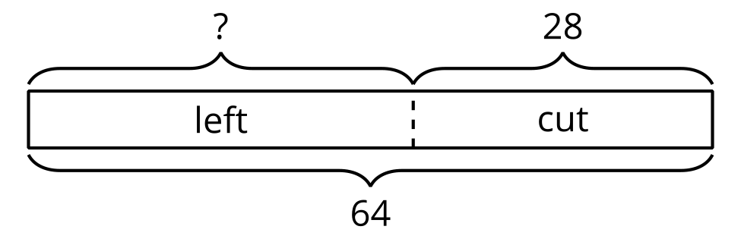
Han had a piece of ribbon that was 64 inches long. He cut off 28 inches to make a necklace for his sister. How much ribbon is left?
© CC BY 2021 Illustrative Mathematics®

