Unit 4 Lesson 14: Center Day 2

WU True or False: Is This 50? (Warm up)

Student Task Statement
Decide if each statement is true or false. Be prepared to explain your reasoning.
- $28+2+20=50$
- $16+3+30=50$
- $36+4+20=50$

1 Introduce Jump the Line, Add and Subtract within 100

Student Task Statement

2 Centers: Choice Time

Student Task Statement
Choose a center.
Jump the Line
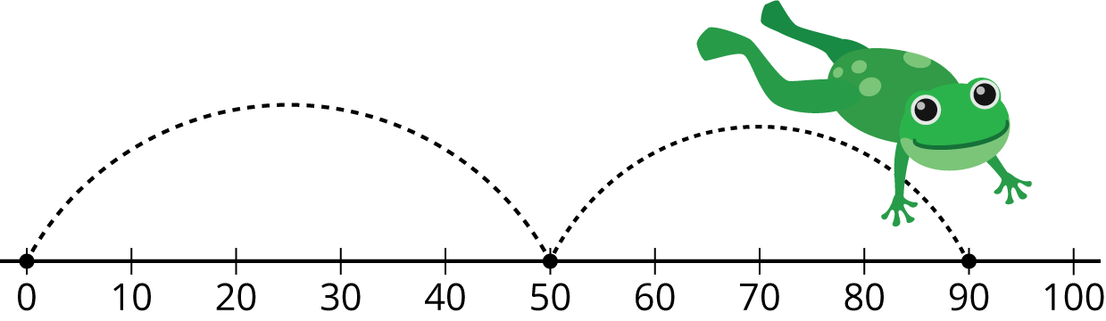
Number Line Scoot
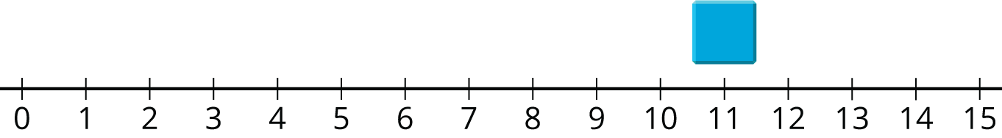
How Close?
© CC BY 2021 Illustrative Mathematics®

