Unit 3 Lesson 11: Add to a Teen Number

WU True or False: Teen Numbers (Warm up)

Student Task Statement
Decide whether each statement is true or false.
Be prepared to explain your reasoning.
- $10+4=10+5$
- $10+3=2+1+10$
- $14=10+4+5$

1 Rock Collection

Student Task Statement
Kiran collects rocks.
So far he has 14 rocks.
He goes on a hike and collects 3 more rocks.
How many rocks does Kiran have?
Show your thinking using drawings, numbers, or words.
Equation: ________________________________
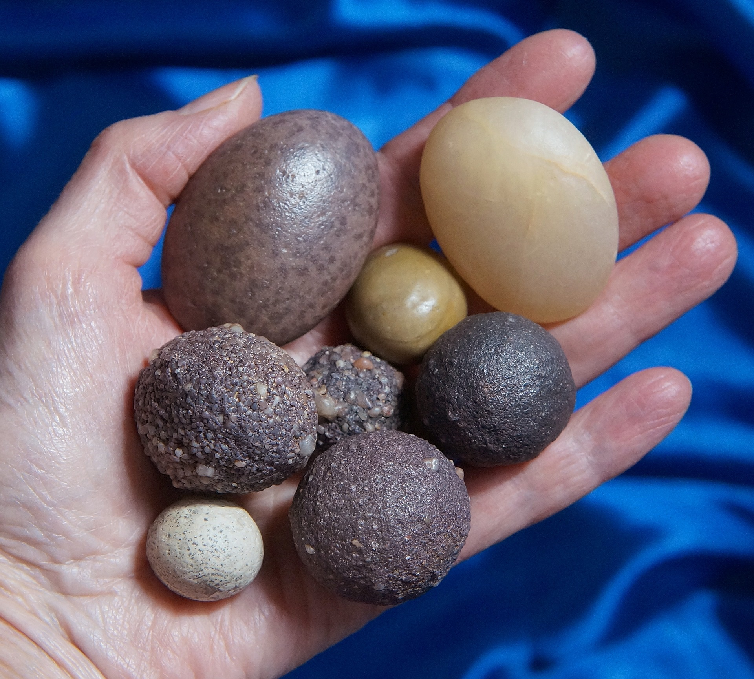

2 Write Equations: Adding on to Teen Numbers

Student Task Statement
Find the number that makes each equation true.
Show your thinking using drawings, numbers, or words.
- 12+5=aaaiaaai
- 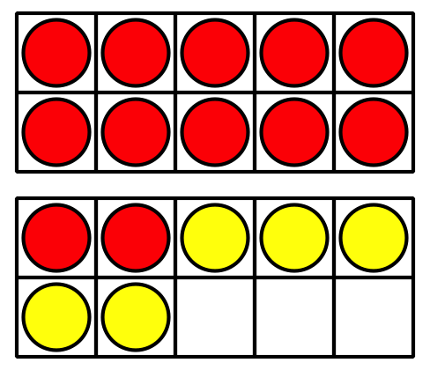
- 6+11=aaaiaaai
- aaaiaaai=17+2
- 4+14=aaaiaaai
- aaaiaaai=15+4
- 16+2=aaaiaaai

3 Centers: Choice Time

Student Task Statement
Choose a center.
Compare
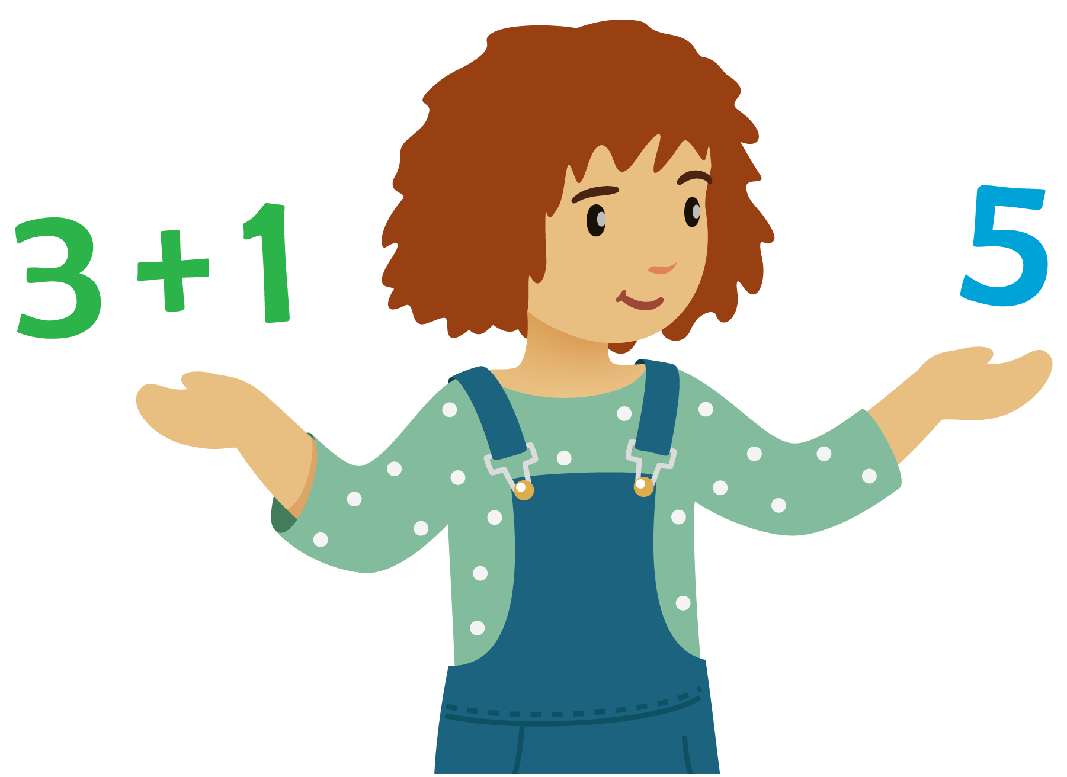
Number Puzzles
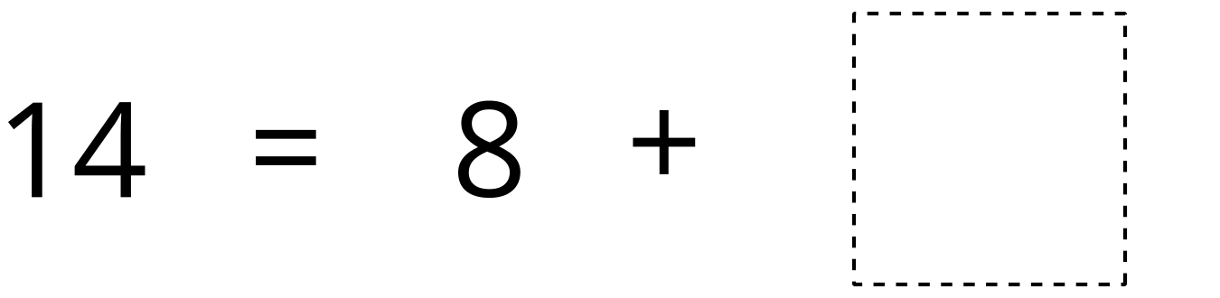
Find the Pair
© CC BY 2021 Illustrative Mathematics®

