Unit 5 Lesson 6: Methods for Multiplying Decimals

1 Equivalent Expressions (Warm up)

Student Task Statement
Write as many expressions as you can think of that are equal to 0.6. Do not use addition or subtraction.

2 Using Properties of Numbers to Reason about Multiplication

Student Task Statement
Elena and Noah used different methods to compute $\left(0.23\right)⋅\left(1.5\right)$. Both calculations were correct.
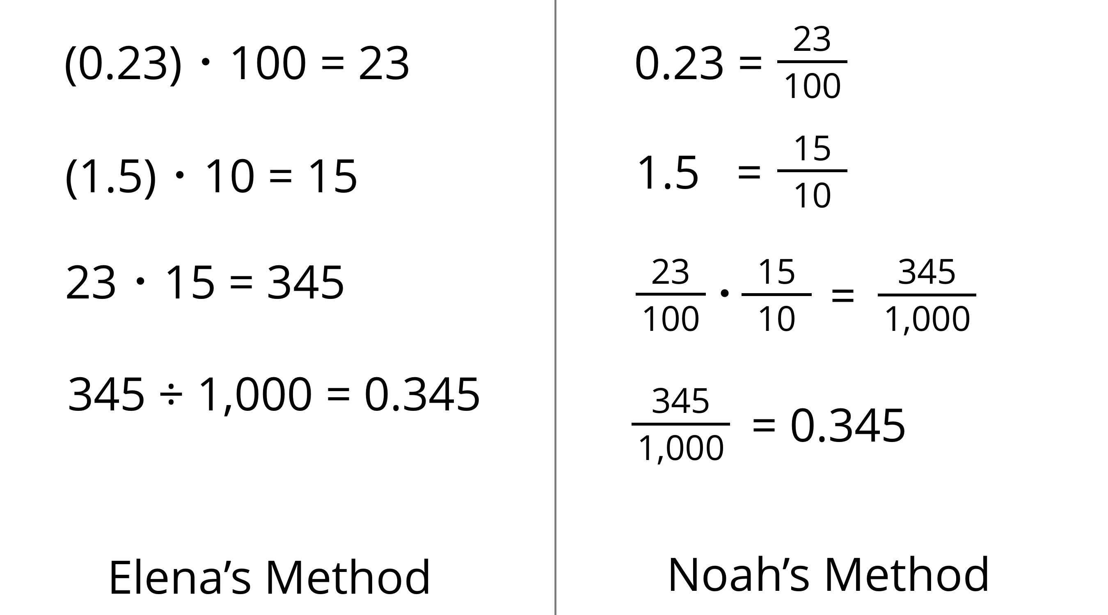
- Analyze the two methods, then discuss these questions with your partner.
  - Which method makes more sense to you? Why?
  - What might Elena do to compute $\left(0.16\right)⋅\left(0.03\right)$? What might Noah do to compute $\left(0.16\right)⋅\left(0.03\right)$? Will the two methods result in the same value?
- Compute each product using the equation $21⋅47=987$ and what you know about fractions, decimals, and place value. Explain or show your reasoning.
  - $\left(2.1\right)⋅\left(4.7\right)$
  - $21⋅\left(0.047\right)$
  - $\left(0.021\right)⋅\left(4.7\right)$

3 Using Area Diagrams to Reason about Multiplication (Optional)

Images for Launch
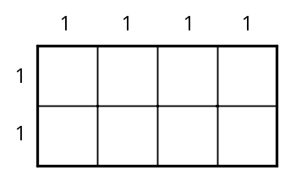

Student Task Statement
- In the diagram, the side length of each square is 0.1 unit.
  - Explain why the area of each square is not 0.1 square unit.
  - 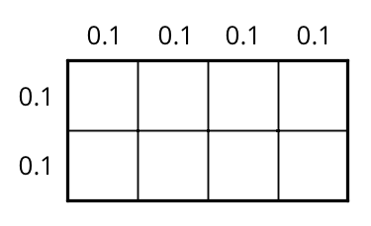
  - How can you use the area of each square to find the area of the rectangle? Explain or show your reasoning.
  - Explain how the diagram shows that the equation $\left(0.4\right)⋅\left(0.2\right)=0.08$ is true.
- Label the squares with their side lengths so the area of this rectangle represents $40⋅20$.
  - What is the area of each square?
  - Use the squares to help you find $40⋅20$. Explain or show your reasoning.
- 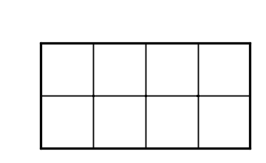
- Label the squares with their side lengths so the area of this rectangle represents $\left(0.04\right)⋅\left(0.02\right)$.
- Next, use the diagram to help you find $\left(0.04\right)⋅\left(0.02\right)$. Explain or show your reasoning.
© CC BY Open Up Resources. Adaptations CC BY IM.

