## Unit 2 Lesson 10: Introducing Graphs of Proportional Relationships

### 1 Notice These Points (Warm up)

#### Student Task Statement

1. Plot the points .

* 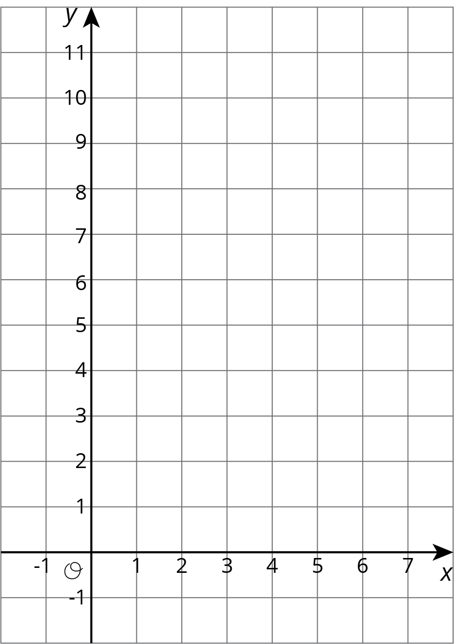

1. What do you notice about the graph?

### 2 T-shirts for Sale

#### Student Task Statement

Some T-shirts cost $8 each.

|  |  |
| --- | --- |
|  |  |
| 1 | 8 |
| 2 | 16 |
| 3 | 24 |
| 4 | 32 |
| 5 | 40 |
| 6 | 48 |

1. Use the table to answer these questions.
   1. What does represent?
   2. What does represent?
   3. Is there a proportional relationship between and ?
2. Plot the pairs in the table on the **coordinate plane**.

* 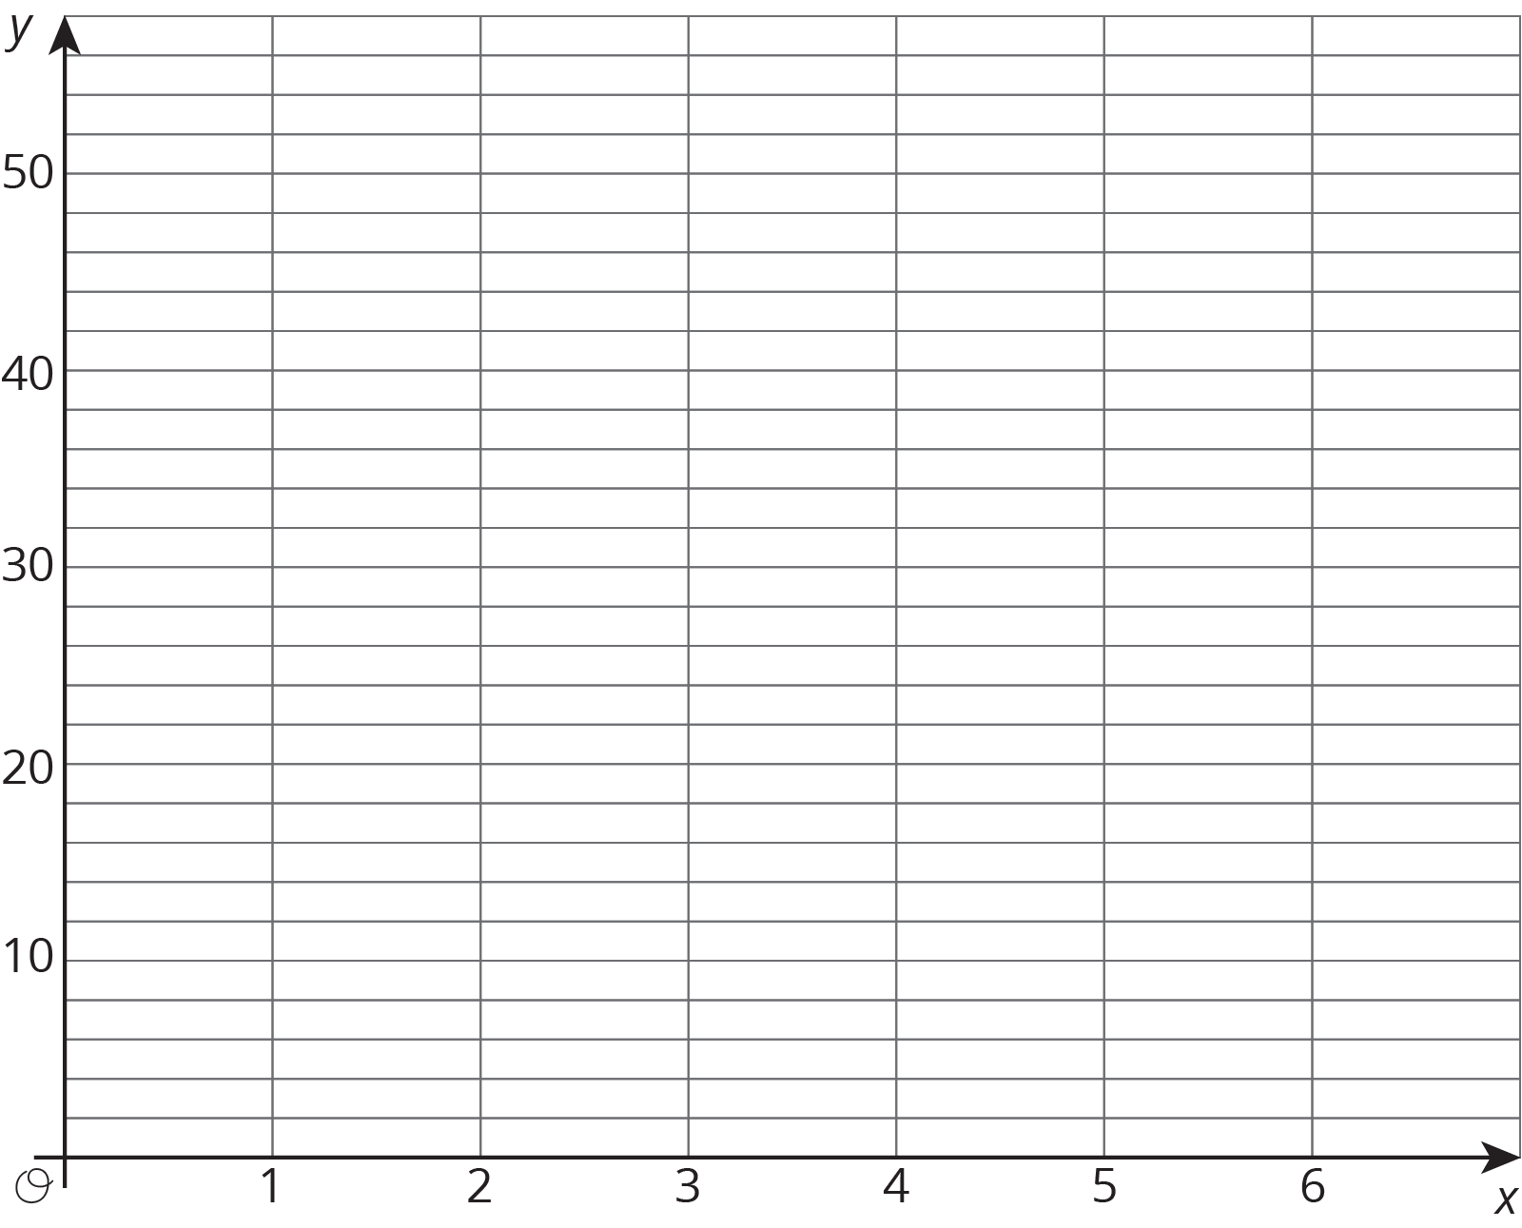

1. What do you notice about the graph?

### 3 Matching Tables and Graphs

#### Student Task Statement

Your teacher will give you papers showing tables and graphs.

1. Examine the graphs closely. What is the same and what is different about the graphs?
2. Sort the graphs into categories of your choosing. Label each category. Be prepared to explain why you sorted the graphs the way you did.
3. Take turns with a partner to match a table with a graph.
   1. For each match you find, explain to your partner how you know it is a match.
   2. For each match your partner finds, listen carefully to their explanation. If you disagree, work to reach an agreement.

* Pause here so your teacher can review your work.

1. Trade places with another group. How are their categories the same as your group's categories? How are they different?
2. Return to your original place. Discuss any changes you may wish to make to your categories based on what the other group did.
3. Which of the relationships are proportional?
4. What have you noticed about the graphs of proportional relationships? Do you think this will hold true for *all* graphs of proportional relationships?



© CC BY Open Up Resources. Adaptations CC BY IM.