Lesson 5: Compongamos y descompongamos números hasta 1,000

Standards Alignments
Addressing | 2.NBT.A, 2.NBT.A.1

Teacher-facing Learning Goals
- Compose and decompose numbers within 1,000.
- Represent numbers within 1,000 in different ways.

Student-facing Learning Goals
- Representemos números de muchas maneras diferentes.

Lesson Purpose
The purpose of this lesson is for students to compose and decompose three-digit numbers in different ways.
In previous units, students represented three-digit numbers by composing and decomposing units using base-ten blocks, base-ten diagrams, and equations.
In this lesson, students compose and decompose three-digit numbers using base-ten blocks and other representations that make sense to them. Throughout the lesson, students are encouraged to show and deepen their understanding of place value by composing and decomposing units.

Access for:

Students with Disabilities
- Action and Expression (Activity 1)

Instructional Routines
MLR7 Compare and Connect (Activity 2), What Do You Know About _____? (Warm-up)

Materials to Gather
- Base-ten blocks: Activity 1
- Tools for creating a visual display: Activity 2

Lesson Timeline
Warm-up | 10 min
Activity 1 | 15 min
Activity 2 | 20 min
Lesson Synthesis | 10 min
Cool-down | 5 min

Teacher Reflection Question
In this section, students are working to develop fluency when adding and subtracting within 100. How does the work of the lesson help deepen students understanding of place value? How will the work of this lesson help students become more fluent when adding and subtracting within 100?

Cool-down
(to be completed at the end of the lesson) 5min
Doscientos sesenta y tres

Standards Alignments
Addressing | 2.NBT.A

Student-facing Task Statement
- Marca las representaciones que muestran 263.
  - 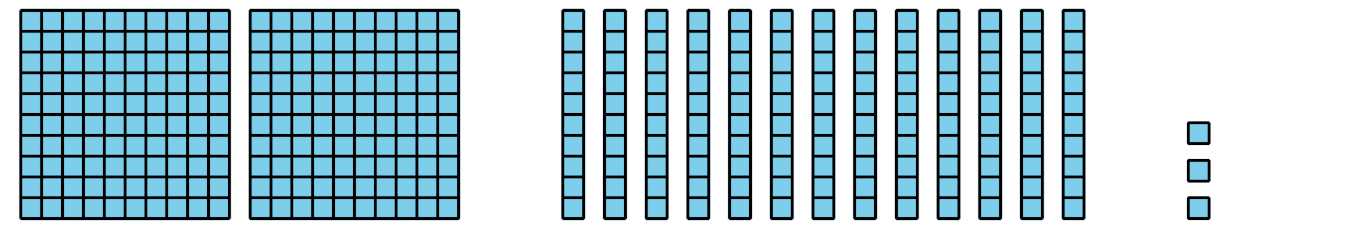
  - 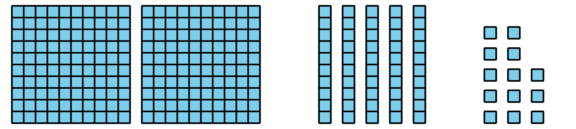
  - 2 centenas + 4 decenas + 23 unidades
- Representa 263 de otra manera.

Student Responses
- B, C
- Sample responses:
  - 1 hundred + 16 tens + 3 ones
  - $200+60+3$
  - Students draw a base-ten diagram that shows 2 hundreds, 6 tens and 3 ones.

