Lesson 2: More Multiplication
- Let’s practice using the multiplication algorithm.

Warm-up: Estimation Exploration: Large Product
$9,​999×896$
Record an estimate that is:
too low | about right | too high

2.1: Kiran’s Work
- Find the value of the product.
- 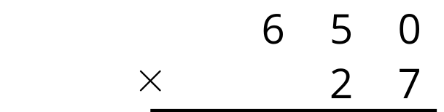
- Below is Kiran’s work finding the value of the product $650×27$. Is his answer reasonable? Explain your reasoning.
- 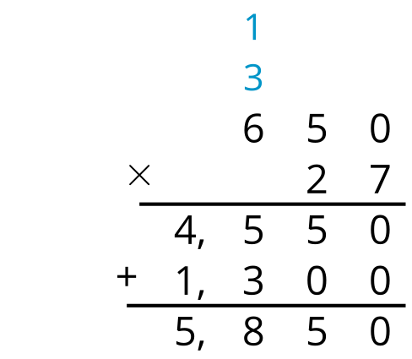
- What parts of the work do you agree with? Be prepared to explain your reasoning.
- What parts of the work do you disagree with? Be prepared to explain your reasoning.
- Look at your solution to problem 1. Is there anything you want to revise? Be prepared to explain.

2.2: Zero the Hero
Find the value of each product.
1.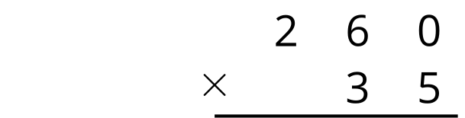
2.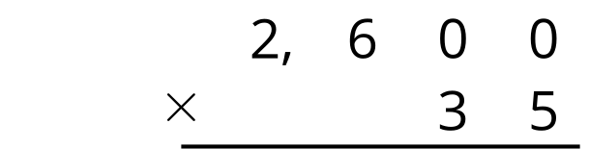
3.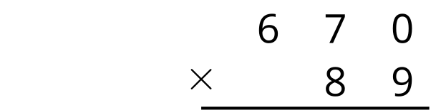
4.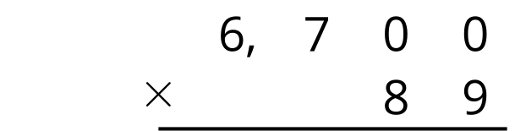
© CC BY 2021 Illustrative Mathematics®

