Lesson 13: Center Day 2
- Let's complete equations and continue to estimate and measure.

Warm-up: Number Talk: Use Ten to Add
Find the value of each expression mentally.
- $58+10$
- $58+12$
- $58+13$
- $67+14$

13.2: Centers: Introduce Number Puzzles, Within 100 with Composing
Choose a center.
Number Puzzles
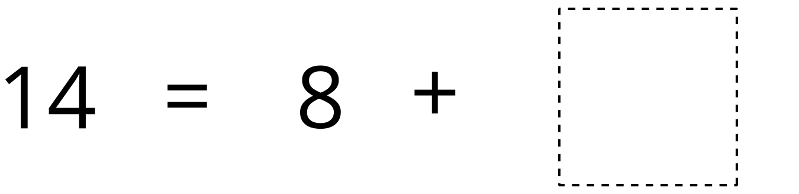
Estimate and Measure
Target Measurements
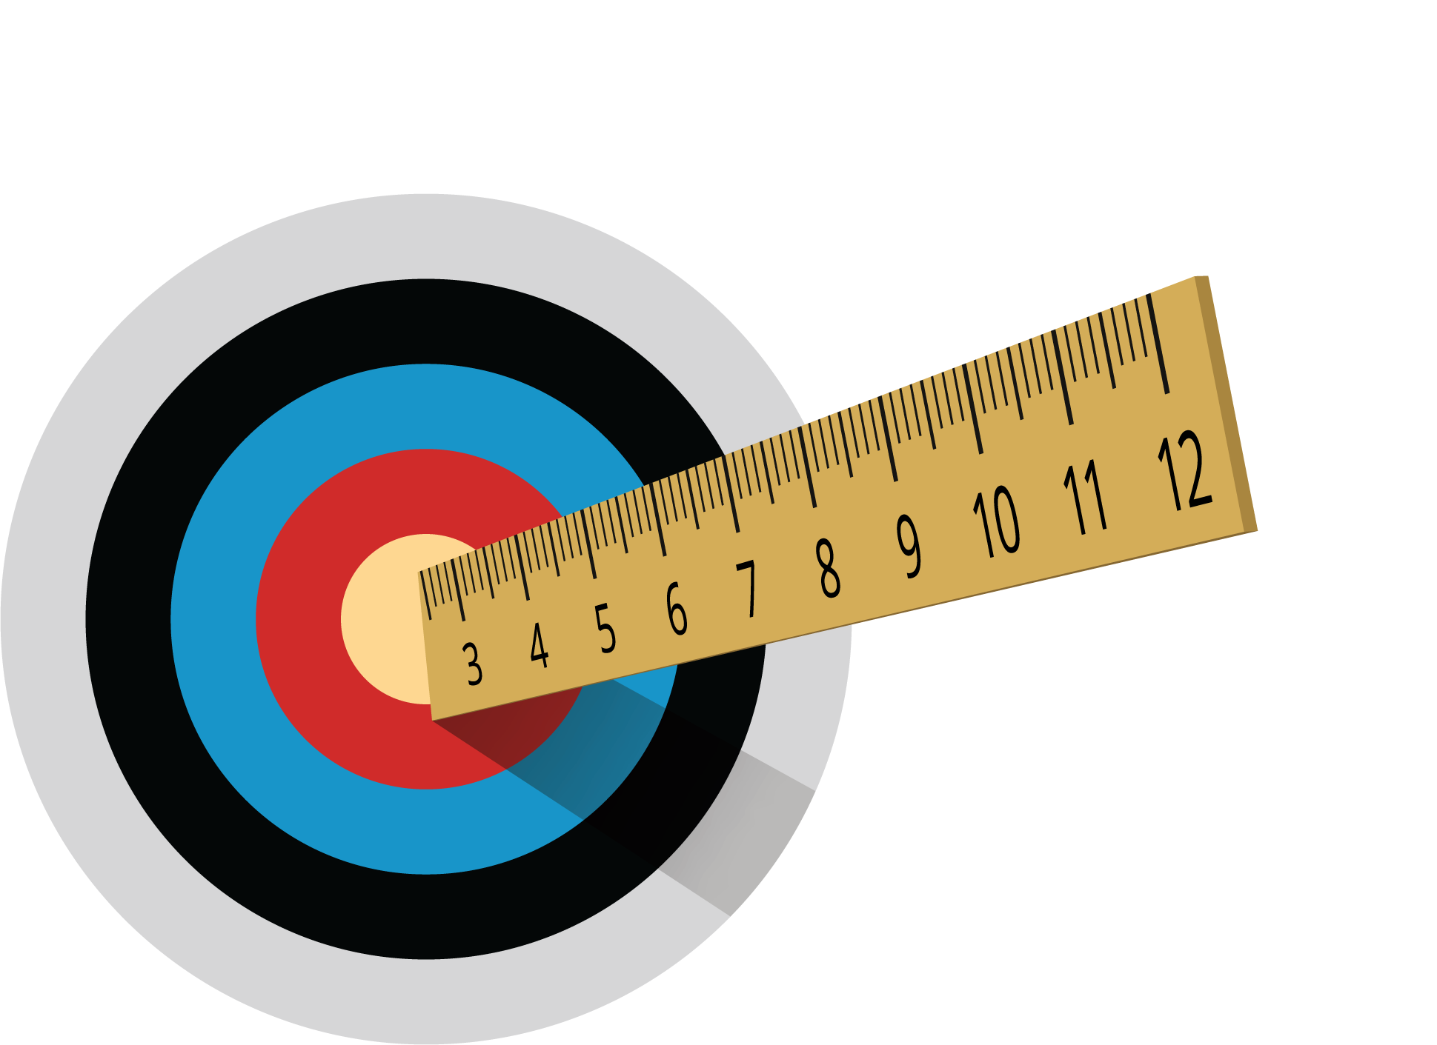
© CC BY 2021 Illustrative Mathematics®

