Unit 4 Lesson 15: Riddles

WU Notice and Wonder: Birthday Candles (Warm up)

Student Task Statement
What do you notice? What do you wonder?
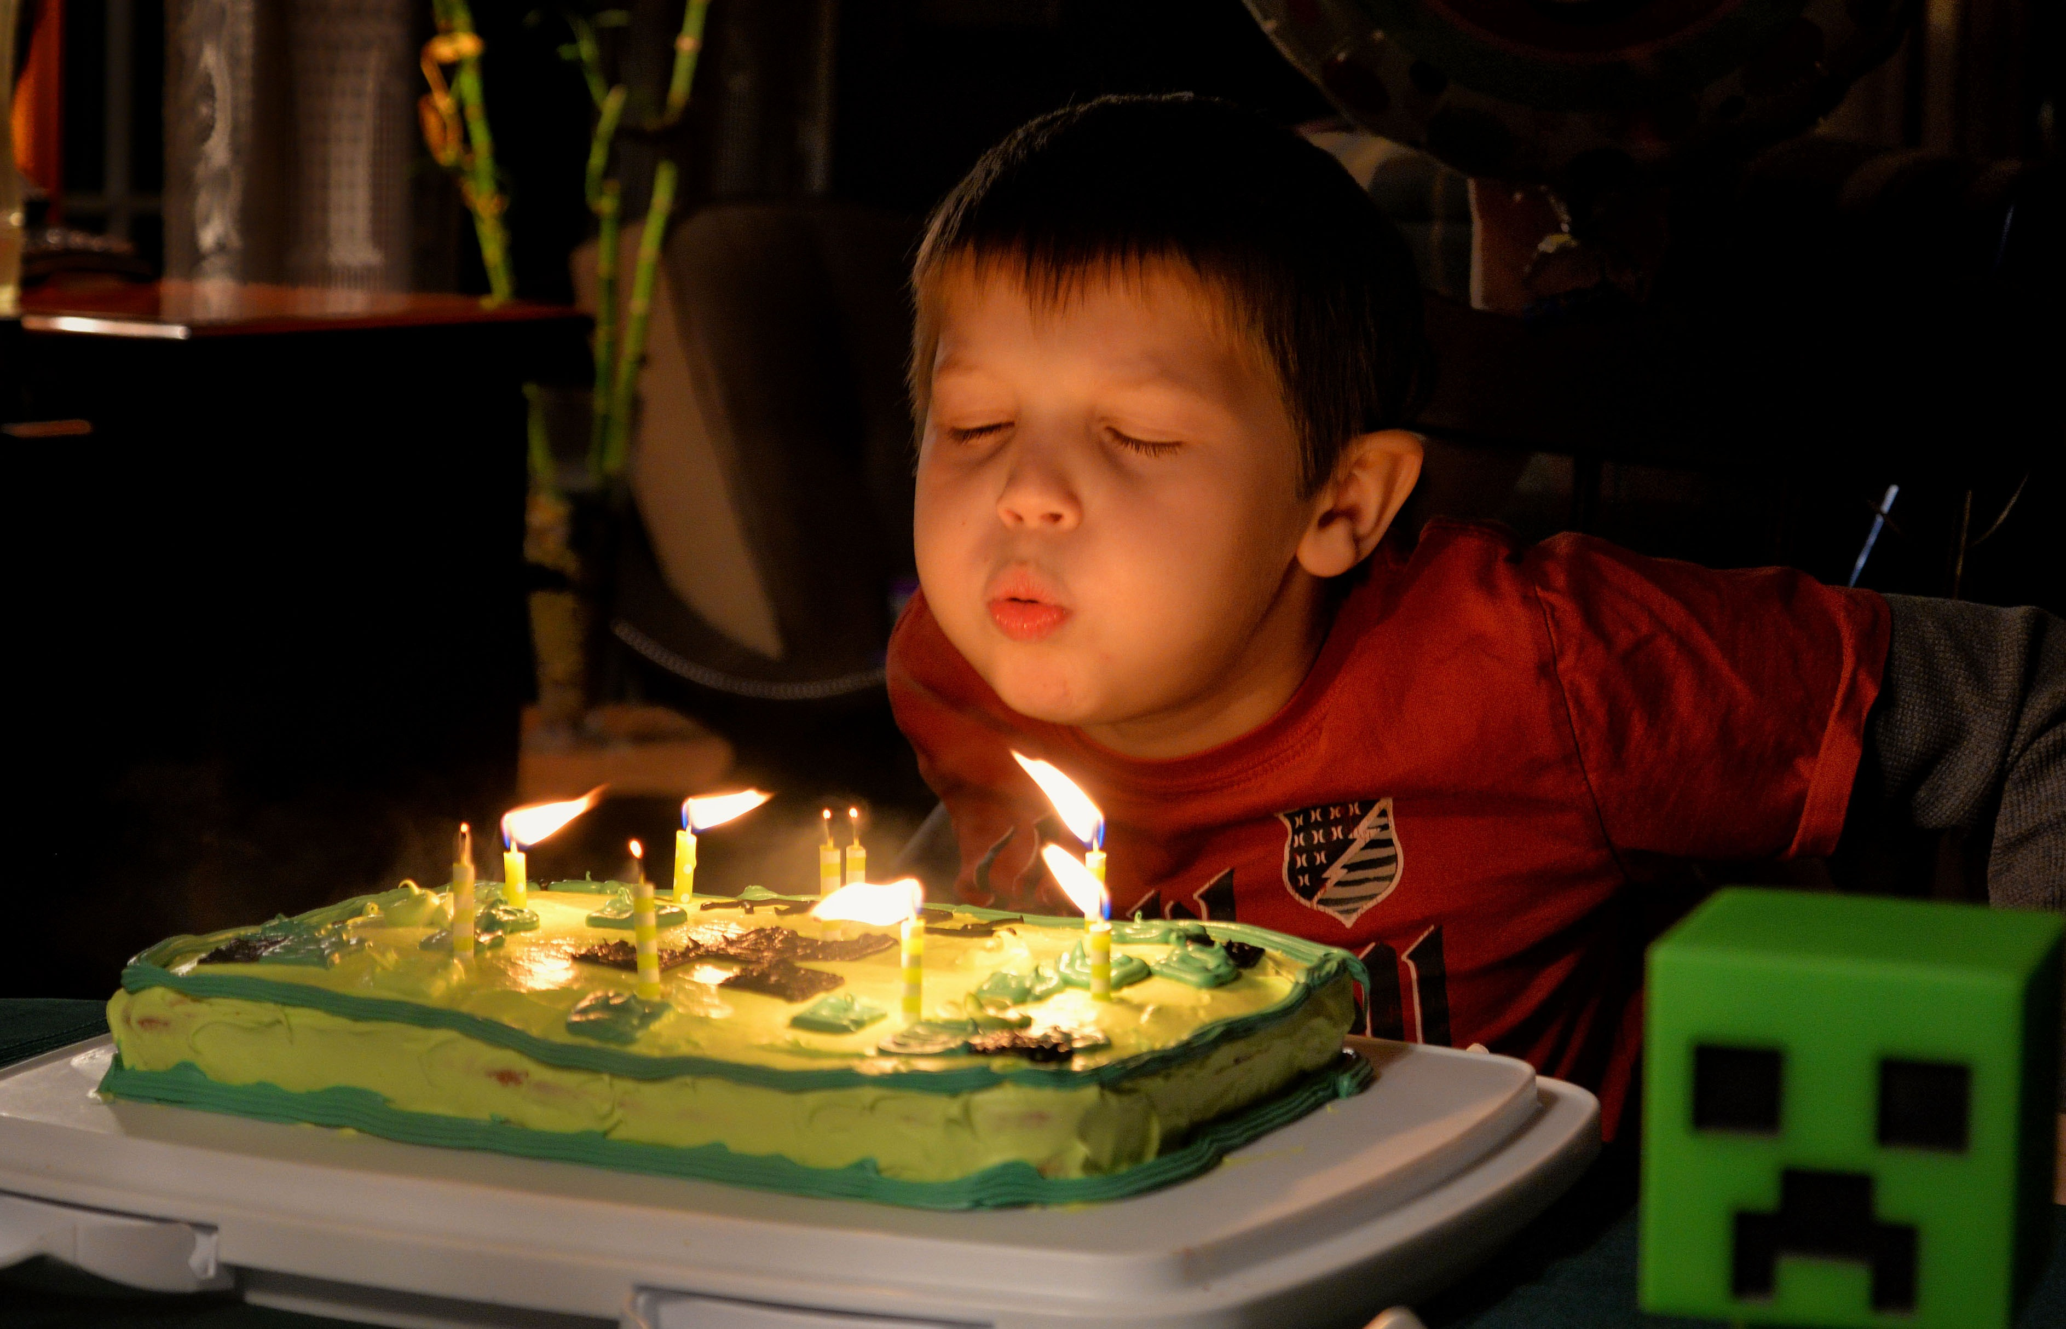

1 Kiran’s Age Riddles

Student Task Statement
Solve Kiran’s age riddles. Show your thinking. Use a number line if it helps.
- I’m 7. My sister is 5 years older than I am. How old is she?
- __________ years old
- If you add 27 years to my sister’s age, you get my mom’s age. How old is my mom?
- __________ years old
- My brother is 24 years younger than my mom. How old is my brother?
- __________ years old
- My grandma is 53 years older than my brother. How old is my grandma?
- __________ years old
- My uncle is 21 years younger than my grandma. How old is my uncle?
- __________ years old
- My uncle is 33 years older than my cousin. How old is my cousin?
- __________ years old
- There is a 50 year difference between my grandpa’s age and my cousin’s age. How old is my grandpa?
- __________ years old

2 Write Riddles

Student Task Statement
- Complete the table by writing down 4 people you know with different ages.
- person's first name | - age (years)
- Come up with 3 mathematical questions to ask your partner.
- Question 1:
- Question 2:
- Question 3:
- Solve your partner's riddles. Show your thinking using a number line or equation.
© CC BY 2021 Illustrative Mathematics®

