Unit 2 Lesson 1: Add and Subtract to Compare

WU Which One Doesn’t Belong: Compare Representations (Warm up)

Student Task Statement
Which one doesn’t belong?
A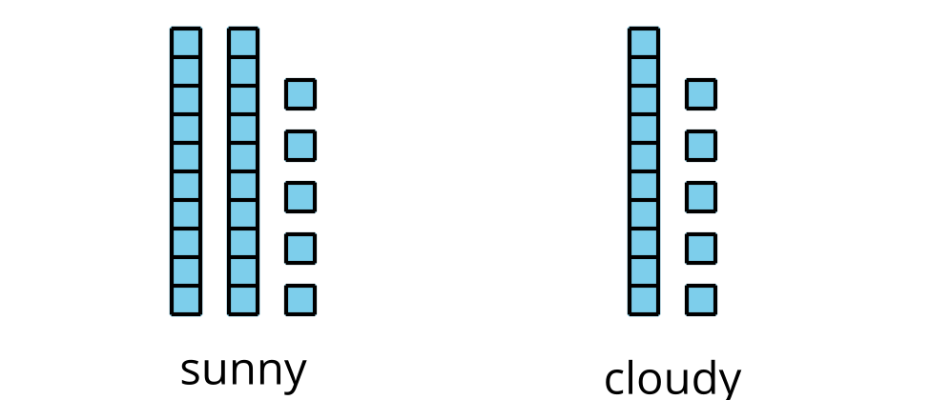
B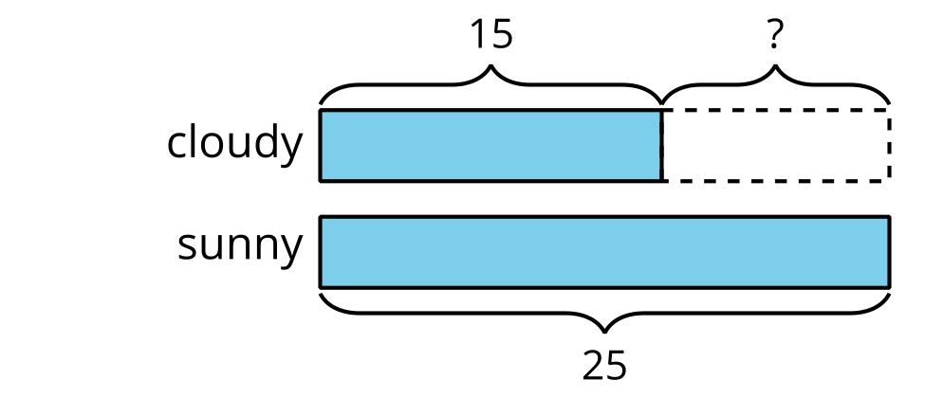
C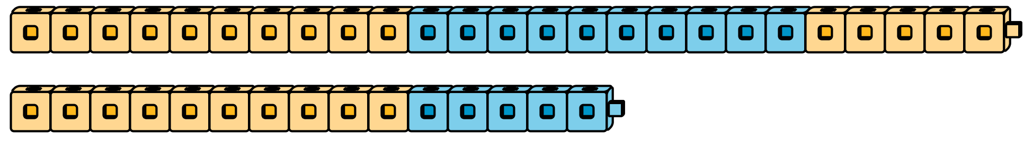
D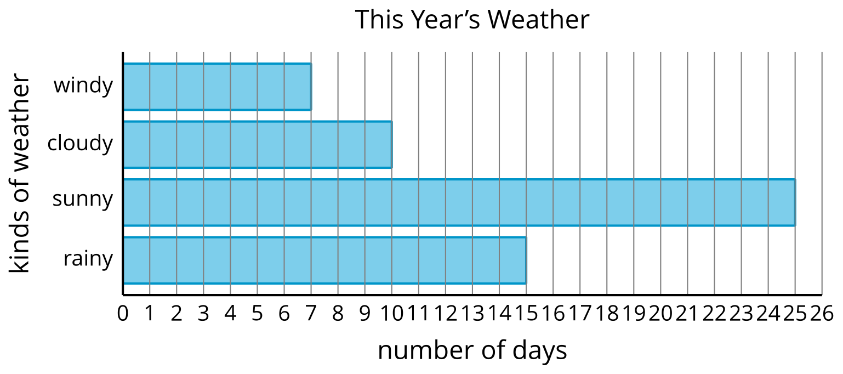

1 Movie Snacks

Student Task Statement
Use the bar graph to answer the questions.
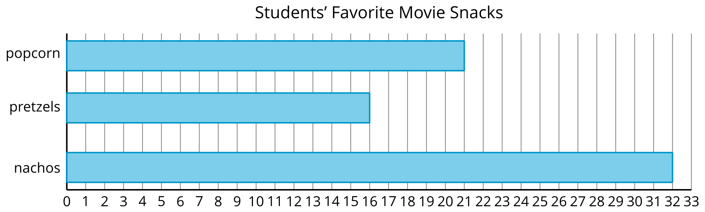
- What is the total number of students that chose popcorn or pretzels? Show your thinking.
- How many more students chose nachos than chose popcorn? Show your thinking.
- 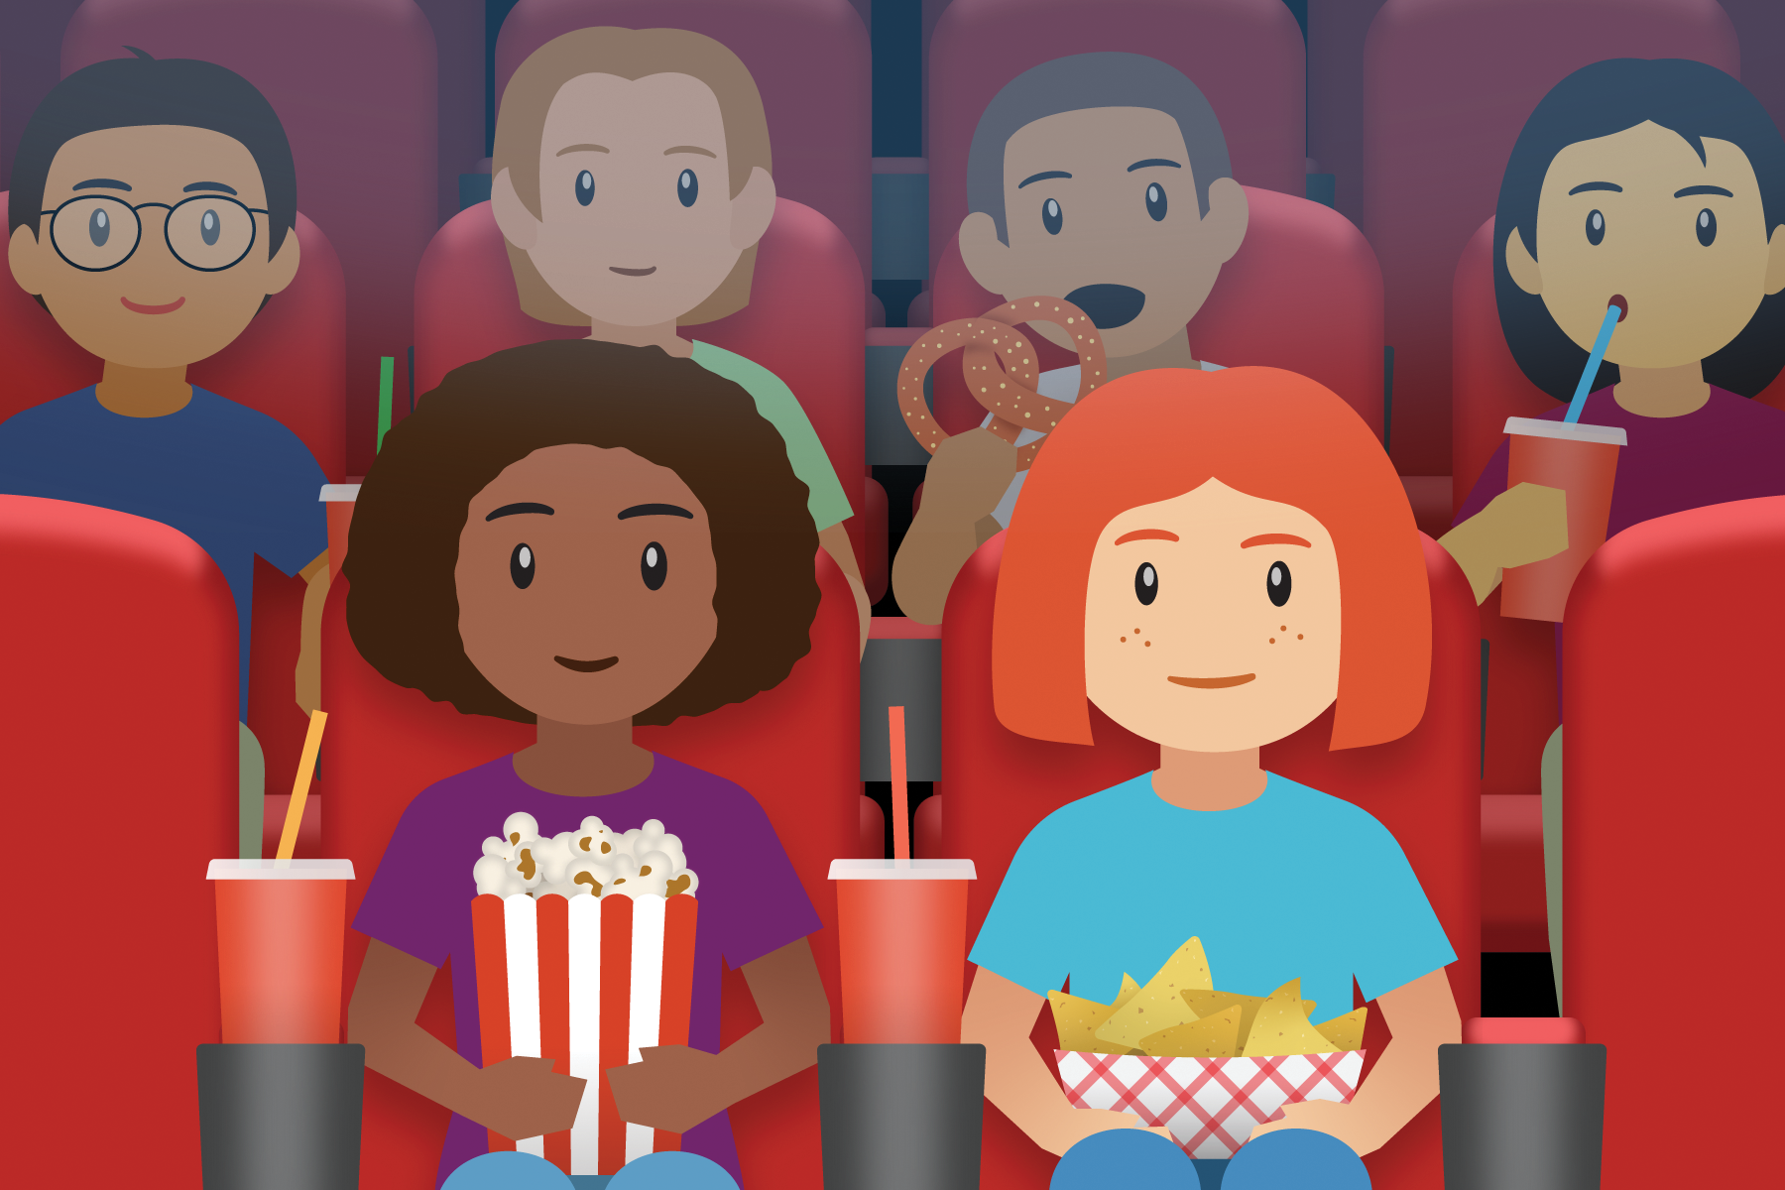

2 Build and Compare

Student Task Statement
- Lin and Clare used cubes to make trains. What do you notice? What do you wonder?
- 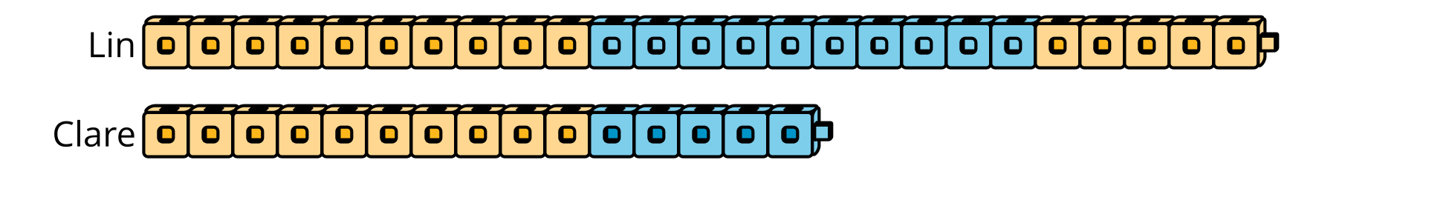
- Make trains with cubes.
- partner | - number of cubes
- Partner A | - 46
- Partner B | - 22
- Find the total number of cubes you and your partner used. Show your thinking.
- Find the difference between the number of cubes you and your partner used. Show your thinking.
© CC BY 2021 Illustrative Mathematics®

