Lesson 14: Problems about Fractional Measurement Data
- Let’s solve problems involving measurement data on line plots.

Warm-up: Notice and Wonder: Shoe Sizes
What do you notice? What do you wonder?
US youth shoe size | insole length in inches
1 | $7\frac{6}{8}$
1.5 | 8
2 | $8\frac{1}{8}$
2.5 | $8\frac{2}{8}$
3 | $8\frac{4}{8}$
3.5
4 | $8\frac{6}{8}$
4.5 | 9
5 | $9\frac{1}{8}$
5.5
6 | $9\frac{4}{8}$
6.5 | $9\frac{5}{8}$
7 | $9\frac{6}{8}$
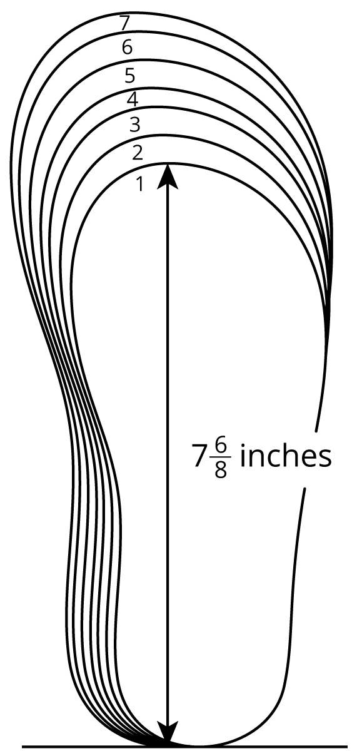

14.1: Shoe Lengths
Students in a fourth-grade class collected data on their shoe sizes and lengths. They plotted the shoe lengths on a line plot.
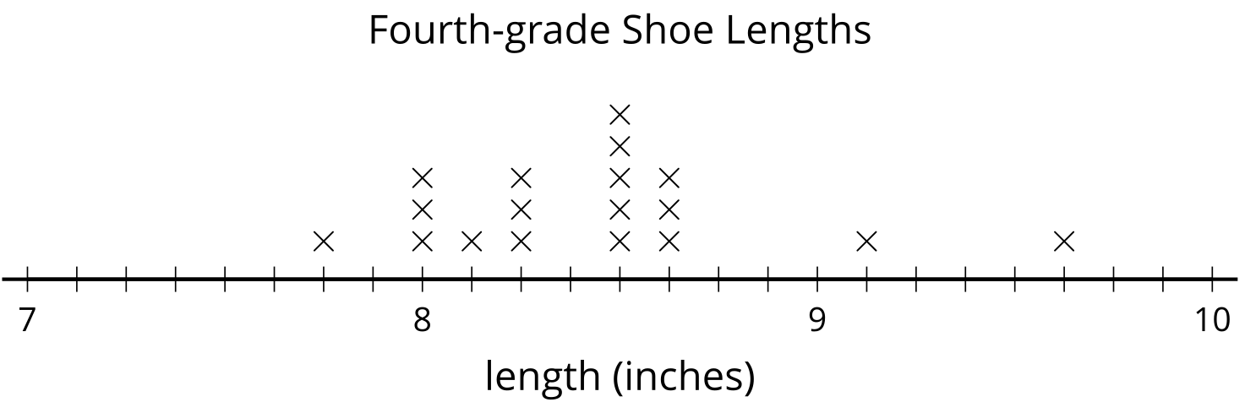
The line plot is missing the shoe lengths of six students:
9 | $9\frac{1}{8}$ | $8\frac{6}{8}$ | $7\frac{6}{8}$ | $9\frac{2}{8}$ | $8\frac{1}{8}$

- Complete the line plot with the missing data.
- Use the completed line plot to answer the following questions:
  - What is the largest shoe length?
  - What is the smallest shoe length?
  - What is the difference between the largest and smallest shoe lengths? Explain or show your reasoning.
  - The student who recorded 9 inches for her shoe length made a mistake when reading the shoe chart. Her actual shoe length is $\frac{7}{8}$ inches shorter.
  - What’s her shoe length? Plot her corrected data point on the line plot.

14.2: Larger Shoes, Anyone?
Ten students recorded their shoe lengths in third grade and then again in fourth grade.
They found how much their feet have grown over a year and organized the data in a table and on a line plot.
student | change in shoe length (inches)
Jada | $\frac{5}{4}$
Priya | $\frac{7}{8}$
Andre | $\frac{3}{4}$
Elena | $\frac{1}{2}$
Han | $1\frac{2}{8}$

student | change in shoe length (inches)
Clare | $1$
Tyler | $1\frac{1}{8}$
Kiran | $\frac{6}{8}$
Diego | $1\frac{1}{4}$
Lin | $\frac{5}{8}$
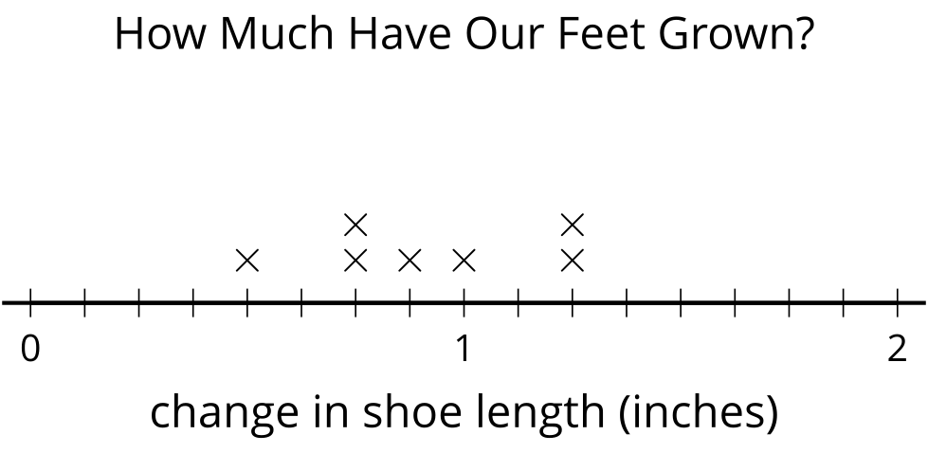
- The line plot shows only seven points. Whose information is missing? Add the three missing points to the line plot.
- If Han’s shoe length now is $9\frac{1}{8}$ inches, what was his shoe length in third grade?
- If Priya’s shoe length was $7\frac{6}{8}$ inches last year, what’s her shoe length this year?
- Tyler made a calculation error. What he recorded, $1\frac{1}{8}$ inches, was $\frac{3}{8}$ inches off from the actual change in shoe length.
  - What could be the actual change in his shoe length? Explain or show your reasoning.
  - How does his error affect the line plot? Explain your reasoning.

Section Summary
Section Summary
In this section, we added and subtracted fractions with the same denominator, using number lines to help with our reasoning.
First, we learned that a fraction can be decomposed into a sum of smaller fractions. For example, here are a few ways to write $\frac{6}{10}$:
$\frac{6}{10}=\frac{4}{10}+\frac{2}{10}$
$\frac{6}{10}=\frac{5}{10}+\frac{1}{10}$
$\frac{6}{10}=\frac{2}{10}+\frac{2}{10}+\frac{2}{10}$
If the fraction is greater than 1, it can be decomposed into a whole number and a fraction less than 1. For instance, we can decompose $\frac{17}{10}$ and rewrite it as $1\frac{7}{10}$. A number such as $1\frac{7}{10}$ is called a mixed number.
$\frac{10}{10}+\frac{7}{10}$
$1+\frac{7}{10}$
$1\frac{7}{10}$
Later, we decomposed fractions into sums and wrote equivalent fractions to help us add and subtract fractions. For example, to find the value of $1\frac{2}{5}−\frac{3}{5}$, we can:
- Decompose $1\frac{2}{5}$ into $1+\frac{2}{5}$ or $\frac{5}{5}+\frac{2}{5}$, which is $\frac{7}{5}$.
- Find the value of $\frac{7}{5}−\frac{3}{5}$, which is $\frac{4}{5}$.
Finally, we organized and analyzed measurement data on line plots. The data were lengths measured to the nearest inch, $\frac{1}{2}$ inch, $\frac{1}{4}$ inch, and $\frac{1}{8}$ inch.
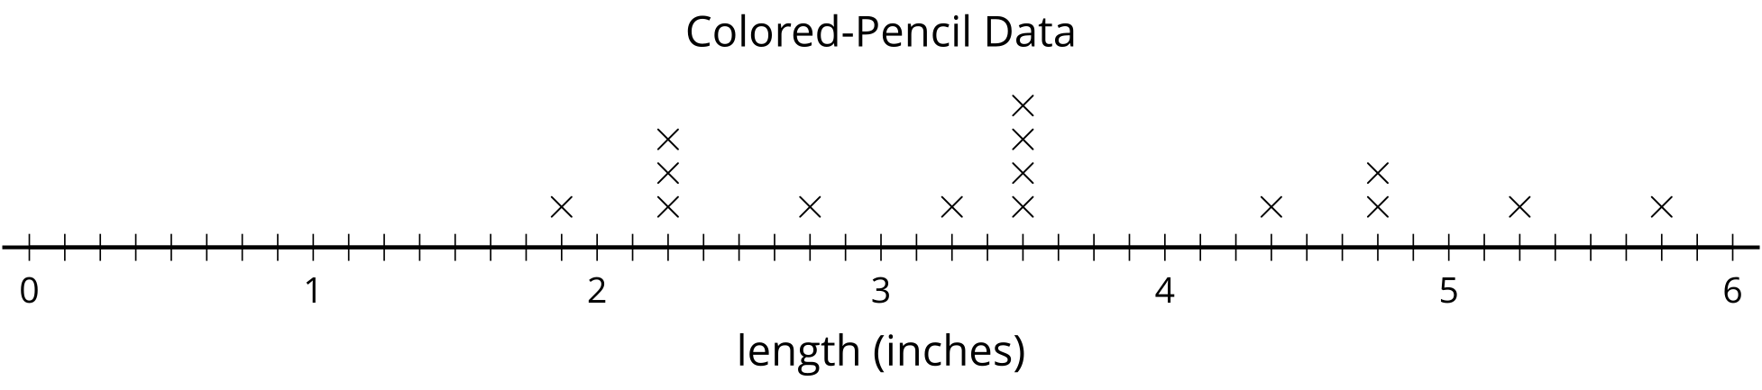
Because the measurements have different denominators, we used equivalent fractions to plot them. Then, we used the line plots and what we know about addition and subtraction of fractions to solve problems about the data.
© CC BY 2021 Illustrative Mathematics®

