Unit 5 Lesson 4: Solve Multiplicative Comparison Problems with Large Numbers

WU Notice and Wonder: Too Many Times More? (Warm up)

Student Task Statement
What do you notice? What do you wonder?
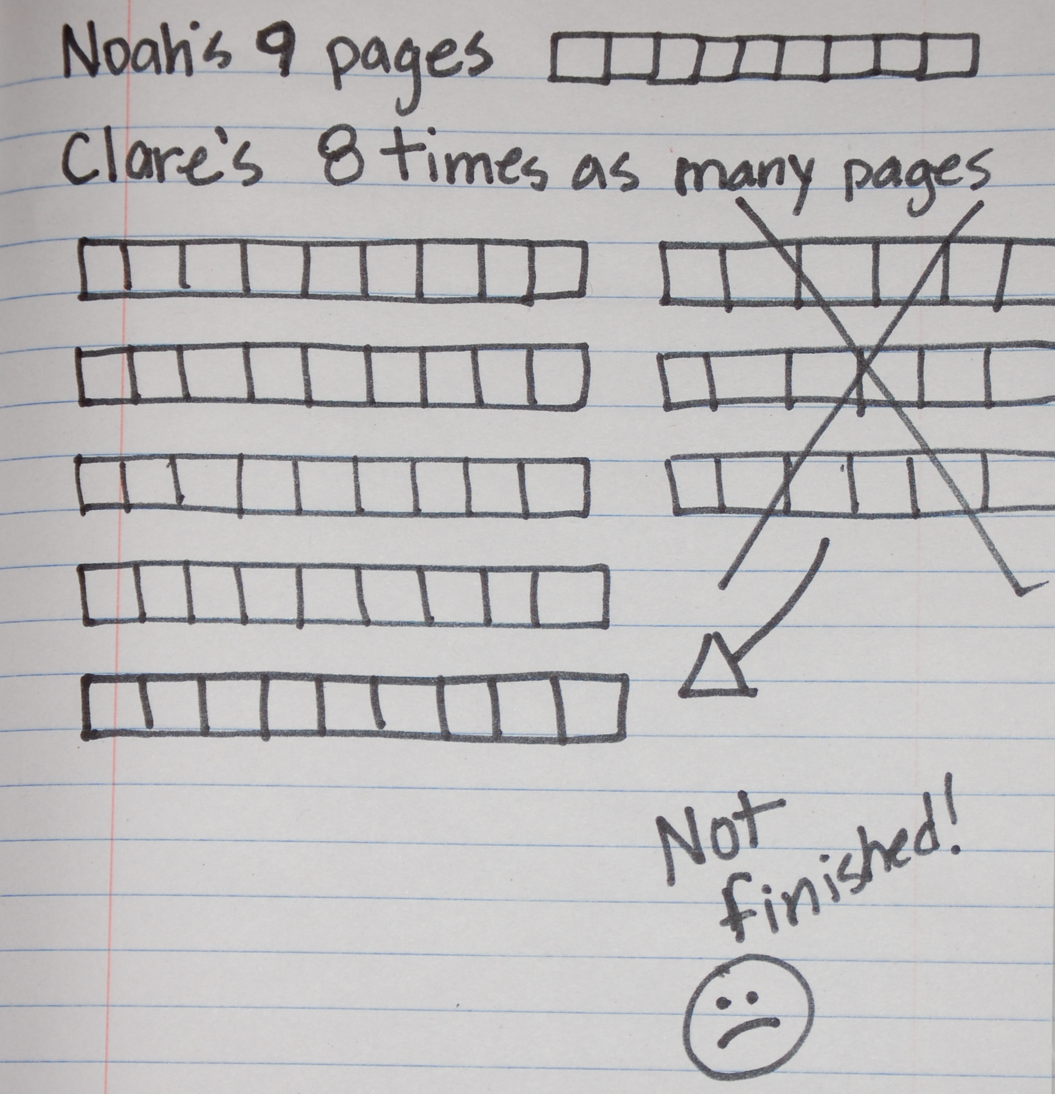

1 A New Kind of Diagram

Student Task Statement
- Mai and Andre compare the number of pages they read on the first day of the reading competition.
- 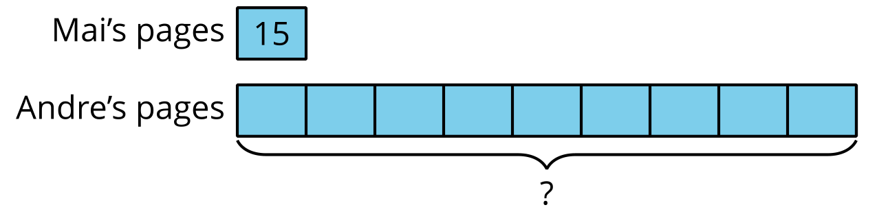
- What would be a good estimate for the number of pages Andre read?
- The diagram shows the pages Lin and Kiran read on one day of the reading competition.
- 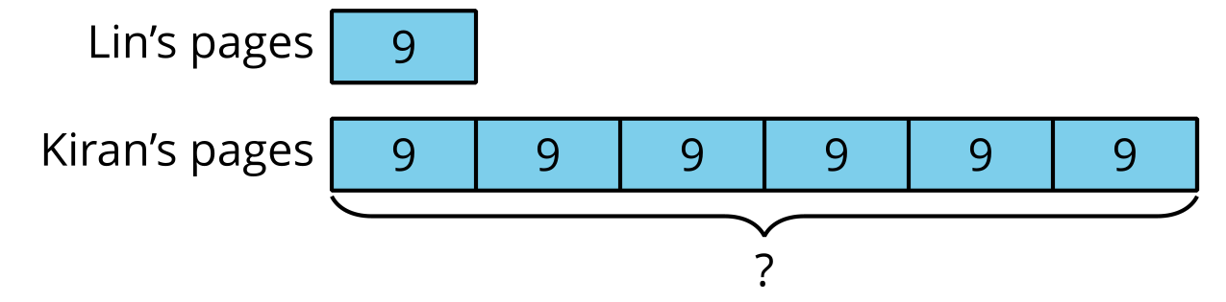
  - Complete the statement and explain how you know.
  - Kiran read _____ times as many pages as Lin.
  - Write a multiplication equation that compares the pages read by Lin and Kiran.
  - How many total pages did Kiran read?
- Jada read some pages. Han read 60 pages altogether.​​​​​​
- 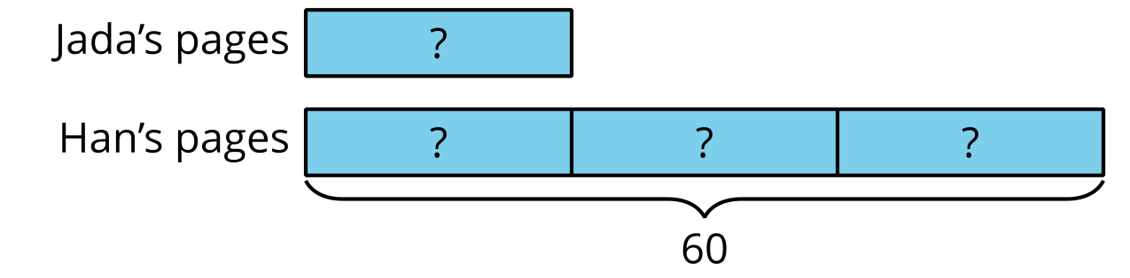
  - How many times as many pages did Han read? Explain how you know.
  - Write a multiplication equation to compare the pages read by Han and Jada. Use a symbol to represent the unknown.
  - How many pages did Jada read? Explain how you know.
- Elena read 72 pages. Clare read 9 pages.
- 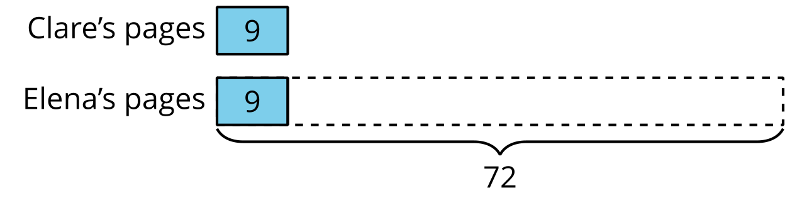
  - How is this diagram different from the earlier diagrams?
  - Write a multiplication equation to compare the pages read by Elena and Clare. Use a symbol to represent the unknown.
  - How many times as many pages does Elena read as Clare?

2 Who Read More?

Student Task Statement
For each situation:
- Write an equation to represent the situation. Use a symbol to represent the unknown.
- Draw a diagram to show the comparison.
- Answer the question about the situation.
- Diego read 8 times as many books as Lin read. Lin read 7 books.
  - Equation:
  - Diagram:
  - How many books did Diego read?
- Tyler has some books. Clare has 72 books, which is 12 times as many books as Tyler has.
  - Equation:
  - Diagram:
  - How many books does Tyler have?
- Noah read 13 books. Elena read 130 books.
  - Equation:
  - Diagram:
  - Complete the statement:
  - _______________ read _____ times as many books as _______________ read.
© CC BY 2021 Illustrative Mathematics®

