Unit 8 Lesson 1: Ways to Look at Figures

WU Which One Doesn’t Belong: Geometric Figures (Warm up)

Student Task Statement
Which one doesn’t belong?
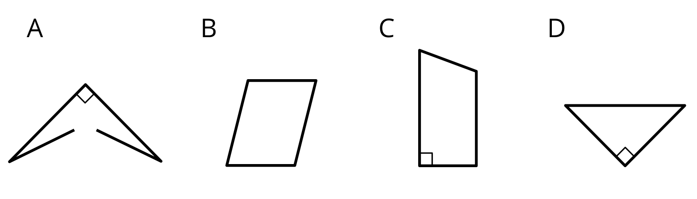

1 Card Sort: Shapes

Student Task Statement
- Sort the shapes from your teacher into 3–5 categories. For each category, write a title on a sticky note.
- Share your categories with another group. Take turns listening to each other’s explanations.
  - Do your categories make sense to them?
  - Do their categories make sense to you?
  - Any suggestions or corrections?
- Cover or hide the titles of your categories. Trade places with another group. Study their sorted cards while they study yours.
- Guess their categories and how they sorted the shapes.

2 Guess the Category

Student Task Statement
Partner A:
- Write down a category from the first activity (or think of a new one). Don’t show it to your partner.
- Find 3 shapes that fit the category and 3 shapes that don’t. Place them in the columns of the table.
Partner B:
- Study the shapes chosen by your partner.
- Pick another shape from the set. Ask: “Does this shape fit in your category?”
- Find 2 shapes that fit the category and 2 shapes that don’t.
- Guess the category. If your guess is off, ask more questions before guessing again.
Switch roles after the category is guessed correctly.
- Partner A’s category:
- $\underset{_}{}$
fit the category | do not fit the category
- Partner B’s category:
- $\underset{_}{}$
fit the category | do not fit the category
© CC BY 2021 Illustrative Mathematics®

