Unit 2 Lesson 11: Interpreting Graphs of Proportional Relationships

1 What Could the Graph Represent? (Warm up)

Student Task Statement
Here is a graph that represents a proportional relationship.
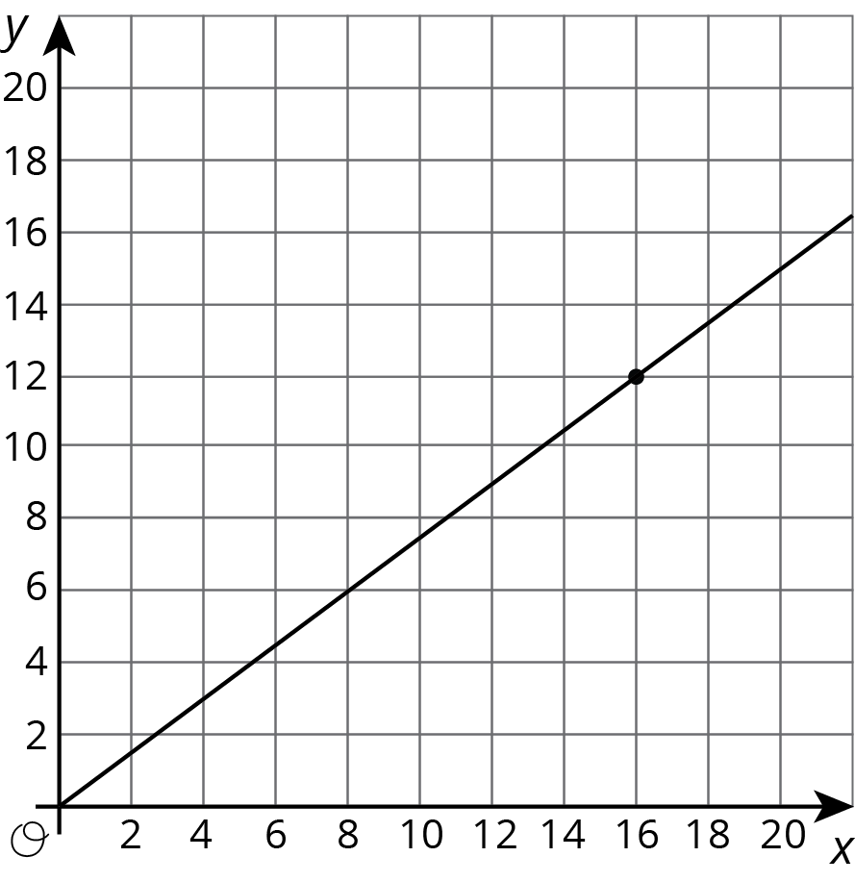
- Invent a situation that could be represented by this graph.
- Label the axes with the quantities in your situation.
- Give the graph a title.
- There is a point on the graph. What are its coordinates? What does it represent in your situation?

2 Tyler's Walk

Student Task Statement
Tyler was at the amusement park. He walked at a steady pace from the ticket booth to the bumper cars.
- The point on the graph shows his arrival at the bumper cars. What do the coordinates of the point tell us about the situation?
- The table representing Tyler's walk shows other values of time and distance. Complete the table. Next, plot the pairs of values on the grid.
- What does the point $(0,0)$ mean in this situation?
- How far away from the ticket booth was Tyler after 1 second? Label the point on the graph that shows this information with its coordinates.
- What is the constant of proportionality for the relationship between time and distance? What does it tell you about Tyler's walk? Where do you see it in the graph?
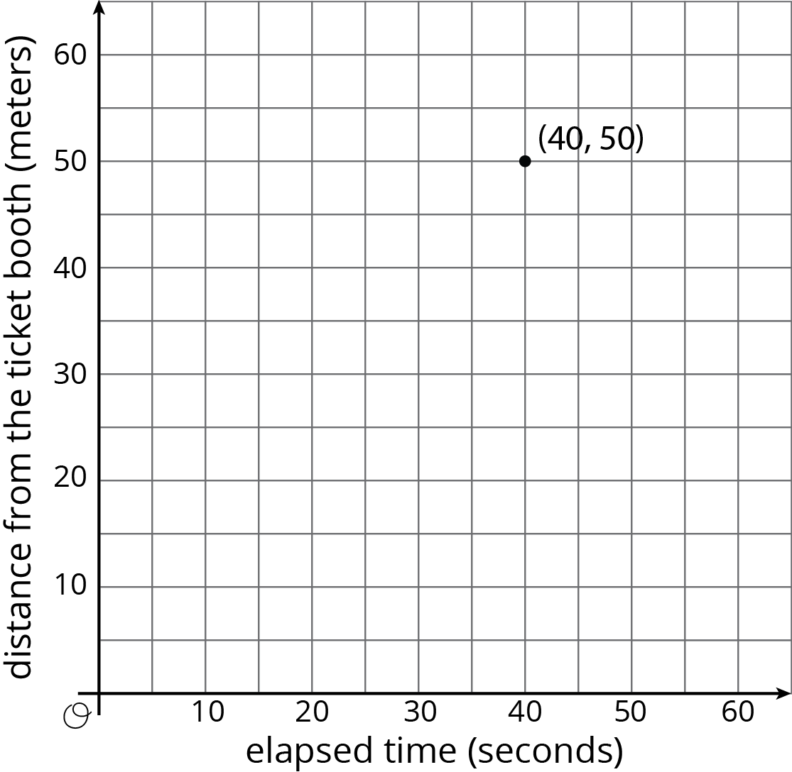
time  (seconds) | distance  (meters)
0 | 0
20 | 25
30 | 37.5
40 | 50
1

3 Seagulls Eat What?

Student Task Statement
4 seagulls ate 10 pounds of garbage. Assume this information describes a proportional relationship.
- Plot a point that shows the number of seagulls and the amount of garbage they ate.
- Use a straight edge to draw a line through this point and $(0,0)$.
- Plot the point $(1,k)$ on the line. What is the value of $k$? What does the value of $k$ tell you about this context?
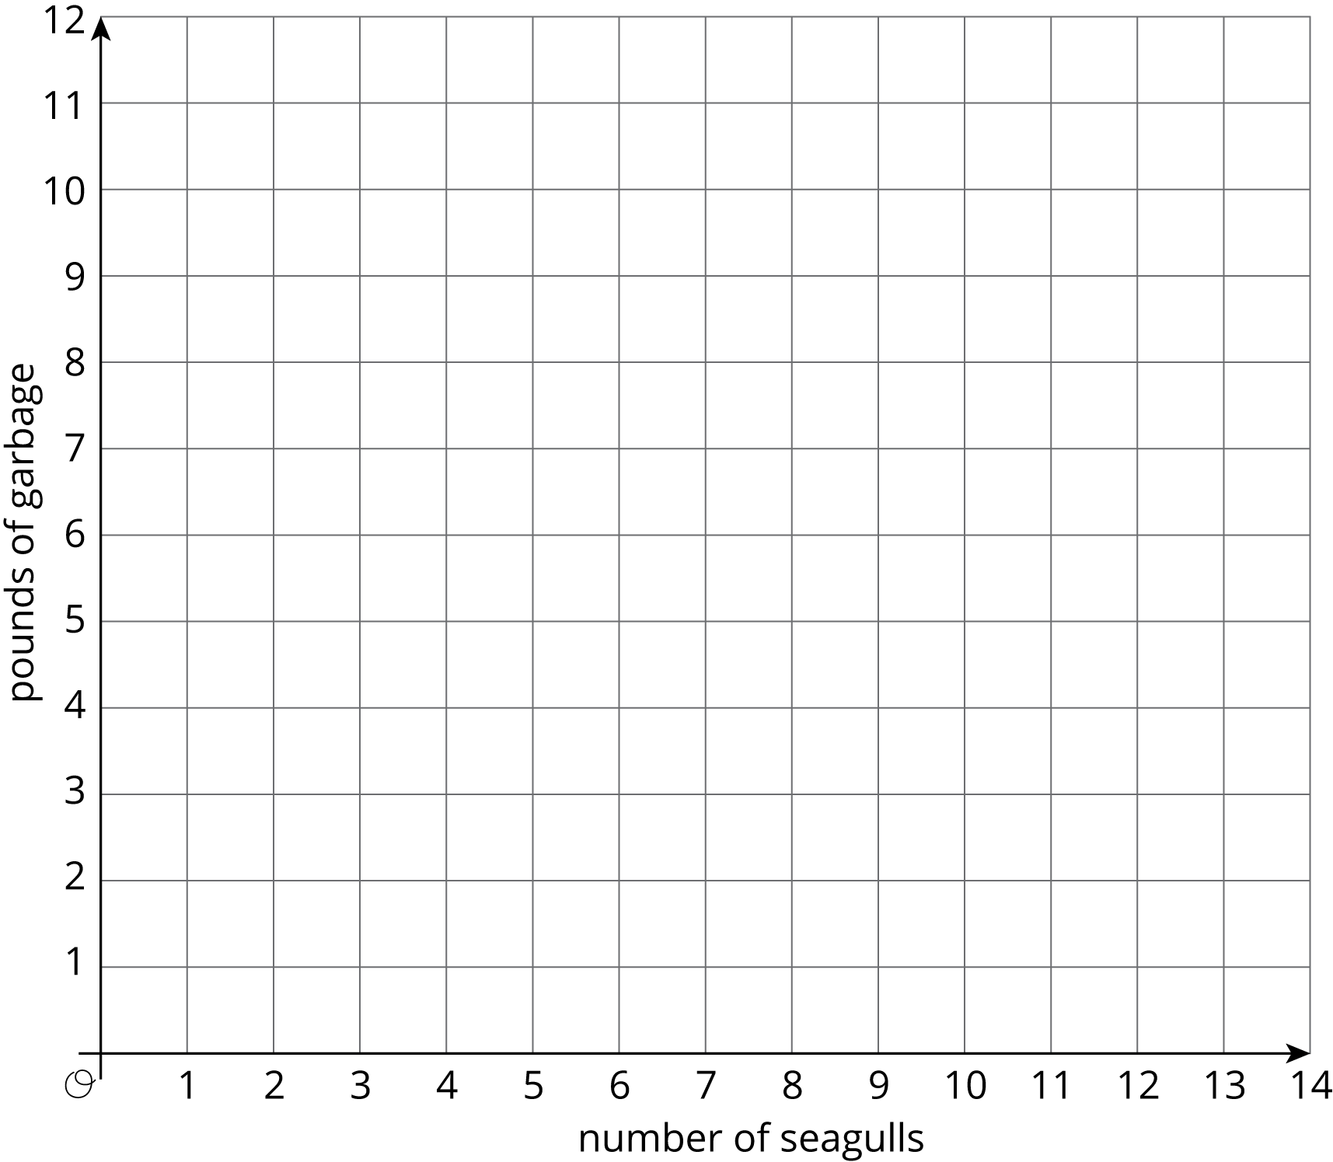
© CC BY Open Up Resources. Adaptations CC BY IM.

