Lesson 7: Building Polygons (Part 2)

7.1: Where Is Lin?
At a park, the slide is 5 meters east of the swings. Lin is standing 3 meters away from the slide.
- Draw a diagram of the situation including a place where Lin could be.
- How far away from the swings is Lin in your diagram?
- Where are some other places Lin could be?

7.2: How Long Is the Third Side?
Your teacher will give you some strips of different lengths and fasteners you can use to attach the corners.
- Build as many different triangles as you can that have one side length of 5 inches and one of 4 inches. Record the side lengths of each triangle you build.
- Are there any other lengths that could be used for the third side of the triangle but weren’t in your set?
- Are there any lengths that were in your set but could not be used as the third side of the triangle?

Are you ready for more?
Assuming you had access to strips of any length, and you used the 9-inch and 5-inch strips as the first two sides, complete the sentences:
- The third side can't be _____ inches or longer.
- The third side can't be _____ inches or shorter.

7.3: Swinging the Sides Around
We’ll explore a method for drawing a triangle that has three specific side lengths. Your teacher will give you a piece of paper showing a 4-inch segment as well as some instructions for which strips to use and how to connect them.
- Follow these instructions to mark the possible endpoints of one side:
  - Put your 4-inch strip directly on top of the 4-inch segment on the piece of paper. Hold it in place.
  - For now, ignore the 3-inch strip on the left side. Rotate it so that it is out of the way.
  - In the 3-inch strip on the right side, put the tip of your pencil in the hole on the end that is not connected to anything. Use the pencil to move the strip around its hinge, drawing all the places where a 3-inch side could end.
  - Remove the connected strips from your paper.
- What shape have you drawn while moving the 3-inch strip around? Why? Which tool in your geometry toolkit can do something similar?
- Use your drawing to create two unique triangles, each with a base of length 4 inches and a side of length 3 inches. Use a different color to draw each triangle.
- Reposition the strips on the paper so that the 4-inch strip is on top of the 4-inch segment again. In the 3-inch strip on the left side, put the tip of your pencil in the hole on the end that is not connected to anything. Use the pencil to move the strip around its hinge, drawing all the places where another 3-inch side could end.
- Using a third color, draw a point where the two marks intersect. Using this third color, draw a triangle with side lengths of 4 inches, 3 inches, and 3 inches.

Lesson 7 Summary
If we want to build a polygon with two given side lengths that share a vertex, we can think of them as being connected by a hinge that can be opened or closed:
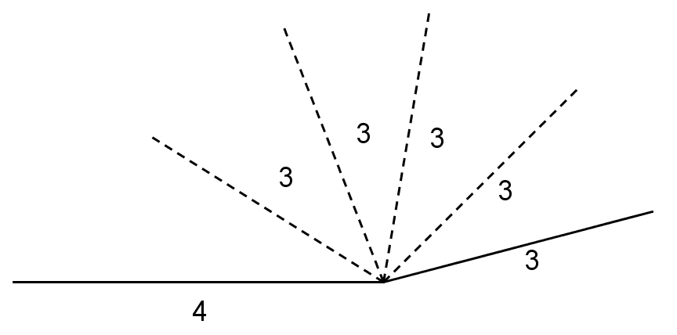
All of the possible positions of the endpoint of the moving side form a circle:
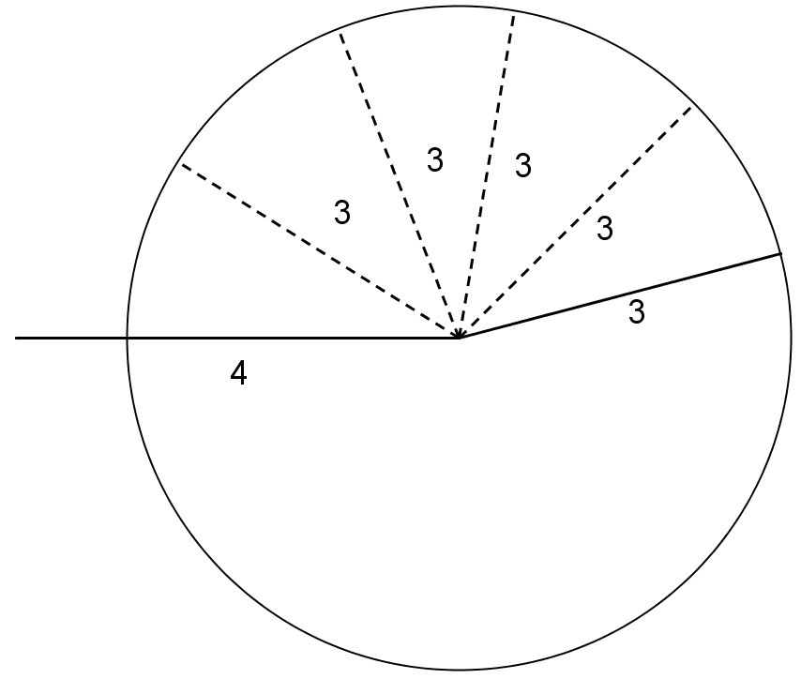

You may have noticed that sometimes it is not possible to build a polygon given a set of lengths. For example, if we have one really, really long segment and a bunch of short segments, we may not be able to connect them all up. Here's what happens if you try to make a triangle with side lengths 21, 4, and 2:
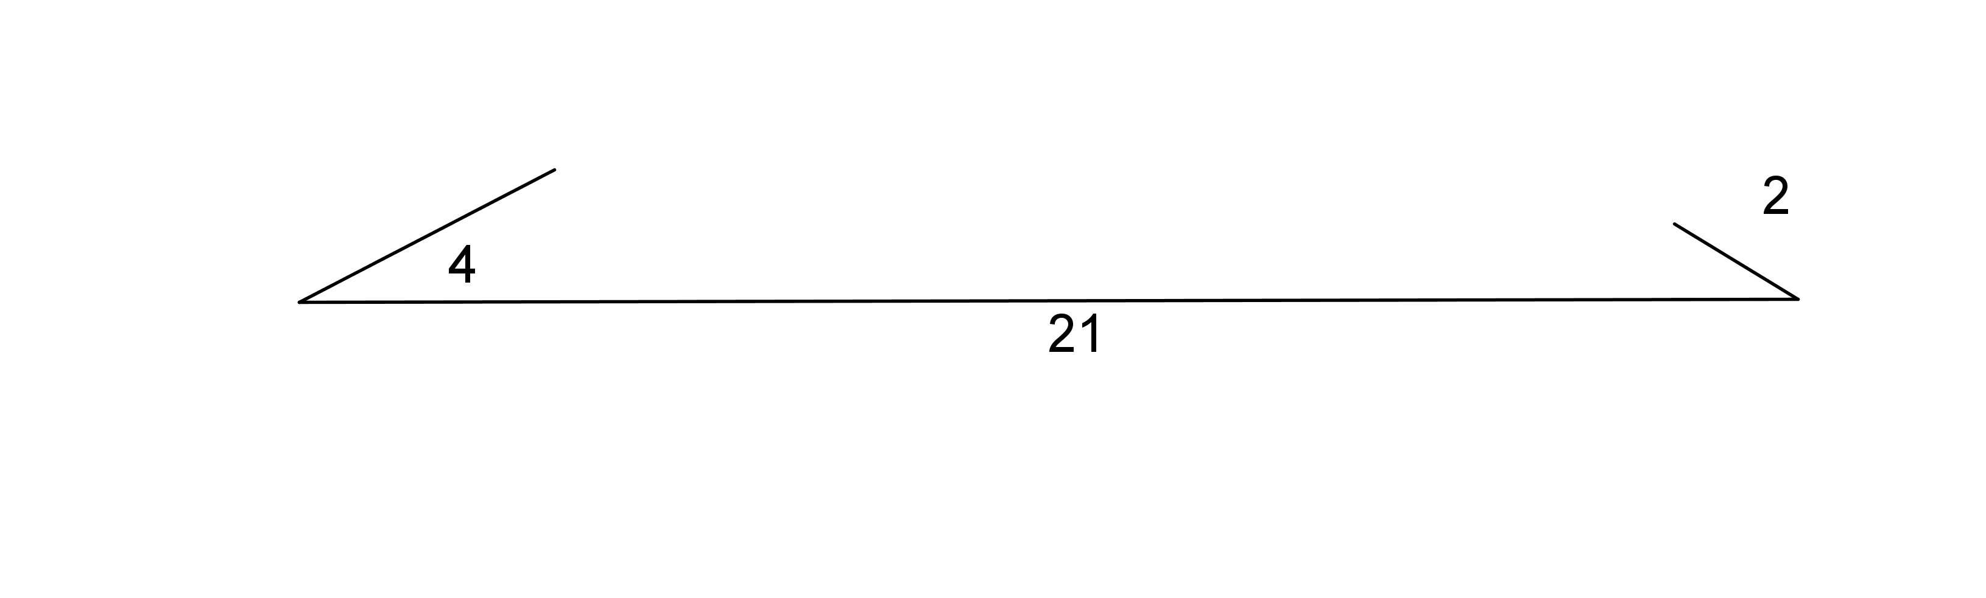
The short sides don't seem like they can meet up because they are too far away from each other.
If we draw circles of radius 4 and 2 on the endpoints of the side of length 21 to represent positions for the shorter sides, we can see that there are no places for the short sides that would allow them to meet up and form a triangle.
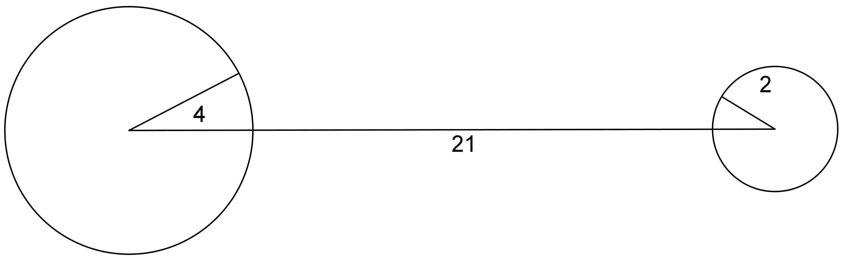
In general, the longest side length must be less than the sum of the other two side lengths. If not, we can’t make a triangle!
If we can make a triangle with three given side lengths, it turns out that the measures of the corresponding angles will always be the same. For example, if two triangles have side lengths 3, 4, and 5, they will have the same corresponding angle measures.
© CC BY Open Up Resources. Adaptations CC BY IM.

