Unit 4 Lesson 11: Using an Algorithm to Divide Fractions

1 Multiplying Fractions (Warm up)

Student Task Statement
Evaluate each expression.
- $\frac{2}{3}⋅27$
- $\frac{1}{2}⋅\frac{2}{3}$
- $\frac{2}{9}⋅\frac{3}{5}$
- $\frac{27}{100}⋅\frac{200}{9}$
- $\left(1\frac{3}{4}\right)⋅\frac{5}{7}$

2 Dividing a Fraction by a Fraction

Student Task Statement
Work with a partner. One person works on the questions labeled “Partner A” and the other person works on those labeled “Partner B.”
- Partner A: Find the value of each expression by completing the diagram.

  - $\frac{3}{4}÷\frac{1}{8}$
  - How many $\frac{1}{8}$s in $\frac{3}{4}$?
  - 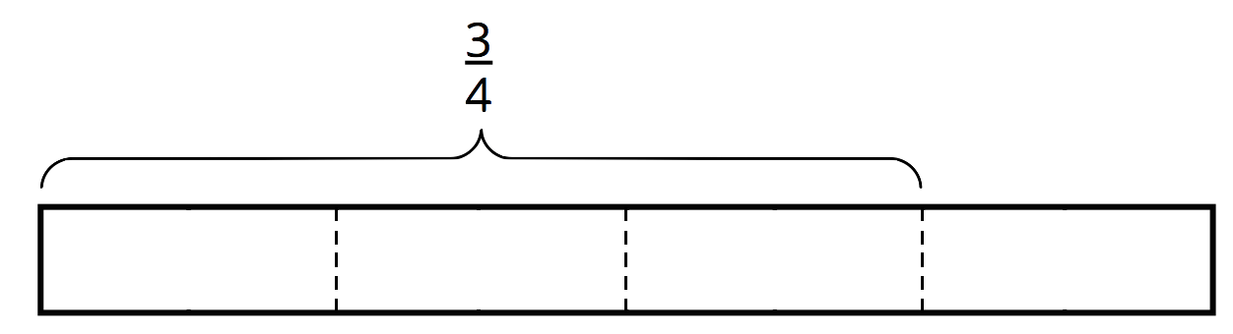

  - $\frac{9}{10}÷\frac{3}{5}$
  - How many $\frac{3}{5}$s in $\frac{9}{10}$?
  - 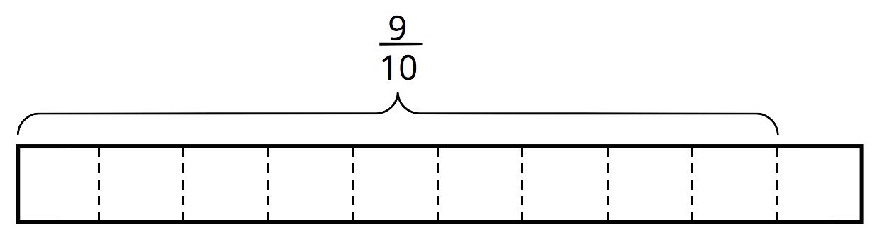
- Partner B:
- Elena said, “If I want to divide 4 by $\frac{2}{5}$, I can multiply 4 by 5 and then divide it by 2 or multiply it by $\frac{1}{2}$.”
- Find the value of each expression using the strategy Elena described.
  - $\frac{3}{4}÷\frac{1}{8}$
  - $\frac{9}{10}÷\frac{3}{5}$
- What do you notice about the diagrams and expressions? Discuss with your partner.
- Complete this sentence based on what you noticed:
- To divide a number $n$ by a fraction $\frac{a}{b}$, we can multiply $n$ by ________ and then divide the product by ________.
- Select all the equations that represent the sentence you completed.
  - $n÷\frac{a}{b}=n⋅b÷a$
  - $n÷\frac{a}{b}=n⋅a÷b$
  - $n÷\frac{a}{b}=n⋅\frac{a}{b}$
  - $n÷\frac{a}{b}=n⋅\frac{b}{a}$

3 Using an Algorithm to Divide Fractions

Student Task Statement
Calculate each quotient. Show your thinking and be prepared to explain your reasoning.
- $\frac{8}{9}÷4$
- $\frac{3}{4}÷\frac{1}{2}$
- $3\frac{1}{3}÷\frac{2}{9}$
- $\frac{9}{2}÷\frac{3}{8}$
- $6\frac{2}{5}÷3$
- After biking $5\frac{1}{2}$ miles, Jada has traveled $\frac{2}{3}$ of the length of her trip. How long (in miles) is the entire length of her trip? Write an equation to represent the situation, and then find the answer.
© CC BY Open Up Resources. Adaptations CC BY IM.

