Unit 5 Lesson 1: Make 2 Parts

WU Notice and Wonder: 2 Pictures (Warm up)

Student Task Statement
What do you notice?
What do you wonder?
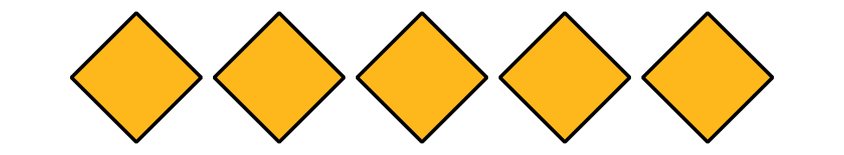
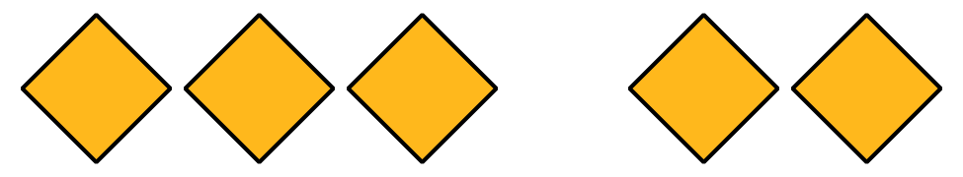

1 6 Connecting Cubes

Student Task Statement

2 Diego’s and Lin’s Connecting Cubes

Student Task Statement
Diego’s cubes
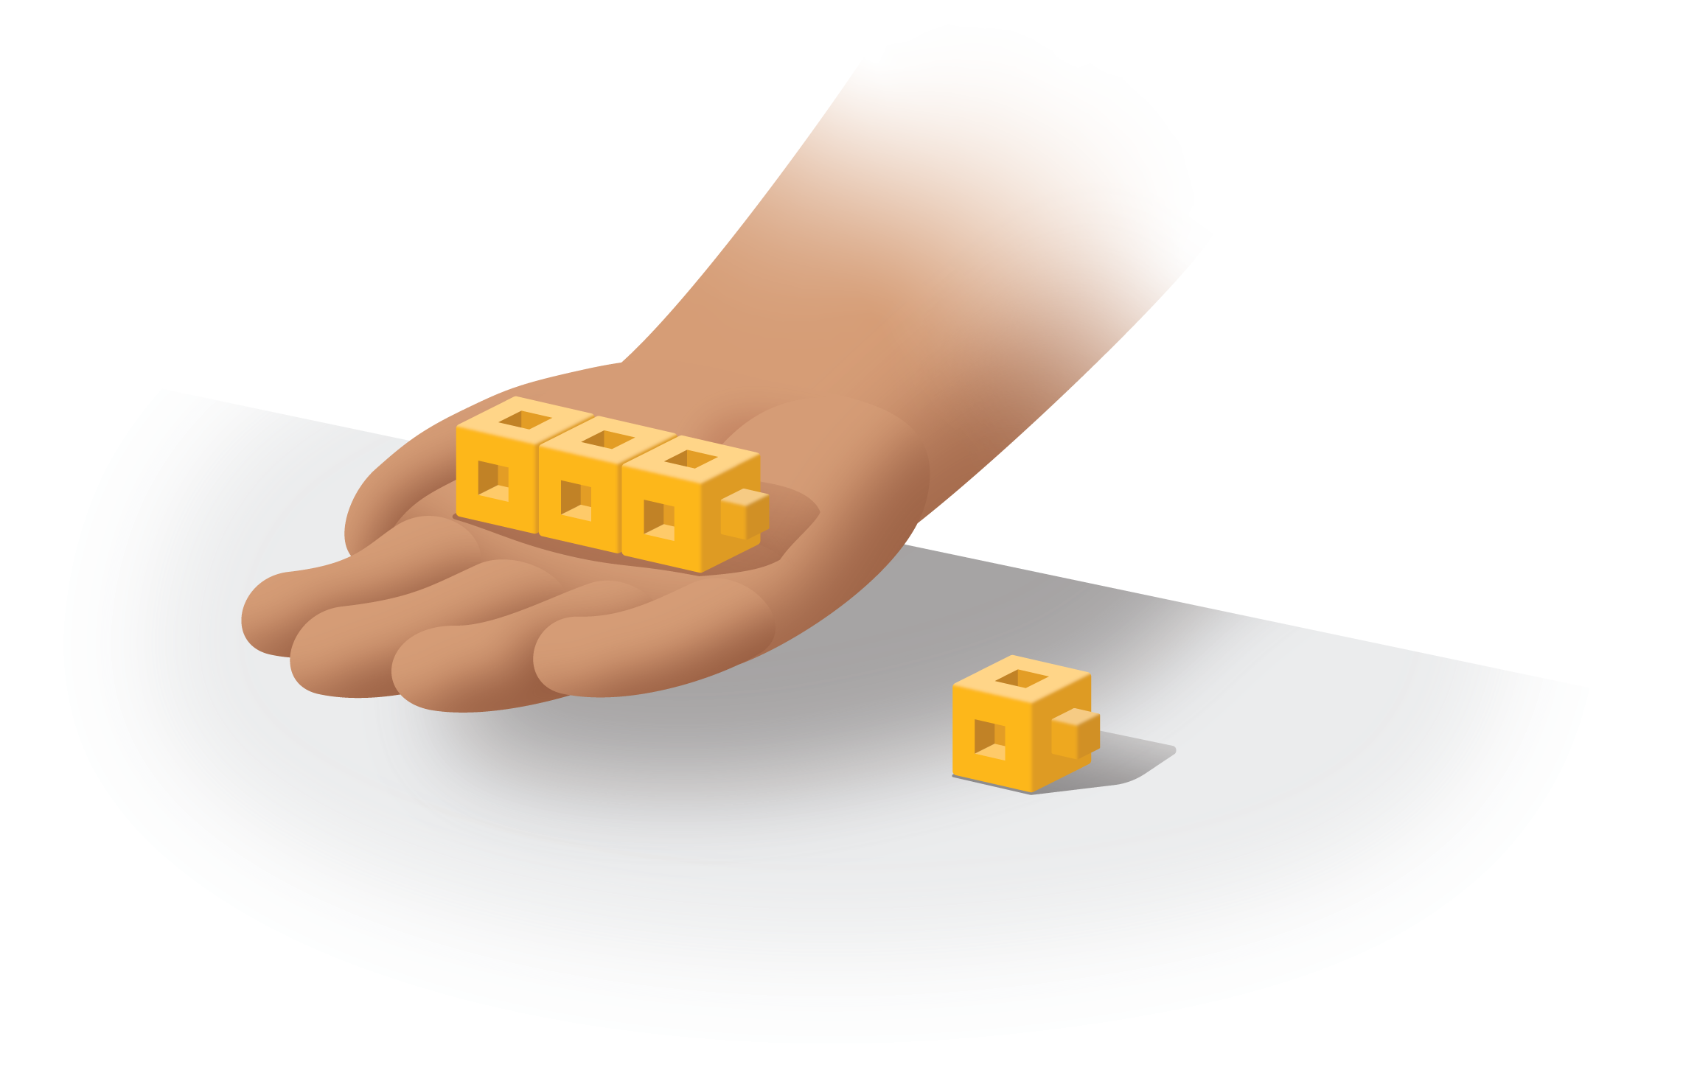
Lin’s cubes
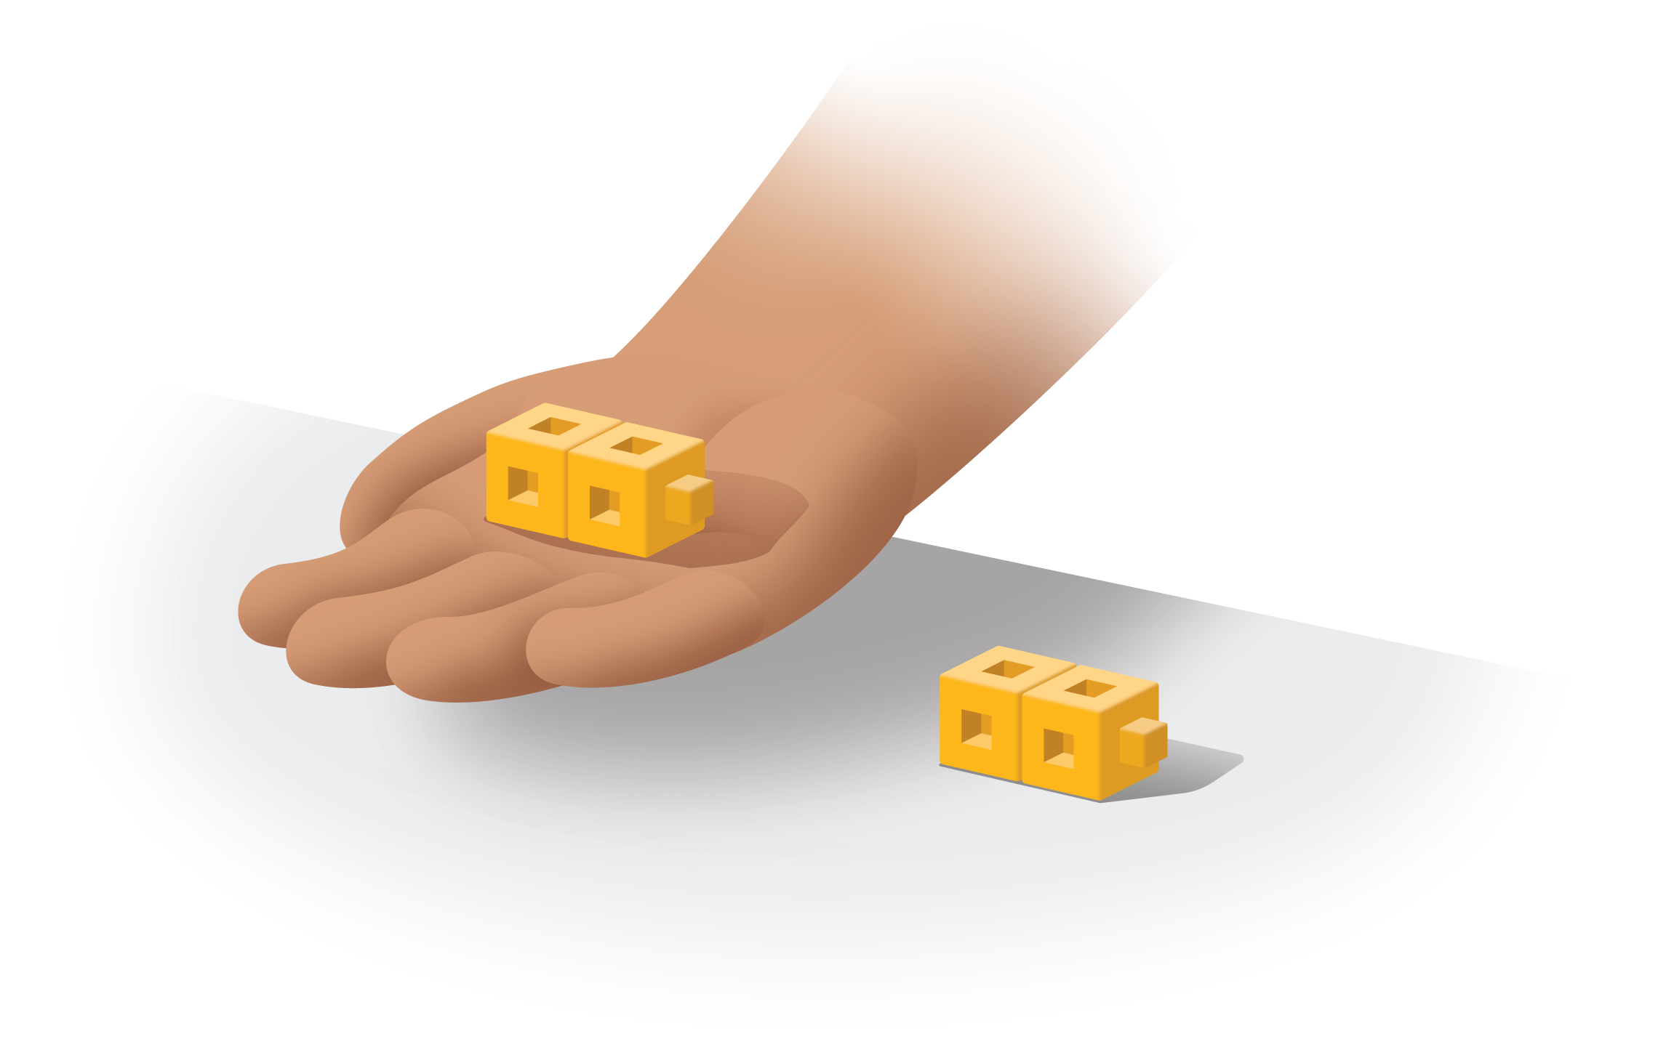

3 Introduce Check It Off, Add Within 10

Student Task Statement
Choose a center.
Check it Off
Bingo
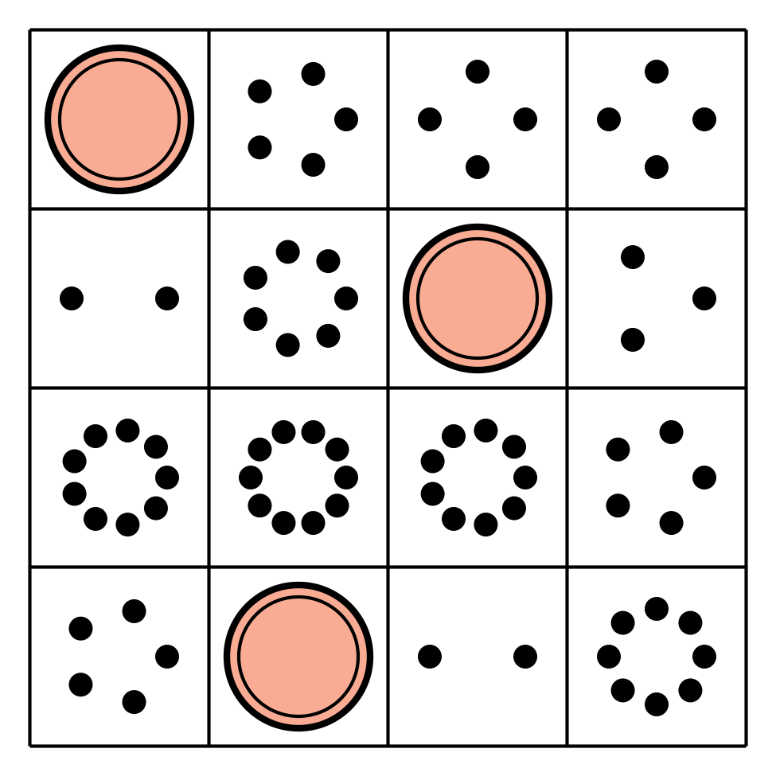
Find the Value of
Expressions
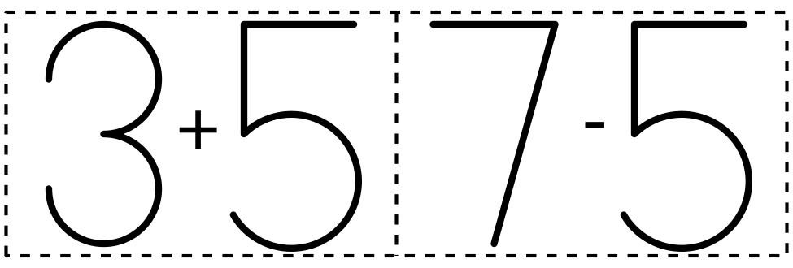
Shake and Spill
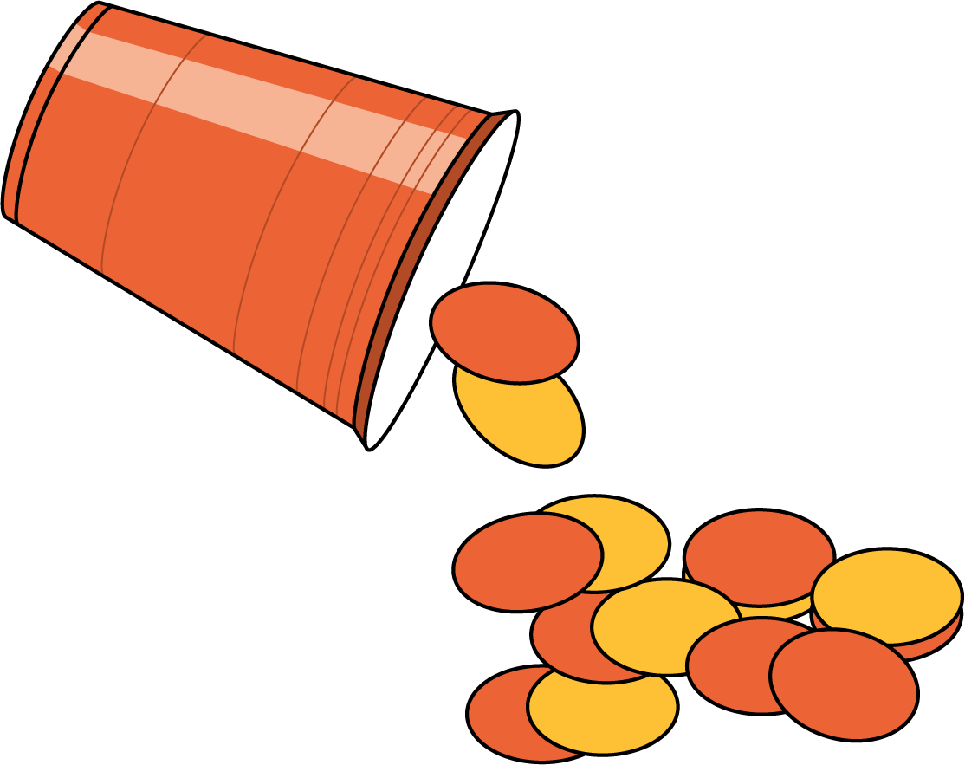
© CC BY 2021 Illustrative Mathematics®

