Lesson 1: Make 2 Parts
- Let’s break numbers up into parts.

Warm-up: Notice and Wonder: 2 Pictures
What do you notice?
What do you wonder?

1.2: Diego’s and Lin’s Connecting Cubes
Diego’s cubes
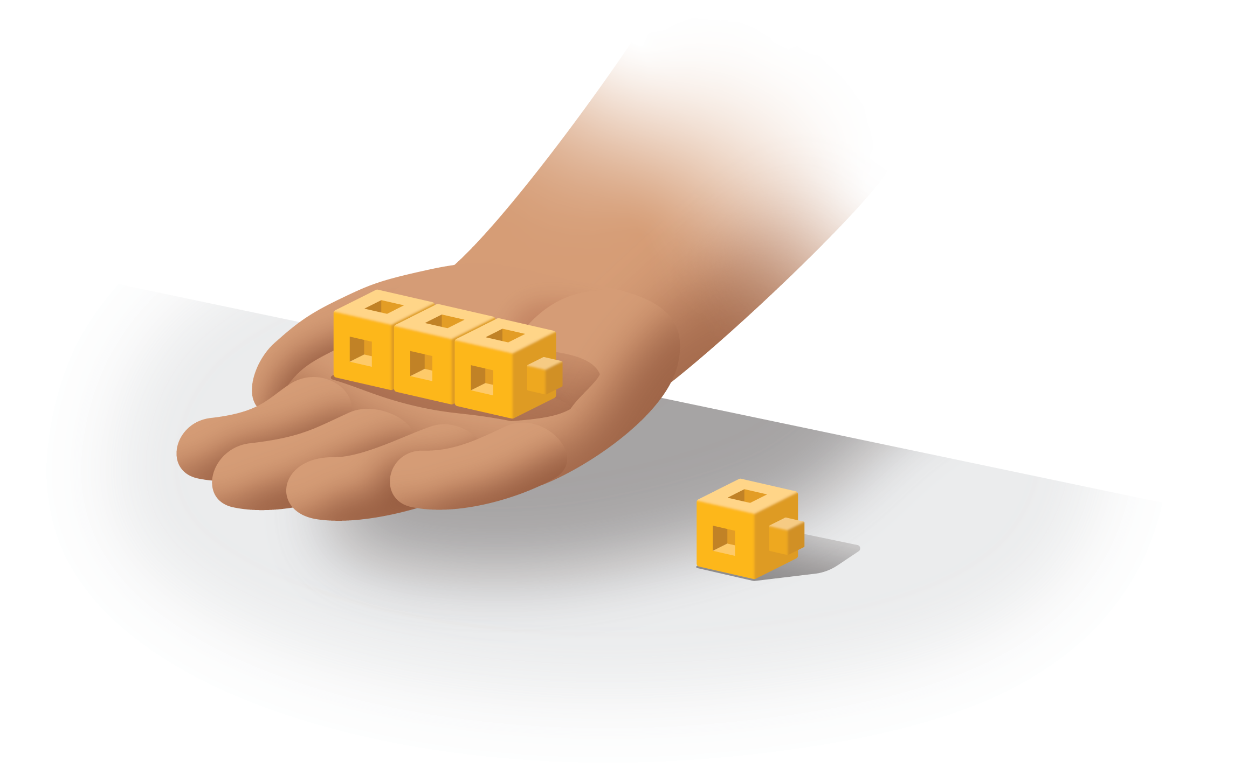
Lin’s cubes
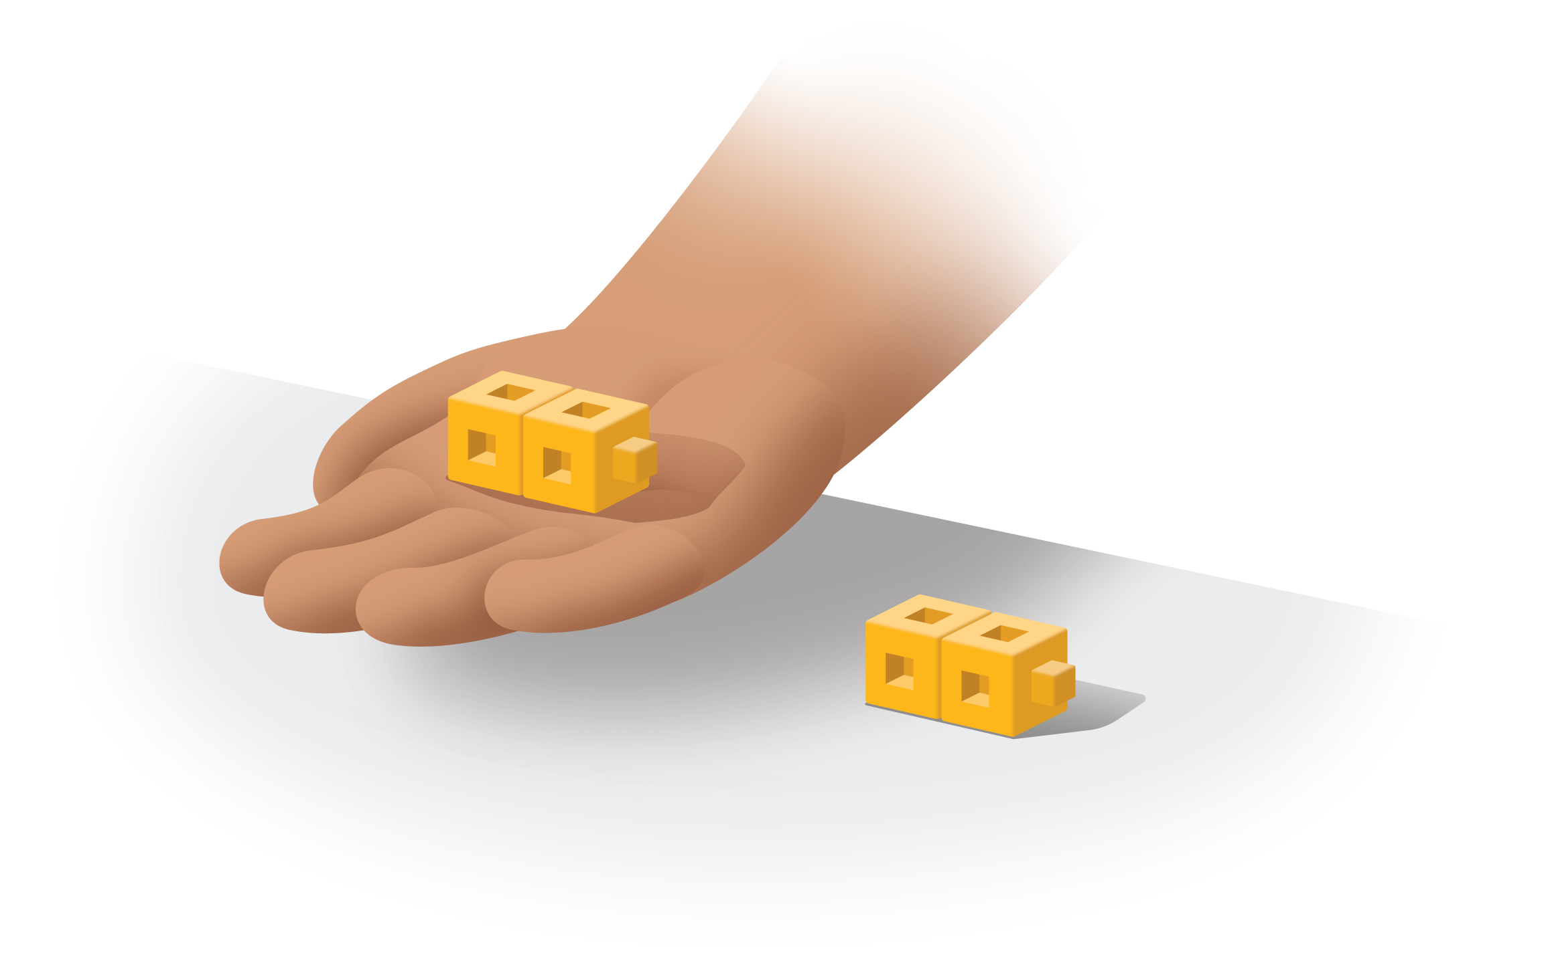

1.3: Introduce Check It Off, Add Within 10
Choose a center.
Check it Off
Bingo
Find the Value of
Expressions
Shake and Spill
© CC BY 2021 Illustrative Mathematics®

