Lesson 7: Build Multiplication Fluency
- Let’s multiply multi-digit whole numbers using the standard algorithm.

Warm-up: Notice and Wonder: Same Solution
What do you notice? What do you wonder?
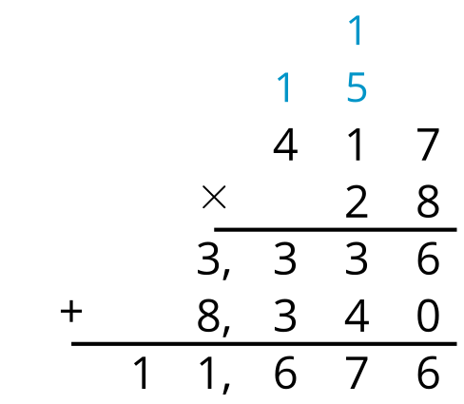
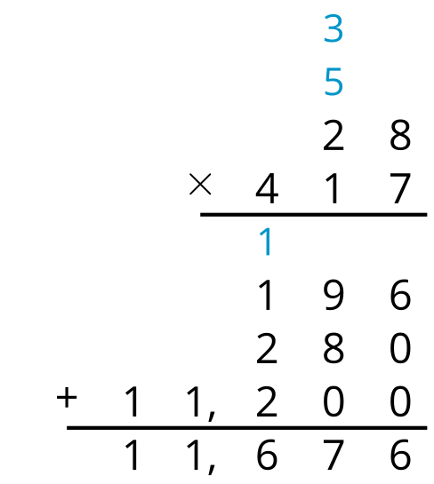

7.1: Greatest Product
Directions:
- Partner A chooses a number card and writes the number in one of the blanks for Round 1.
- Partner B does the same.
- Repeat until each partner has a two-digit by three-digit multiplication problem.
- Find the product.
- The partner with the greater product wins a point.
- The partner with the most points after 5 rounds wins the game.

7.2: Desperately Seeking 9 New Units
Tyler notices that when he uses the standard algorithm and composes a new unit, sometimes there is 1 new unit, sometimes 2, all the way up to 8. He has not seen an example with 9 of the new unit.
- For each of these products, how many of each new unit do you compose?
  - $256×5$
  - $587×8$
  - $809×9$
- Do you think it is possible to compose 9 of a new unit with the standard multiplication algorithm?
© CC BY 2021 Illustrative Mathematics®

