Lesson 14: What is a Line Plot?
- Let’s learn a new way to represent data.

Warm-up: Notice and Wonder: “Handy” Graphs
What do you notice? What do you wonder?
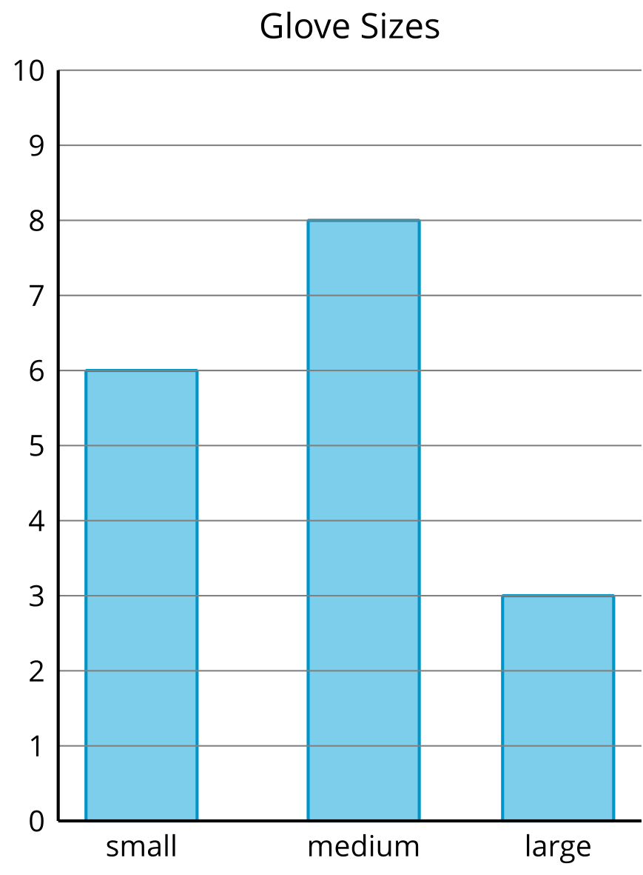
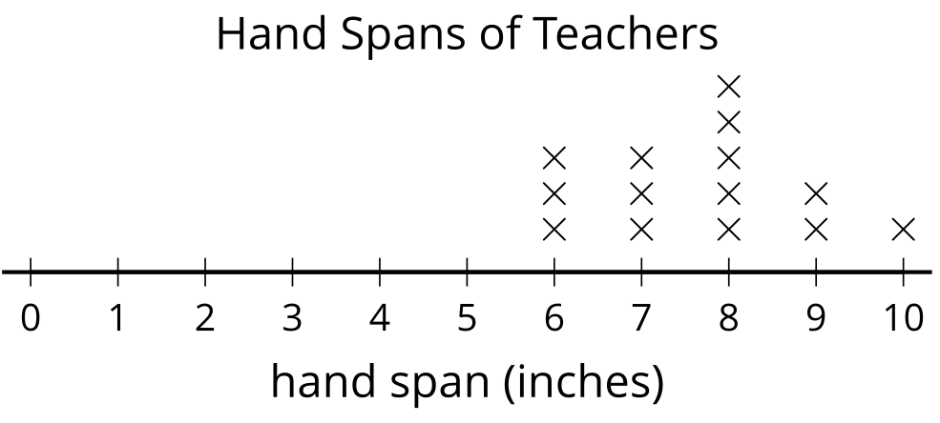

14.1: Measure Our Hand Spans
- Trace your hand. (Spread your fingers wide.)
- Draw a line from your thumb to your pinky. This line represents your hand span. Measure the length of your hand span in inches.
- My hand span is ____________ inches.
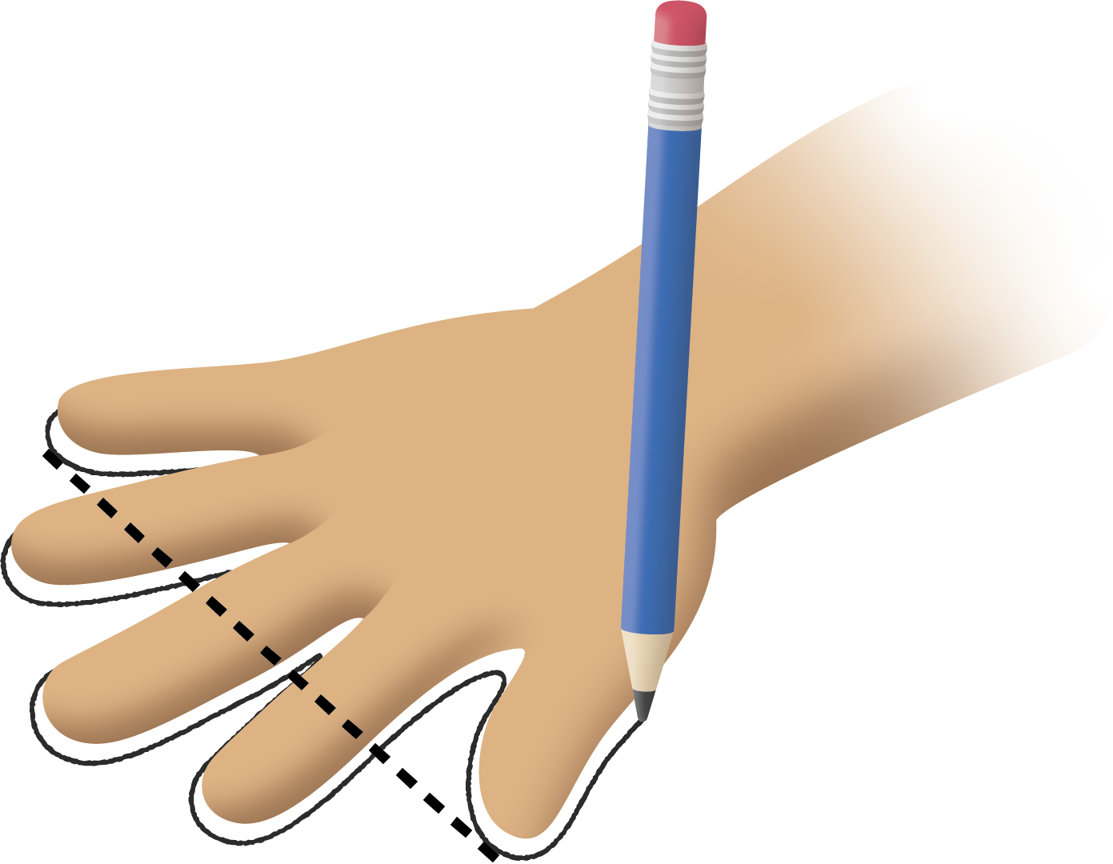

14.2: Interpret Our Numerical Data
- What was the longest hand span?
- What was the shortest hand span?
- Write another statement about our class’ hand spans based on the line plot.
© CC BY 2021 Illustrative Mathematics®

